Student worksheet:
Puzzling out Pacific migrations
– learning activities

These learning activities use the article ‘The long pause’ by Dr Amber Aranui. You can read the article using Google slides or this PDF. You can also listen to an audio recording of the article.

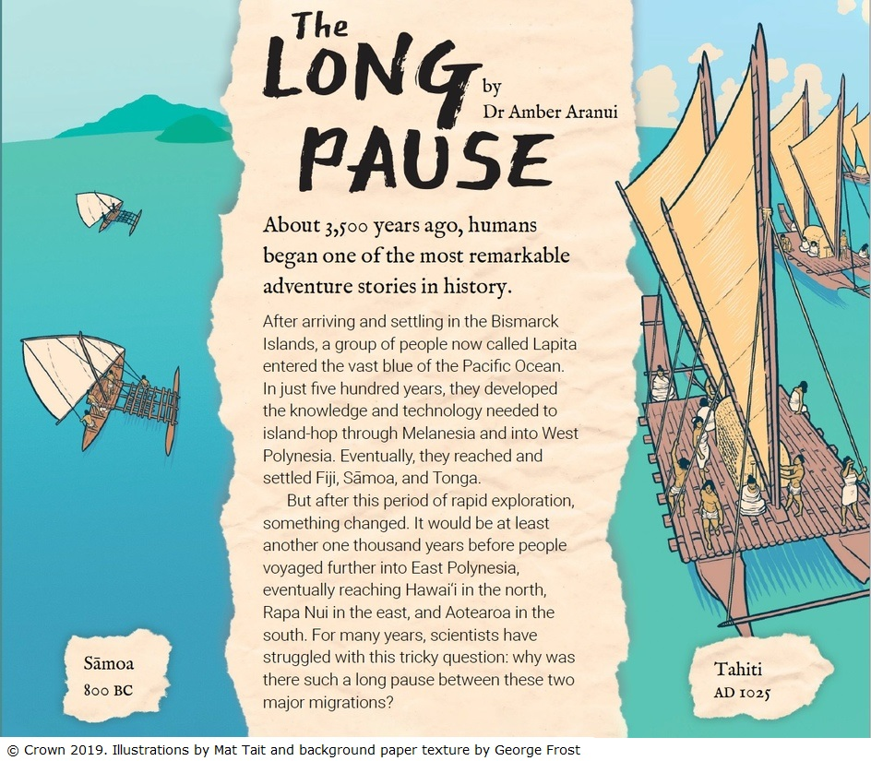

Before you read

- Look at the images on the article’s title page (without the text). Think like a scientist to answer this question:
- What do you see in the image? (These are your observations)

- Now think like a reader to answer these questions:
- The title is ‘The long pause.’ What do you think the article will be about?
- Why do you think the author chose to use drawings instead of photographs?

While you read

Using specialist language

This article has quite a bit of specialist language.

Scan the list in the table below. When you spot one of the words, read around it and write what you think the word means. Hint: only 10 of these were mentioned!

Word | Present in the text?  yes/no | If present, what does it mean?
Lapita
Raparapa
Rapa Nui
migrations
radioactive waste
radiocarbon dating
archaeologists
hypotheses
hypotenuse
waka ama
waka hourua
adze
hospitable

The winds of change – slide 7

Look at the three maps.

The three pieces of information that change between each map are the:
- dates
- wind direction
- direction human migration could take place.

Complete the following table to summarise these differences.

Date | Wind direction | Migration movement (or not)
 |  | Difficult to travel east
 | Eastward
AD 1200–1220

After you read

Scientists look at their data and then think carefully about how to make sense of that data. Use the text to answer the first two questions. Then think about what more scientists could be looking for.

- The text explains that perhaps having the larger waka hourua enabled the people to travel longer distances. What other reasons might cause the people to move eastward across the Pacific?

- What evidence in the text supports these ideas about reasons for movement?

- What other sorts of information would be useful to support this explanation?

Uncertainty in science

In science, there can be different interpretations of data. This uncertainty is part of science, and it helps scientists to keep working with an open mind. Use the table below to record words or phrases that suggest there could be uncertainty. Record the slide you noticed them on. Two examples are included.

Words for phrases | Slide number
possible timeline | Slide 2
Some researchers disagree | Slide 3

Observing images

Now you have read the article, what do you think the author wanted you to notice in that first image? How good were you at observing like a scientist? Thinking about these differences is an important part of this article. Use the table below to make a list of the differences between the two images.

Outrigger canoe – waka ama | Double-hulled canoe – waka hourua

Wind direction

Wind direction seemed to be quite an important factor for the sailors.

      - Talk to your whānau and family and see if you can find out what the prevailing winds are at your home. Go to https://www.metservice.com/national and see if you can find your place and from which direction the wind is most frequent. Is that the same as what you and your whānau thought?

      - During the day, go outside at three different times – morning, midday and late afternoon – and decide which direction the wind is coming from. If the breeze is very small, you might need to wet your finger and hold it up in the air. Your wet finger should feel a little colder in the direction that the wind is coming from. Wind direction is labelled according to the direction the wind is coming from. You may need help to identify the direction. Record the wind direction in the table below.

Time of day | Wind direction

Observing the effects of wind

Observe the images below.

- Can you work out which direction the wind usually comes from?

- Why do you think the trees in the image on the left are so misshapen?
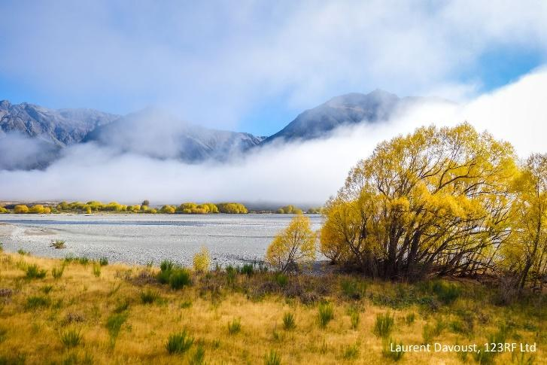
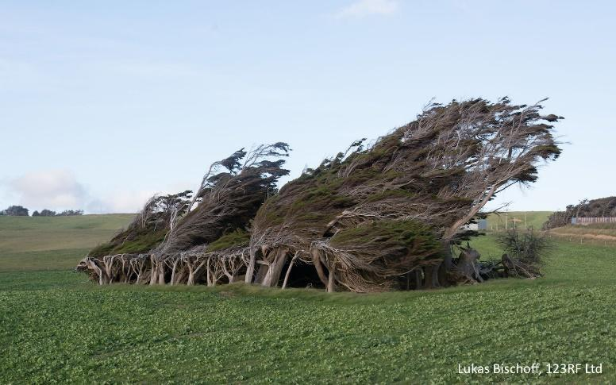
Wind power

Wind was one of the factors that contributed to the early migrants setting sail in their waka heading out into the unknown.

- How does wind work for us? How does wind work against us? Design a poster that shows the good and bad effects of wind.

- One use of wind is for generation of electricity. Wind is free and we always need electricity, but there are drawbacks. Design an advertisement that will persuade people that wind power is a good thing.

- An anemometer measures how fast the wind goes. Find out how to make one. Can you get it to turn by blowing or using a fan? Try taking it outside!

- This table shows the wind direction and wind strength for Paeroa. Use this data to see if you can work out the prevailing wind direction for Paeroa.

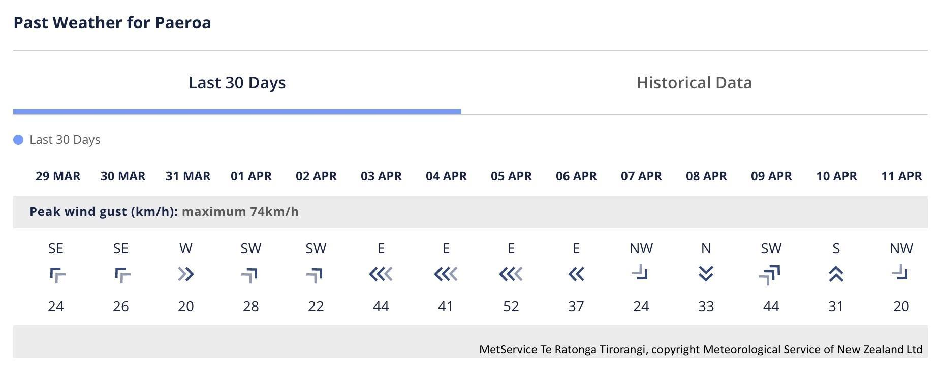

Looking at how the wind keeps changing, being an explorer that relied on wind would be pretty challenging to get to where you thought you wanted to be!

