Student worksheet:

Poetry with Fred the Thread –

learning activities for upper primary

These learning activities use the poem Fred the Thread written by Dr Robert Hoare. Fred is a native caterpillar that lives in plants with long, very narrow leaves. Scientists think Fred might be the world’s thinnest caterpillar. No one even knew this caterpillar existed until a few years ago, when Robert helped to find him.
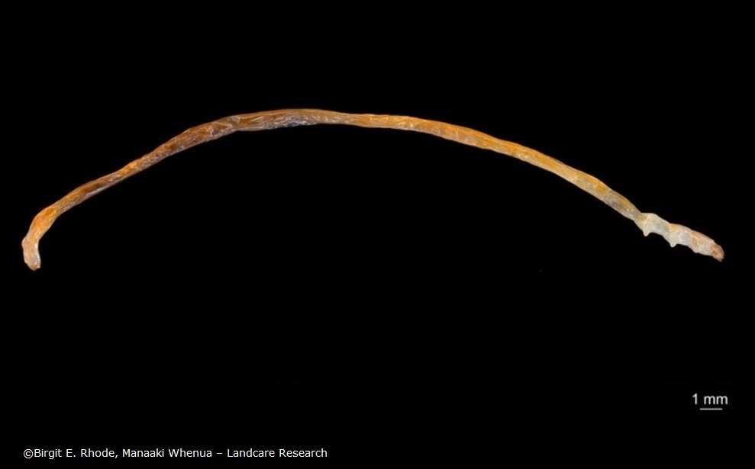

Robert likes Fred so much that he wrote a poem about him.

I have a friend (his name is Fred)
He’s thinner than a cotton thread
His colour is an orange-red
He doesn’t feed on jam or bread
But Sporadanthus stems instead.

Such narrow tunnels must he tread
He needs a hinge inside his head
To give his jaws the room to shred
The food that is his home and bed
And stop himself from dropping dead.

Now when our friend is fully fed
And knows the time has come to shed
His final skin, a sense of dread
Begins to filter into Fred:
How fast, he thinks, the time has sped!
And what a sheltered life he’s led!
He hopes he’ll have some outdoor cred
And won’t be thought of as inbred.

He sloughs his skin from A to Zed
And there’s a pupa in his stead!
Three weeks have passed, and it’s incred-
ible to see the adult Fred,
A mothy person born and bred
To look like that on which he’s fed.

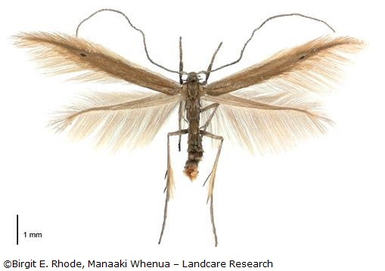
He shows an admirable ded-
ication to his art, his sed-
entary posture leaving ed-
ucated mothmen ruby-red,
The effort of locating Fred
Causing a rush of blood to head
Resulting in potential med-
ical emergency and bed
With cooling drink and favourite Ted
Until delirium has fled.

To summarise, he’s Fred the Thread,
He’s red and has a hing-ed head
His head is used to shred his bed,
His bed’s the food on which he’s fed,
His bed is red and I am led
To think the redness of the Fred
Reflects the bedness of the red
I mean the redness of the bed –
The bed he shreddeth with his head
Until the Fred is fully fed
And sheds the skin he has to shed
To flee the bed that must be fled
To lead the life that must be led
To woo the wife that must be wed
To father further Freds of Thread.
Then Fred can smile and drop down dead.

I’ve said the things I wanted said.

Reading
- Watch the video and listen while Robert reads his poem.

- Try reading the poem aloud. Challenge yourself to read the poem as fluently as Robert does. (He read the poem in one continuous take – no video edits were required!)

- Read the article Fred the Thread. It tells the story of how Robert and his colleague Corinne discovered this new species.

- Examine a stanza or stanzas from the poem for factual versus fanciful statements (stanzas are a bit like paragraphs – a recurring pattern throughout a poem). For example, in the first stanza, Fred is described as an orange-red colour and as eating Sporadanthus stems. These are both true. However, Fred is not actually thinner than a cotton thread. He is extremely thin (1 mm across), and this reference is used to highlight thinness as a special feature of Fred. Write down an example (or examples) that you have found.

- Identify words or phrases that:
- create scientific meaning
- create and sustain interest
- promote humour
- explore feelings rather than scientific fact.

Maths
Fred the Moth is even smaller than Fred the Thread. The adult moth is less than half a centimetre long with a wingspan of 12 mm.

- Use a ruler to draw a 4 mm x 12 mm rectangle.

- Make a drawing of Fred the thread larva with accurate dimensions (this image will help).

- Find other items outdoors or around the house that fit in your rectangle.

- Look at the images of Fred as a larva (or caterpillar form) and a moth. How would you check whether the measurements given in each caption are accurately reflected by the scale in each image?

Science
- Adaptations are specific features that help a species live in its habitat. Identify the lines that describe Fred’s adaptations for living inside the narrow Sporadanthus cane rush stem.

- View and compare images of Fred the caterpillar with a red admiral caterpillar. Read the articles Fred the Thread and Butterfly defence mechanisms to learn more about the larvae’s adaptations. Create a table with similarities and differences between Fred and the red admiral caterpillar.

- Reread the article Fred the Thread and explain why the scientists who discovered this species decided to give it the scientific name Houdinia flexilissima.

Writing and presenting
Newly discovered species are often named by the people who discover them. The scientists who discovered Fred gave the species the scientific name Houdinia flexilissima.

- Watch this video to hear how Robert and Corinne named Fred. What features does its scientific name refer to?

- Invent and sketch a species of your own and give it a name that describes some of its features. It can be a plant, mammal, insect etc.

- Write a paragraph or create a short video introducing your new species and explaining the name you have chosen for it.

