Student worksheet:

Poetry with Fred the Thread –

learning activities for middle primary

These learning activities use the poem Fred the Thread written by Dr Robert Hoare. Fred is a native caterpillar that lives in plants with long, very narrow leaves. Scientists think Fred might be the world’s thinnest caterpillar. No one even knew this caterpillar existed until a few years ago, when Robert helped to find him.
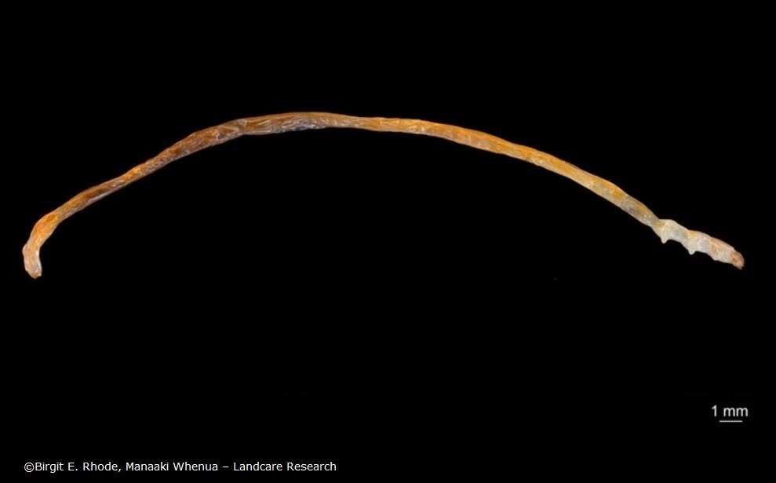

Robert likes Fred so much that he wrote a poem about him.

I have a friend (his name is Fred)
He’s thinner than a cotton thread
His colour is an orange-red
He doesn’t feed on jam or bread
But Sporadanthus stems instead.

Such narrow tunnels must he tread
He needs a hinge inside his head
To give his jaws the room to shred
The food that is his home and bed
And stop himself from dropping dead.

Now when our friend is fully fed
And knows the time has come to shed
His final skin, a sense of dread
Begins to filter into Fred:
How fast, he thinks, the time has sped!
And what a sheltered life he’s led!
He hopes he’ll have some outdoor cred
And won’t be thought of as inbred.

He sloughs his skin from A to Zed
And there’s a pupa in his stead!
Three weeks have passed, and it’s incred-
ible to see the adult Fred,
A mothy person born and bred
To look like that on which he’s fed.

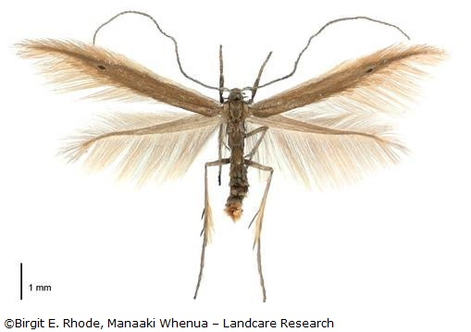
He shows an admirable ded-
ication to his art, his sed-
entary posture leaving ed-
ucated mothmen ruby-red,
The effort of locating Fred
Causing a rush of blood to head
Resulting in potential med-
ical emergency and bed
With cooling drink and favourite Ted
Until delirium has fled.

To summarise, he’s Fred the Thread,
He’s red and has a hing-ed head
His head is used to shred his bed,
His bed’s the food on which he’s fed,
His bed is red and I am led
To think the redness of the Fred
Reflects the bedness of the red
I mean the redness of the bed –
The bed he shreddeth with his head
Until the Fred is fully fed
And sheds the skin he has to shed
To flee the bed that must be fled
To lead the life that must be led
To woo the wife that must be wed
To father further Freds of Thread.
Then Fred can smile and drop down dead.

I’ve said the things I wanted said.

Reading
- Watch the video and listen while Robert reads his poem.

- Play the video again. Use the words in the poem to read along with the video.

- Choose a favourite part of the poem and read it aloud on your own. Video yourself reading it so you can share the video with your class or someone else.

- Write down three words that describe what Fred looks like.

- Write down three things that Fred does.

- Fill in the table below:

Words that rhyme with Fred  that are easy for me to read | Words that rhyme with Fred  that are hard for me to read

Maths
Fred is tiny! He is 2 cm long and 1 mm wide.

- Use a ruler to draw a line 2 cm long.

- How many 2 cm long caterpillars could fit along your 30 cm ruler?

- What can you find that is also 2 cm long? Fill in the table below.

Indoor things that are 2 cm long | Outdoor things that are 2 cm long

- Place one of the 2 cm items next to your ruler and take a photo of it.

Science
Fred is a tiny caterpillar that turns into a tinier moth. Fred the Thread’s life cycle has the same stages as a butterfly. The stages are egg, caterpillar, pupa and adult.

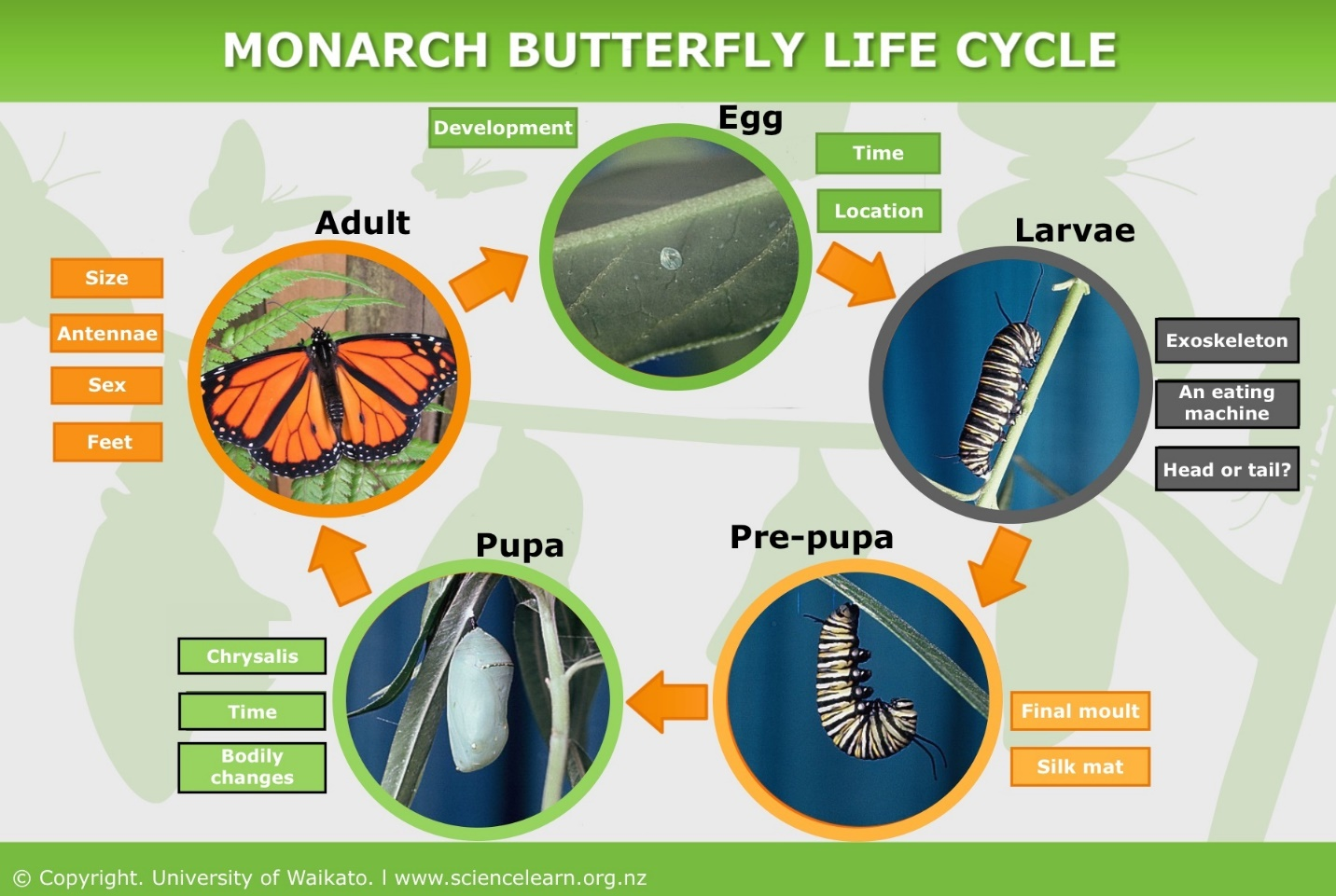

- Draw Fred’s life cycle. Use the images of Fred the caterpillar and Fred the moth when making your drawings, but you will have to guess what the egg and pupa stages look like. Remember to add a title and arrows to the life cycle.

- As an extension activity, what about finding a moth at home and identifying it?

Writing and presenting
- Choose an insect you like (or don’t like) and write a poem about it. See if you can make some of the words rhyme.

- Read your poem to an audience (family or friends or classmates), or make a video recording just like Robert.

