Student worksheet:

Tired muscles? – learning activities

These learning activities use the article ‘Why do our muscles get tired?’ by Zoe Armstrong and Dave Armstrong. You can read the article using Google slides or this pdf. You can also listen to an audio recording of the article.

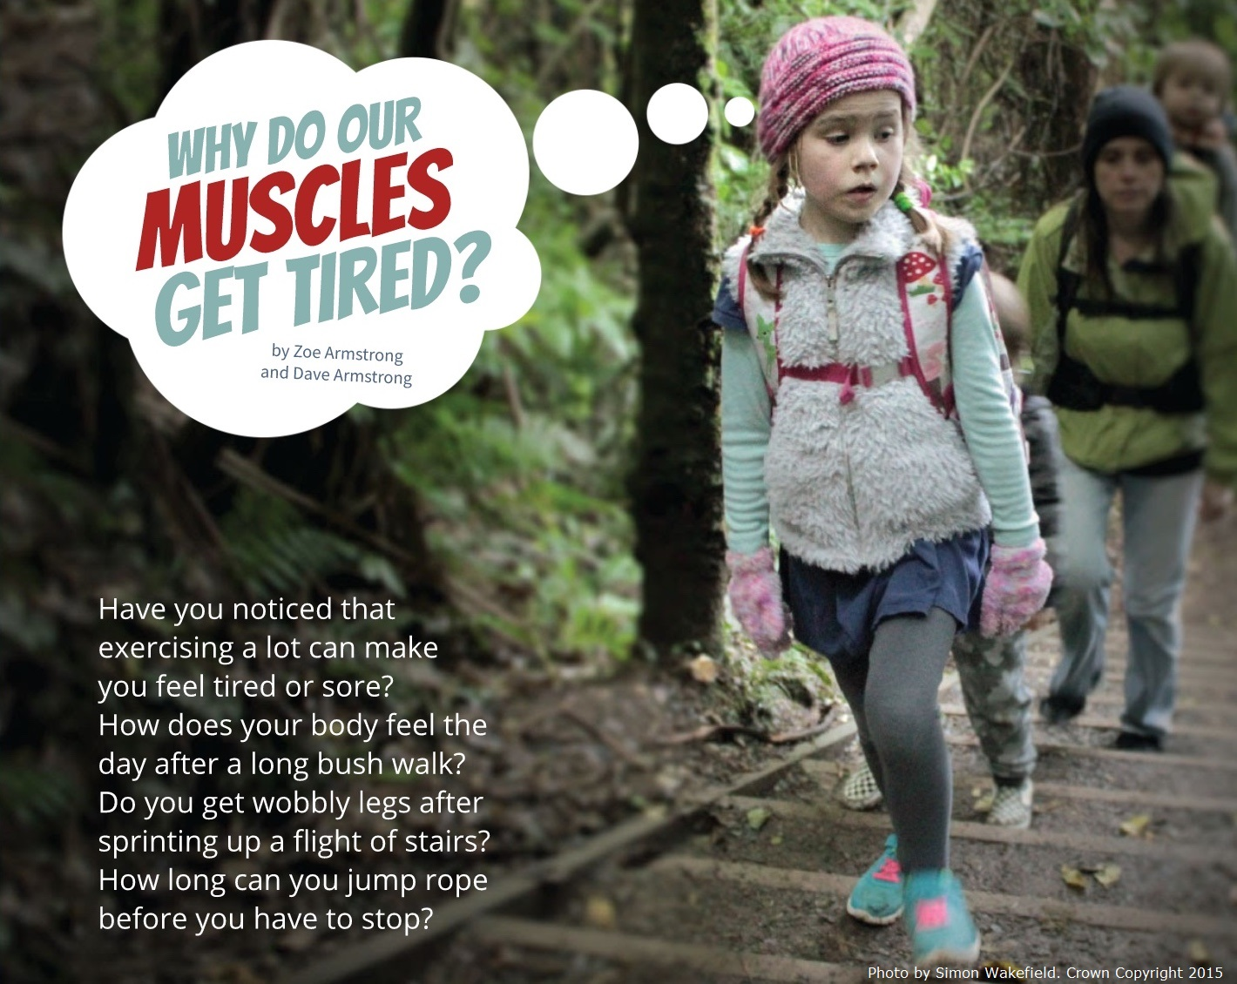

Before you read
Look at the images in the story. Use them to help you answer these questions:
- Why do you think the article uses a mixture of photos and drawings?
- Which pages show images of people with tired muscles?
- Why do you think they are tired? What is your evidence?

While you read
Think about these questions
- What is muscle fatigue? Explain it using words from the article.
- What are three things we can do to beat muscle fatigue?
- Why does Oscar think his fingers are fit?
- Why does Moana think her fingers are fit?
- What is another hobby that might make someone’s fingers fit?
- What are three facts about Oscar and Moana’s investigation?

After you read
- Create a fittest fingers investigation of your own.
- Create a table like the one in the article.
- Find a stopwatch (you can use most cell phones) and a clothes peg.
- Challenge someone in your family to complete the investigation with you.
- Record your results.
- Discuss whether the results are reliable. (Use the information on slide 6 ‘What’s going on?’ to help with this discussion.)
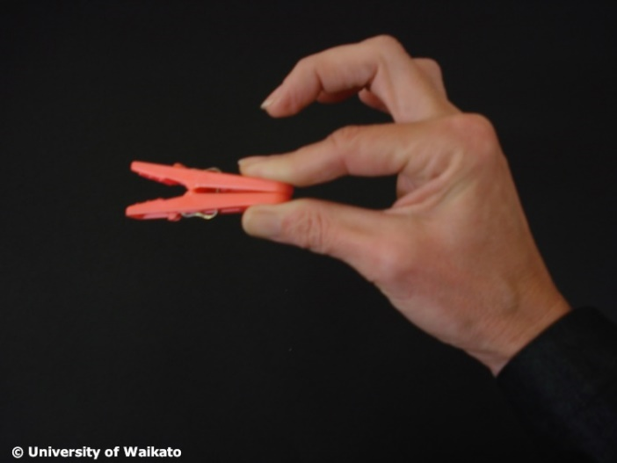
- Share your findings with the class.

- Look at the images in the article Meet some muscles. The muscles have tricky names to read but you can see where they are on your body. Why do you think scientists give specific names to different muscles?

- Create a new investigation using another set of your muscles – for example, star jumps, lifting a filled water bottle above your head, sit-ups or even opening and closing your mouth.
- Create a table to record your results.
- Make a graph of the results.
- Repeat the investigation for 5 days. Record and graph the results. Try to explain why the results might have changed.

- Watch the video of the Samoan sasa (slide 10 of the Google slides).
- Watch the video again and see if you can do some of the actions – these boys move fast!
- Observe changes to your body. Is your body getting more blood and oxygen to your muscles? How do you know?

- Watch the video again, paying attention to the beat of the drumming. Create your own fast dance. Video it to share with friends or your class.

- Find words from the article in this word search.
- Can you read each word out loud?
- Do you know what each word means? Tick the words you already know once you’ve done the word search. Draw a circle around the words that are new to you.
- Write different sentences that use the words below –for example: When I exercise, my muscles feel wobbly. How many sentences can you write?

