Student worksheet:

Birds in my backyard – learning activities

Read the article ‘The takeaway table’ by Diana Noonan. Use Google slides or this PDF.
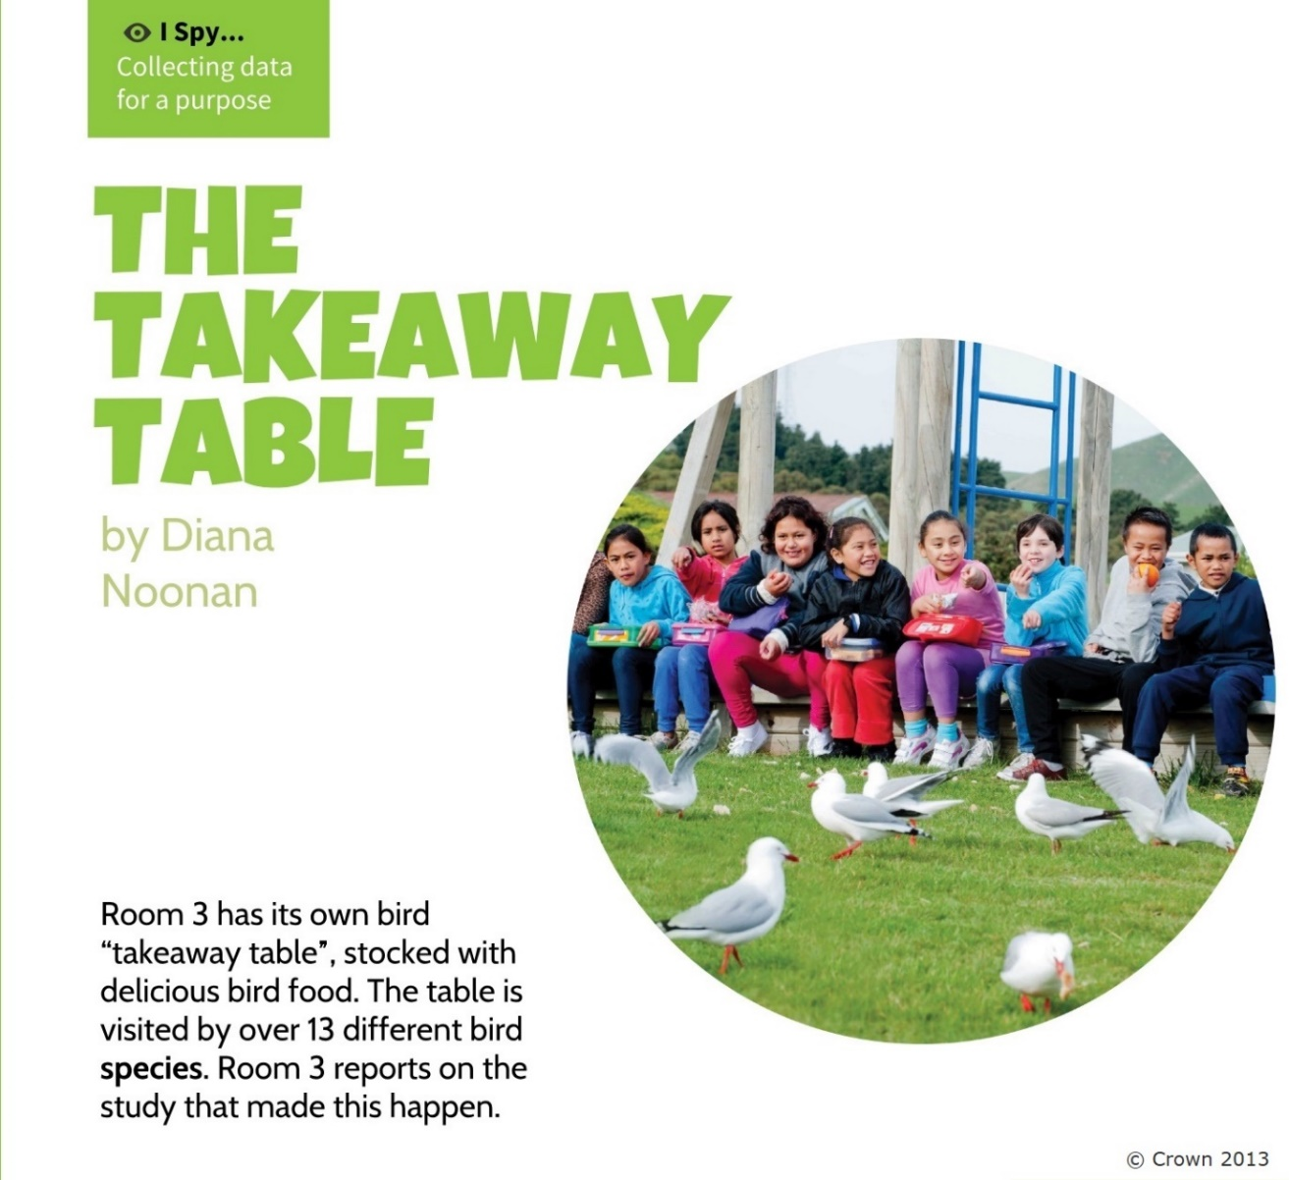

Before you read
Look at the photo of the students and birds. Think like a scientist to answer these questions:
- What do you see in the photo? (These are your observations.)
- What do you think is happening in the photo? (These are your inferences – the meanings you make from your observations.)

Now think like a reader to answer this question:
- The title is ‘The takeaway table’ and the photo shows students with lunchboxes. What do you think the story will be about?

While you read
Think about these questions:

- Why would Mr McIntosh, the school caretaker, be able to see bird species the students would not?

- What did the students do to help them gather data they could trust?

- Why did the students wait 5 minutes before they started each observation?

- What are five comments you can make after looking at Room 3’s graph of results?

After you read
- Find a place at your home or in a nearby park area that will be good for observing birds. This can be a window inside or a spot outside. If you are inside, open the window so you can hear the birds.

- Look at the Garden Bird Guide poster by Landcare Research. It has things to look out for (observe) when identifying birds.

- Make an observation form of your own. Use some of the words from Room 3’s observation form.

- Spend 10 minutes observing birds. Look and listen. Take photos if it does not frighten the birds.

- Identify the birds. Look at the Garden Bird Guide poster or New Zealand Birds Online ‘Identify that bird’ section. Use What Bird? to listen to bird calls.

- Share your findings with the class.

Additional activities
- Find out which birds you have observed are native (found naturally in New Zealand) and which are introduced (brought to New Zealand by humans). Why do you think it is more common to see introduced species than native species in towns? (Hint: Think about the foods they eat and whether they are good at flying.)

- Watch the Department of Conservation video Feeding New Zealand’s Birds. Make a poster (on paper or using a device) with tips for feeding birds. Use the ideas (recommendations) from Room 3 too.

- Choose one bird from this set of colouring-in pages. Use a photo from the Garden Bird Guide poster and coloured pencils to make your bird look as real as you can.

- Observe birds for 10 minutes a day for a week. Record your results in a graph like the one in ‘The takeaway table’. Which bird was most common? Which bird would you like to see more of? Find out what it eats, put some food out for it and then see what happens. You could also change the time of day or place where you do your observations. What difference does this make? What could this tell you?

- New Zealand eBird is an online citizen science project where volunteers collect observational data about birds (day, time, species, number of species and total observation time) and upload this onto the database. You’ll first need to create a user name (ask an adult to help you). You can keep track of your sightings in ‘My ebird’ and also investigate bird sightings from around the world.

- Read ‘Bringing back the birdsong’ in this Google slide presentation. Identify three different ways that communities can work together to help native birds.

