Planning pathways using earthquake resources
This interactive groups Hub resources into key science and teaching concepts. The article Earthquake resources – planning pathways provides pedagogical advice and links to the New Zealand Curriculum.
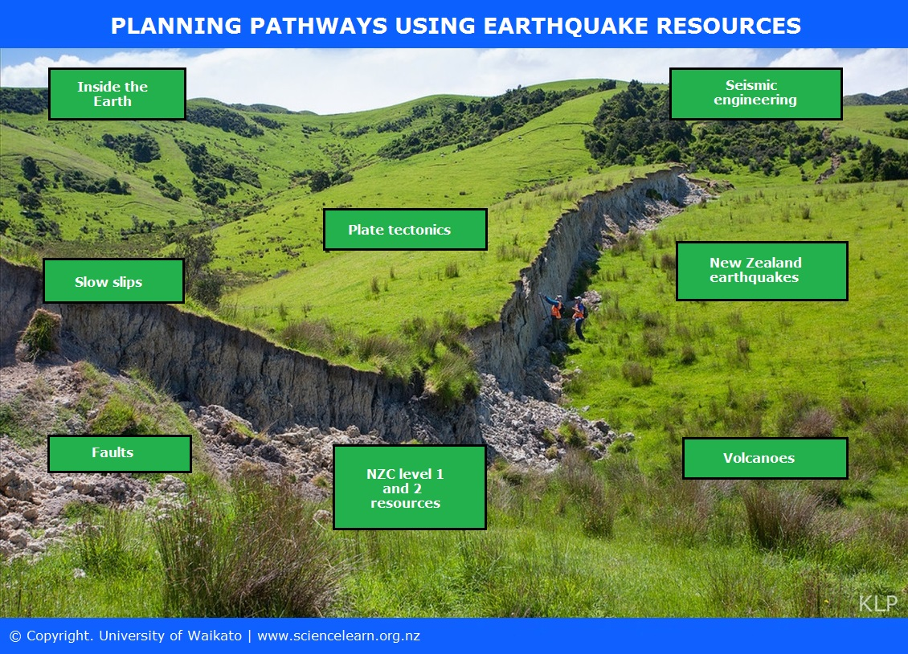

This interactive diagram provides a selection of pathways that allow for differing approaches and starting points using our earthquakes resources. The aim is to assist educators with their planning of lessons and units of work by providing options that cover multiple science concepts. If using the online version, click on the labels for links to supporting articles, media, data and student materials.
Background image: Dr Katherine Pedley
Transcript index
- Inside the Earth
- Seismic engineering
- Plate tectonics
- Slow slips
- New Zealand earthquakes
- Faults
- NZC level 1 and 2 earthquake resources
- Volcanoes

Transcript

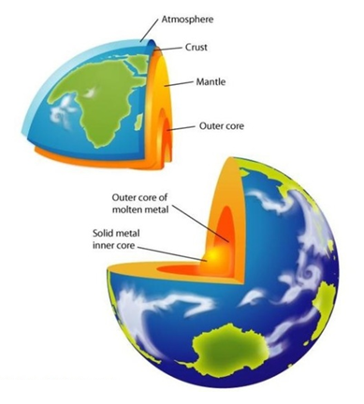
Inside the Earth
The Earth is divided into layers.
Related articles
- Inside the Earth
- Moulding the Earth
- Magma on the move
- Magma formation
Related activities
- World of quakes
- Plates and quakes
- New Zealand plate boundary models
University of Waikato

Seismic engineering
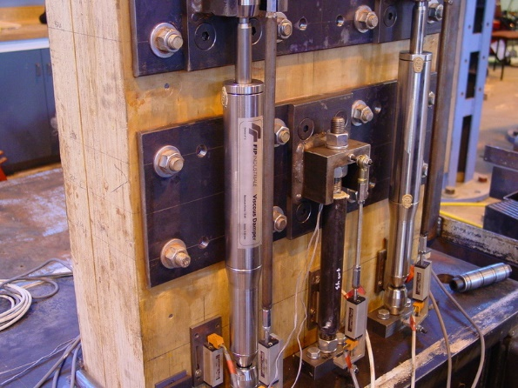
Seismic engineers develop new techniques and new materials to help buildings withstand earthquakes.
Related articles
- Seismic engineering
- Strengthening Parliament House
- Base isolation and seismic dampers
- Seismic engineering at Canterbury University
- Dr Bill Robinson
Related activity
- Best base isolator
Robinson Seismic Limited

Plate tectonics
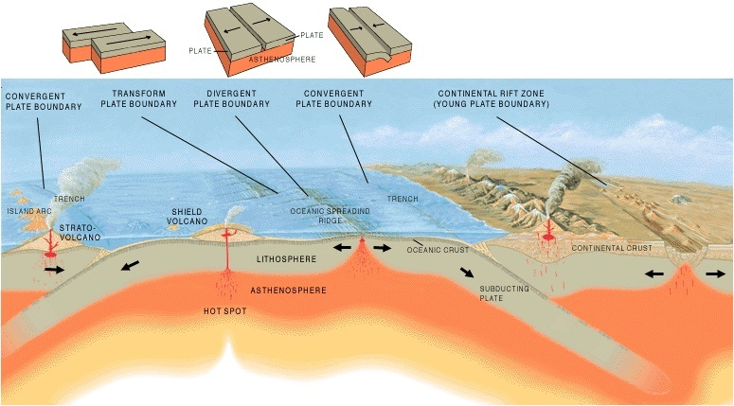
The Earth’s crust is made up of many plates that slide past each other causing friction and heat.
Related articles
- Plate tectonics
- Plate tectonics, volcanoes and earthquakes
Related activity
US Geological Survey (USGS)
- Tectonic jigsaw puzzles

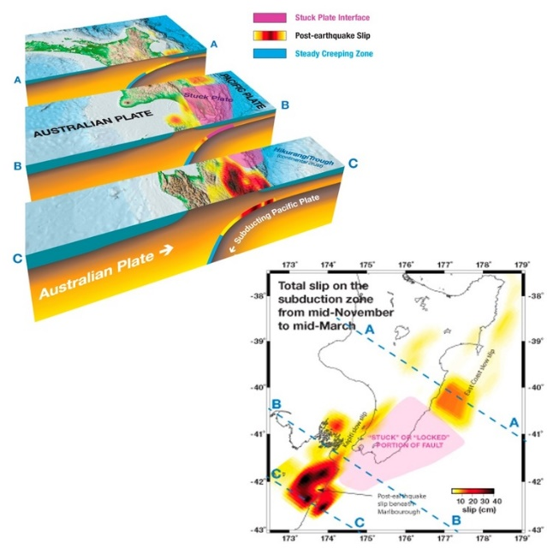
Slow slips
Large areas of New Zealand are silently and slowly moving due to slow slip events.
Related articles:
- What are slow slips?
- Dr Laura Wallace
Related activity:
- Something creepy is happening
Laura Wallace, Geonet

New Zealand earthquakes
Scientists record around 15,000 earthquakes in New Zealand every year. There are some big quakes that have become part of our history.
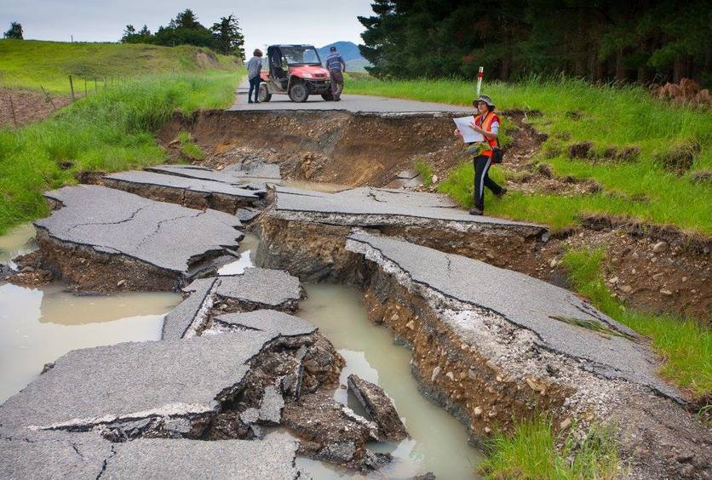
Related articles
- Canterbury earthquakes
- Liquefaction
- Kaikōura earthquake
- Investigating earthquakes – introduction
Related activities
- Shaky New Zealand
- Earthquakes past and future
- Earthquake location
Dr Katherine Pedley

Faults
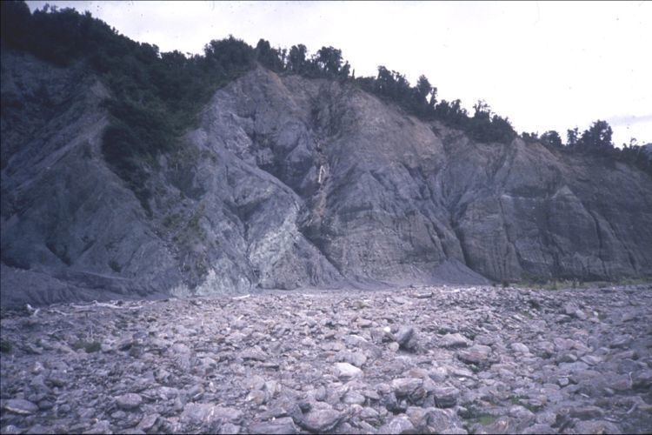
A fault is a fracture in the Earth’s crust where the rock mass on either side has been displaced. Earthquakes occur on active fault lines.
Related articles
- Faults
- The Alpine Fault
- Squishy rocks and earthquakes
Related media
- Why study the Alpine Fault?
- From mountains to microscopes
Dave Prior

Related activities
- New Zealand plate boundary models
- Earthquakes past and future

NZC level 1 and 2 earthquake resources
These resources offer an introduction to the science behind earthquakes.
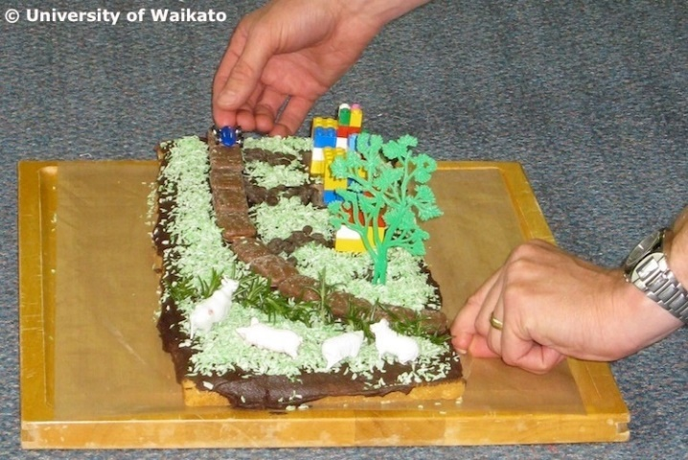
Related articles
- Earthquakes and volcanoes
- Under the Earth’s surface
- The moving Earth
- Shaky scientists and engineers
Related media
- Tectonic plates, volcanoes and earthquakes
Related activities
- Models of the Earth
- Tectonic jigsaw puzzles
- Tectonic sandwiches
- Earthquakes – unit plan
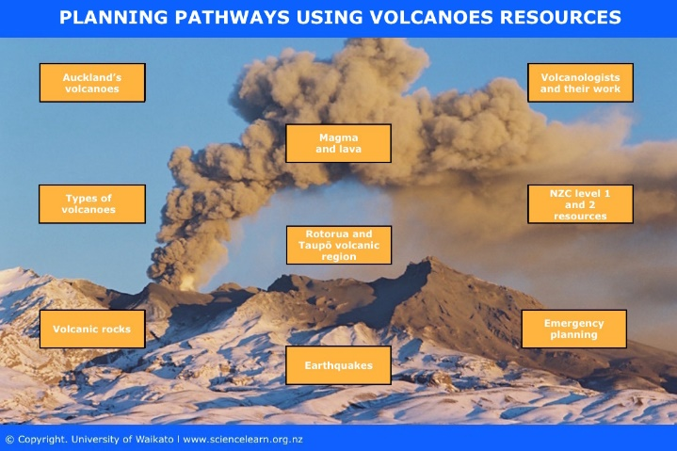

Volcanoes
The interactive Planning pathways using volcanoes resources groups Hub volcanoes resources into key science concepts and topics.

