ACTIVITY: Investigating pendulums – what matters?

Activity idea

In this investigation, students investigate a simple pendulum to determine which variables (length, amount of weight or length of swing) influence the period (time for one full swing) of a pendulum.

By the end of this activity, students should be able to:
- describe the variables in a pendulum system
- describe why it is important to only change one variable at a time
- record data from an experiment
- state the experimental evidence used to decide the factors that influence the period of a pendulum.

For teachers

This simple investigation can be used to focus on the nature of science (identifying and isolating variables in an experiment) or on developing students’ skills and understanding about measurement, data manipulation and potential and kinetic energy.

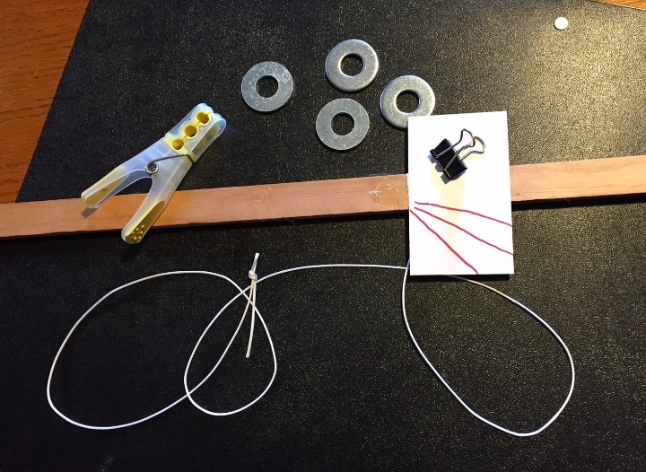
What you need

Per student group:
- Approximately 1 m of string
- Small rectangular piece of cardboard
- Paper clip
- Four large washers (approximately 20–30 mm)
- Binder clip or clothes peg
- Metre stick or other stick approximately 1 m long
- Smartphone with a timing/stopwatch app

Investigation set-up

- Place the metre stick over the back of two chairs or desks. | 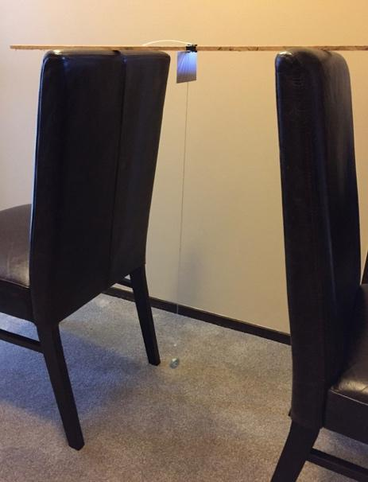
- Bend a paper clip to form a hanger for the washers, and attach the paper clip to one end of a piece of string. | 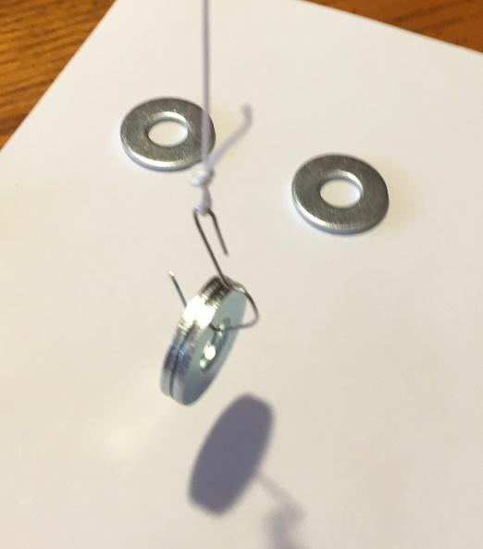
- Tape an index card to the underside of the metre stick, and using a binder clip or clothes peg, attach the string to the metre stick.  - Mark three lines on the card so that the pendulum can be reliably started from three positions. | 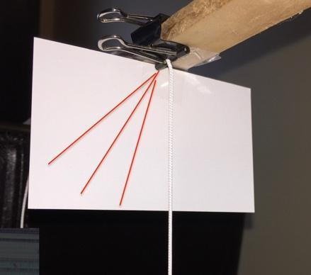

Teaching suggestions

- You may wish to begin by demonstrating a pendulum and asking the class to speculate what things could be changed about the pendulum that might change the period. Three variables will likely emerge: weight, length and degree of arc (how far back it is pulled).
- In order for the students to determine which variable(s) influence the period, they will need to look at each variable in isolation. This will require them to keep two of the variables constant while changing the third, then repeat the process with the other two variables. For example, if they wish to vary the weight, they will need to try the experiment with 1, 2, 3 and 4 washers while keeping the string length and degree of arc the same. To investigate the length variable, they will need to keep the number of washers and the degree of arc the same for each trial.
- Varying amounts of instruction can be given. Depending on the level of understanding and experience of your students, you may decide to simply divide them into groups, provide them with the materials and let them begin investigating. Alternatively, you may wish to demonstrate the equipment and provide them with guidance and suggestions.
- A challenging part of this investigation is timing the period. Students will quickly find that, when timing a relatively fast event, they get different answers because it is difficult to start and stop the stopwatch with precision. Some teachers may wish to allow the students to notice this for themselves and challenge them to think of ways to solve the problem. Two ways around the problem are to take multiple measurements and find the average or to time multiple swings (e.g. 10) and divide the time by the number of swings. Although the pendulum will not swing exactly as high each time (because of friction), it will swing many times without a noticeable change.

A common alternative conception

Some students may believe the period of a pendulum is dependent on all three variables. However, the period of a pendulum is primarily determined by the length of the pendulum. Other variables such as weight of the fob (weight on the end of a pendulum) or the amount of arc affects the period very slightly. (The period is slightly affected by the arc angle – if the angle is less than 45°, the period increases by less than 4%.)

Scientific emphasis

- The point of this investigation is to answer a question using scientific methodology. The investigation introduces students to the concept of controlling variables so that it is possible to look at each variable in isolation. It also introduces the techniques of data averaging and the importance of collecting multiple data points.
- A question that will likely emerge during this investigation is what to do when students record a data point that is very different to the others. For example, a group might record times of 2.23 seconds, 2.10 seconds and 11.23 seconds (probably caused by not starting or stopping the timer appropriately). If they can identify a reason for the errant point, it is appropriate to simply draw a line through that point and take an additional measurement. A data point that is well outside of the range of the other points is call an outlier and should not be included in an average. There are statistical tests for data that can identify outliers, but these are beyond the scope of this investigation.
- When the degree of arc is kept relatively small (less than 45°), the only variable that affects the period of a pendulum is the length. When you pull back a pendulum, you are really lifting the weight as it is pulled back. The weight then attempts to fall to the floor, but the string constrains the path of the pendulum to an arc. The pendulum goes faster and faster as it approaches the point directly below the point where the string is attached, then begins to slow down, eventually coming to a stop at a point on the opposite side at almost the exact height that it started, then it swings back and the process is repeated. If the pendulum is lifted only a little, it travels more slowly, because it does not have as far to fall (it has less potential energy). The time it takes in each case is almost exactly the same.
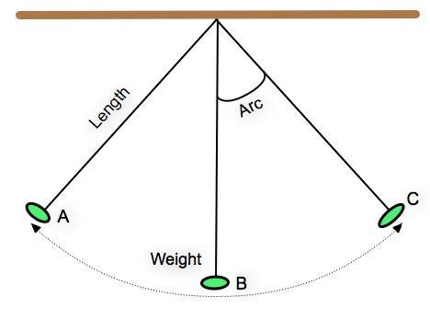

Extension ideas

- A pendulum is an excellent example of energy transformation. When the pendulum is in position A, it has been lifted up from its rest position at B and therefore has added potential energy. When it is released, that potential energy is converted to kinetic (moving) energy, which increases until it gets to point B, then that kinetic energy begins to be converted back to potential energy until it is all converted back and it comes to rest momentarily at point C. Then the process repeats.
- The students could be challenged to look at their pooled data and estimate how long a pendulum would need to be for the period to be exactly 1 second.
- If you start a pendulum by dropping the fob from against a wall (and it is not released with any additional force), it will not swing back and hit the wall. Why not?

