ACTIVITY: Investigating mirrors and reflection

Activity idea

In this investigation, students will trace rays of light from an object reflected by a plane mirror, predict the location of the image produced by the object and confirm their prediction.

By the end of this activity, students should be able to:
- explain how and where an image is formed in a plane mirror
- describe how light travels from an object, is reflected off of a mirror and is observed as an image
- describe the difference between an object and an image.

Background information for teachers
Extension ideas
Investigation instructions

Background information for teachers
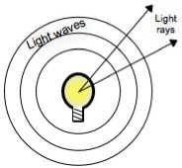
We use mirrors every day, but how do they work? Light travels in many directions, like the ripples that fan out from objects in a pond. Light can be thought of as waves or as rays. A light ray is a particular point on the light wave that travels in a straight line from the light source.

By analysing the rays of light that travel from an object to a mirror and are reflected into our eyes, we can understand how light is reflected from a mirror and where the image in the mirror appears to be.

In this investigation, students will conduct an experiment that shows how light rays are reflected in plane mirrors to form virtual images that appear to be behind the mirror. They look at an object’s reflection in a small mirror and predict the location of the image in relation to the object. Then, by placing a similar object at the location of the image, they can confirm their diagram and observe an interesting visual effect. They will observe that light travels in straight lines, and is reflected by a mirror much like a pool ball rebounds off the edge of a pool table. (Locating small mirrors may be challenging – hobby shops, home decorating shops, and tile shops may sell packages of small mirrors.)

This investigation will work best divided into three parts. First have students draw the rays of light coming from the object and going to the eye (part 1). Once they all have completed part 1, give them the instructions on extending the lines from the eye to the mirror to locate the object (part 2). Finally suggest placing another real object at the location of the image and look around the edges of the mirror (part 3). Discuss any observations and what they mean.

As with all planned scientific investigations, we advise that you work through this first before supporting your students in their investigations. The illustrations are designed to help work through the investigation but will spoil the ending if all parts are provided to the students in advance.

Scientific explanation
- Light rays travel in straight lines. When light rays strike an object they are ether reflected (bounce off the object), refracted (travel through the object) or absorbed (stopped by the object). In reality, almost all objects do all three to some extent. Flat (or plane) mirrors have the ability to reflect most of light that strikes them without altering it.
- When we look at the reflection of an object in a mirror, we only see the light that comes from the object that hits the mirror at exactly the right angle to bounce into our eyes. Using our eyes as light detectors and using the skewers to line up the light rays, we can trace the path of light from the object to the mirror and then into our eyes.
- Images are either real or virtual. An image that can be formed on a screen is known as a real image. An example of a real image is the image formed by a camera lens. An image that we can see but not form on a screen is a virtual image. The images that are made by plane mirrors are virtual images. We can see them, but if we were to place a screen where we see the image (i.e. behind the mirror), it would be blank.

A common alternative conception
A common alternative conception about light and eyes is that many students will draw the light coming from the eyes and going to the object being observed. The directionality of the light is depicted by the direction of the arrows in the diagrams. However, the light travels from the object to the eyes.

Extension ideas
- The distance an image appears behind a plane mirror is exactly equal to the distance the object is in front of the mirror. Students can investigate this by positioning the lids at different distances from the mirror.
- The angle a light ray forms as it strikes the mirror is equal to the angle made as it leaves the mirror. Students could measure the angles and deduce this law.
- The mirror is not as thin as the line drawn on the paper. Some students may ask whether the front or back of the mirror should be on the line. Light reflects from the back of the mirror, so to get the most accurate results the back of the mirror should be on the line - although you could encourage students to work this out for themselves!

Investigation instructions

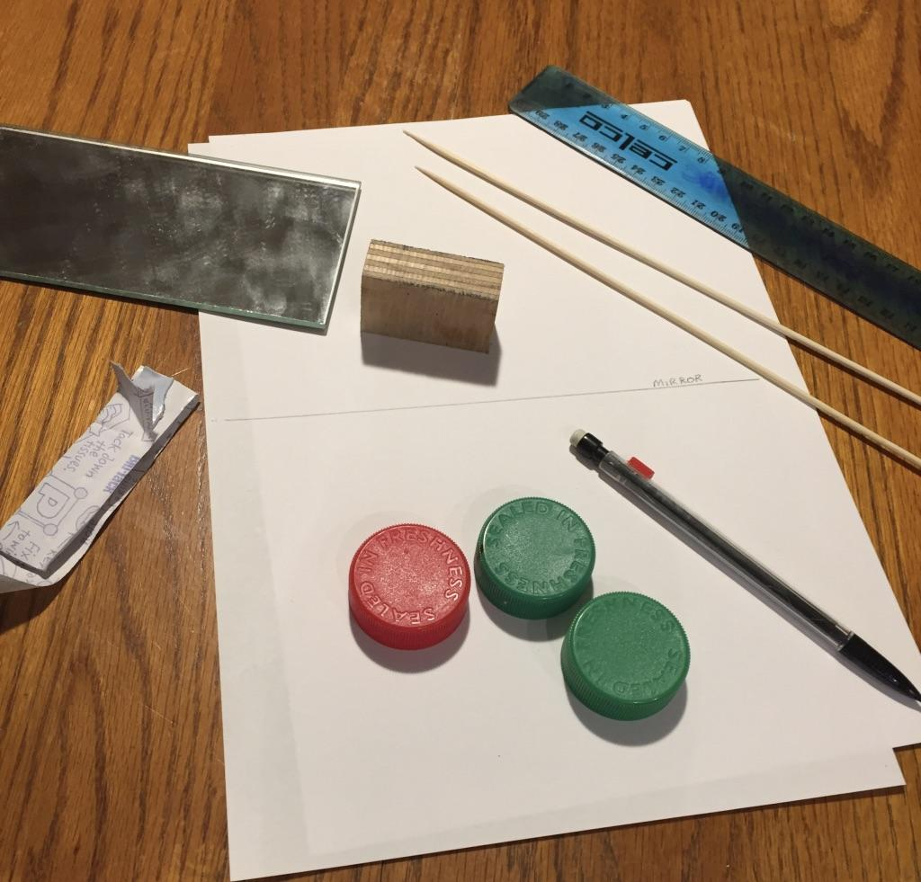
In this investigation, you will look at an object’s reflection in a small mirror and predict the location of the image in relation to the object.

What you need

- 2 x thin wooden or bamboo skewers
- Small rectangular mirror (8–15 cm wide and 5–10 cm tall)
- Small block shorter than the mirror to allow the mirror to stand up on its edge
- Milk bottle lids (or other small lids or similar objects)
- Blu-Tack (or similar), pencil, ruler, paper

Part 1

- Begin by using two small dots of Blu-Tack to hold the mirror in place. Draw a line across middle of the paper and label it ‘mirror’. | 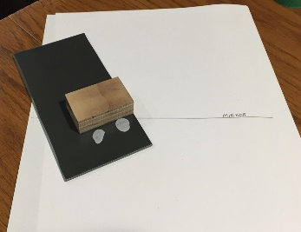
- Place the face of the mirror on this line. | 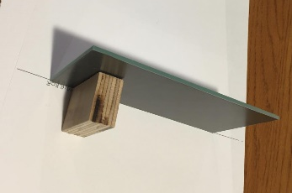
- You need a specific point on the milk bottle lid to observe, so make a mark on the lid and place it on the paper so that the mark is toward the mirror. | 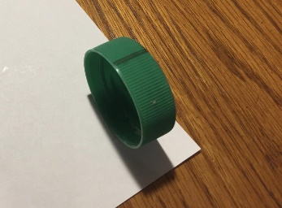
- Draw around the lid to mark its position. | 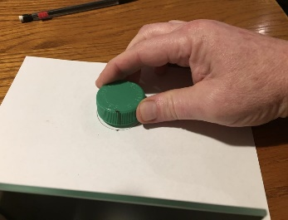
- Now place the mirror on the mirror line and the lid on its mark. Get your eye close to the table and place a skewer so that it points directly toward the mark. | 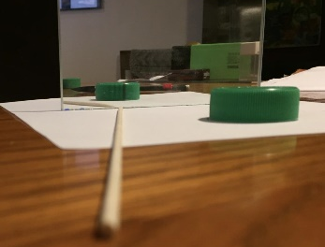
- Carefully mark the position of the skewer by making a mark at either end, making sure not to move the skewer. | 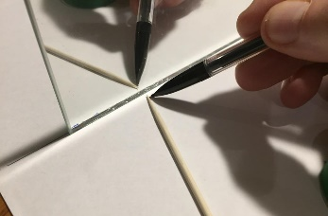
- Move your eye to the other side of the paper, line up the other skewer and mark its position. | 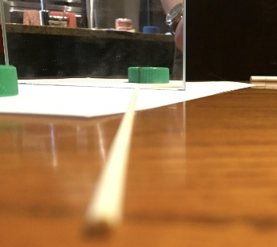
- You should now have marks that will allow you to draw the position of the skewers when they are removed. | 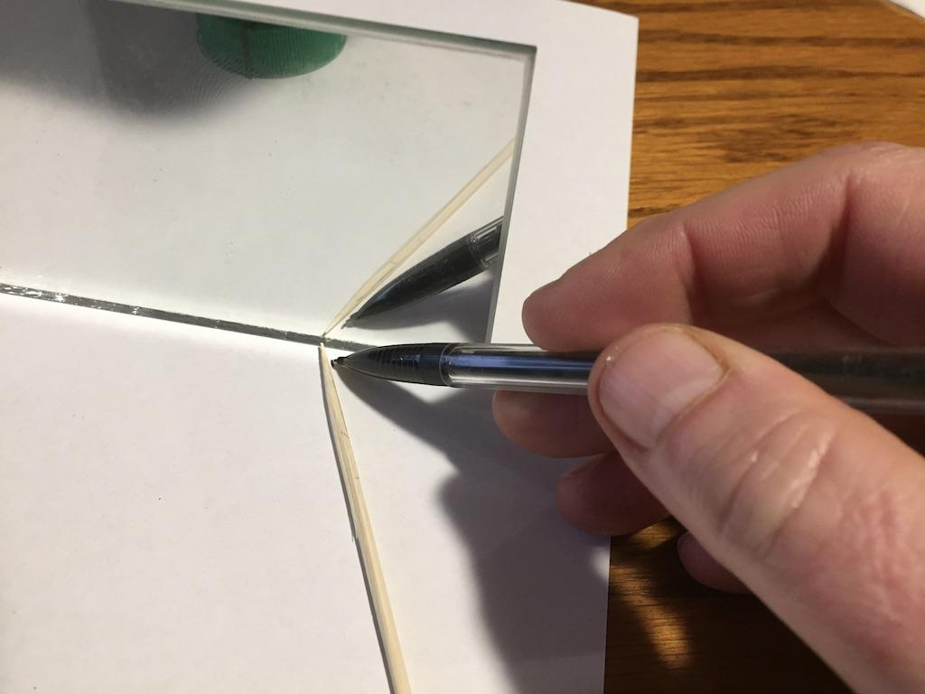
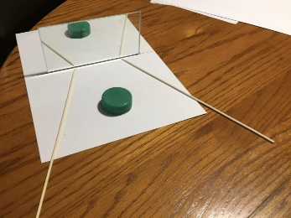  - Draw the lines where the skewers were on both sides. Also sketch the position of your eyes. | 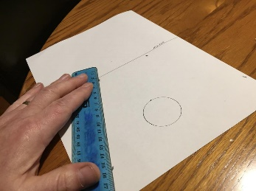
- Draw in the rays of light that came from the mark on the lid to the mirror. These begin at the mark and end on the surface of the mirror at the point where the lines from your eyes meet the mirror. | 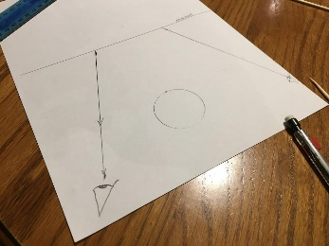
- Then draw arrows on the lines to indicate the direction of the light beginning at the mark on the lid, reflecting off of the mirror and going into your eye. | 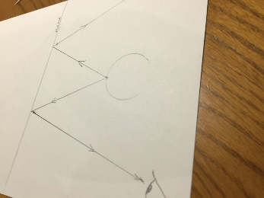

Part 2
- To see where the image is being formed, trace the rays back through the mirror to locate the position where the image appears to be. To do this, extend the lines coming from the mirror to your eye back through the mirror. By convention, this is done using dotted lines on the back side of the mirror. | 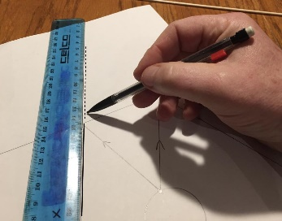
- The point where the two lines cross is the point where the image of the mark on the lid is formed. | 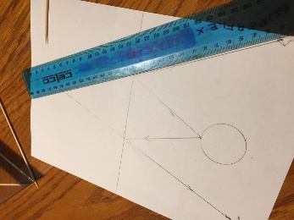
- Place the other lid on this mark and trace around it to mark its position. | 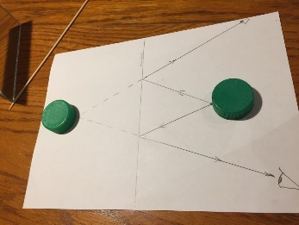

Part 3
- Check your work by placing the two lids on their positions and putting the mirror back into position on the line. The image of the lid seen in the mirror should correspond almost exactly to the real lid. | 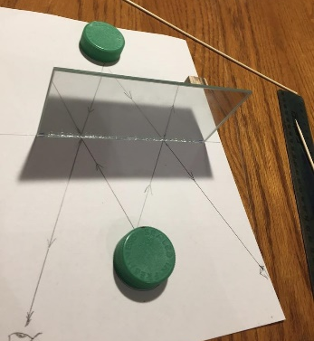
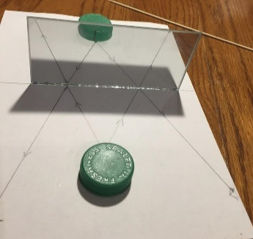
- You can see this by peeking around the edge of the mirror.
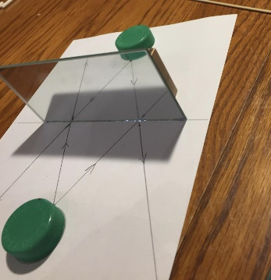

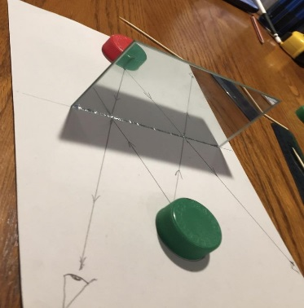  - You may want to substitute a different coloured lid, which produces some interesting effects.  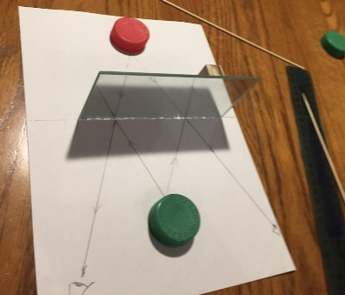 | 