**ACTIVITY: Looking at modern landfill systems**

**Activity idea**

In this activity, students use an interactive to explore modern landfill construction. The accompanying activities provide opportunities to deepen understanding regarding the history and science of landfills and how students can take action to reduce what goes into landfills.

By the end of this activity, students should be able to:

* label the components of a modern landfill system
* discuss how these engineering practices help to protect us and the environment
* consider how waste disposal practices have changed over time
* consider how to further manage and minimise personal waste footprints.

Background information for teachers

Teacher instructions

Student instructions

**Background information for teachers**

The way we have disposed of wastes in New Zealand has changed dramatically over the last few decades. We have moved from literal dumps and tips to complex landfill systems. The Ministry for the Environment notes that, in 1995, there were 327 landfill sites operating in New Zealand. By 2007, the number was down to 60. There are environmental benefits to closing older landfills with less-sophisticated engineering, but this can result in increased transfer and/or transport costs.

This activity is designed to encourage students to think about the science that underpins waste disposal and waste management. It offers four components:

* Engineering practices – how they have changed and how they protect the environment.
* A timeline of rubbish disposal – from middens to tips to landfills.
* Waste management in my local area – how wastes are collected, recycled and transported.
* Considerations about waste management and waste reduction – consider the benefits and drawbacks of modern landfill systems and what we can do to minimise wastes.

The student instructions are in Word – modify them to suit the needs of your programme and/or your students.

***Questions to deepen student thinking***

1. What do you know about waste disposal in times past?
2. Were the disposal methods efficient? What were the health or other consequences?
3. How has waste disposal thinking changed in the last century?
4. What evidence have councils or governments used to support the changes?
5. Why do you think that the number of consented landfills has reduced from over 300 in 1995 to 60 just 10 years later?
6. What do you know about the design features of modern landfills?
7. Why do you think that they are called landfill systems?
8. What labels may be missing from the Modern landfill system interactive? (See <http://www.mfe.govt.nz/sites/default/files/4139_landfill.pdf>, chapter 3, section 3.5, Landfill siting criteria, pages 28–32, for more information.)
9. What are the benefits and drawbacks to the landfill systems we use are using in New Zealand?
10. How do the waste management systems operate in our local environment? Where does recycling, green waste and household rubbish go?
11. What more can we do to minimise our wastes to minimise the ongoing financial and environmental impacts?

**Student instructions**

***Engineering practices***

Use the [Modern landfill system interactive](https://www.sciencelearn.org.nz/labelling_interactives/7-modern-landfill-system) to learn about the components of new landfills.

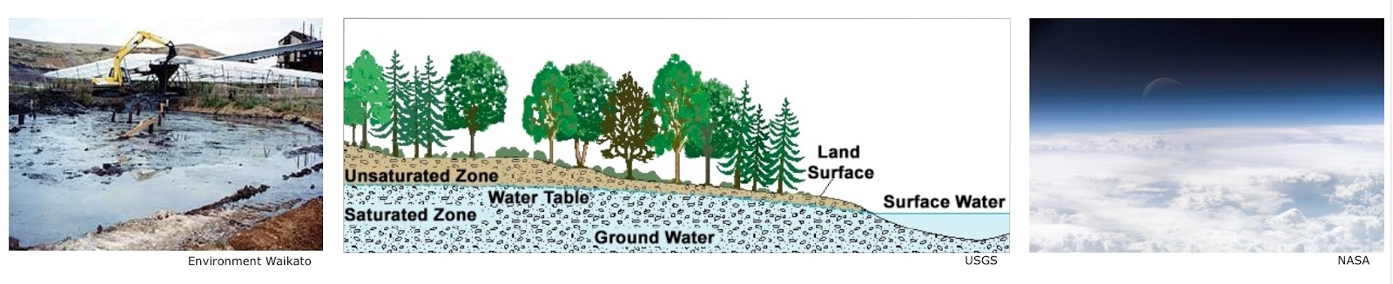

1. What components of the landfill are designed to protect the soil?

Explain how they work.

1. What parts of the landfill are designed to protect groundwater?

Explain how they work.

1. What parts of the landfill are designed to protect the atmosphere?

Explain how they work.

These resources provide additional information to help you answer the questions:

* [Soil contamination](https://www.sciencelearn.org.nz/resources/1545-soil-contamination) – article
* [Point source contamination](https://www.sciencelearn.org.nz/videos/518-point-source-contamination) – video
* [Anaerobic digestion](https://www.sciencelearn.org.nz/videos/887-anaerobic-digestion) (methane gas production from wastes) – article

These activities offer the opportunity to learn more about waste management and why landfill practices have changed:

* [Groundwater contamination](https://www.sciencelearn.org.nz/resources/1255-groundwater-contamination) – build an aquifer model to look at point source and non-point source pollution.
* [Site clean-up](https://www.sciencelearn.org.nz/resources/1559-site-clean-up) – use the web links provided to study the clean-up of sites contaminated by hazardous waste.
* [Water pollutants on trial](https://www.sciencelearn.org.nz/resources/1560-water-pollutants-on-trial) – research the effect of common pollutants on our waterways and hold a mock trial to determine the worst pollutant in the country.

***A timeline of rubbish disposal***

|  |  |  |
| --- | --- | --- |
| https://www.sciencelearn.org.nz/system/images/images/000/001/773/full/Excavation-of-a-midden20160826-15379-op0cjn.jpg?1522303447  NZ Historic Places Trust | https://www.sciencelearn.org.nz/system/images/images/000/001/769/full/Household-waste20160826-15827-1rsac7.jpg?1522303419  Waste MINZ | https://www.sciencelearn.org.nz/system/images/images/000/003/245/full/Recycling_ART_02_Flight_Plastic_recycling_technology_PlasticBales.jpg?1522314644  Flight Plastics |

Construct a short timeline of how we have disposed of our rubbish throughout Aotearoa/New Zealand history. Use the template below. Add a title, information, dates and arrows linking the information to the dates.

These resources provide useful information for the timeline.

* [Middens](https://www.sciencelearn.org.nz/resources/1460-middens) – article
* [Sewage, water and waste](https://teara.govt.nz/en/sewage-water-and-waste) – Te Ara articles and media
* [Flight Plastics recycling technology](https://www.sciencelearn.org.nz/resources/2517-flight-plastics-recycling-technology) – article
* [Biodegradability, compostability and bioplastics](https://www.sciencelearn.org.nz/resources/1473-biodegradability-compostability-and-bioplastics) – article

Information

Information

Information

Information

Information

Information

Information

Information

Title

|  |  |  |  |  |  |  |  |  |  |
| --- | --- | --- | --- | --- | --- | --- | --- | --- | --- |
| Dates |  |  |  |  |  |  |  |  |  |

**Waste management in my local area**

|  |  |  |
| --- | --- | --- |
| https://www.sciencelearn.org.nz/system/images/images/000/001/943/full/AST_PEO_PEO_01_MelanieJH_Melanie_radio.jpg?1522304723  Project Hotspot | https://www.sciencelearn.org.nz/system/images/images/000/001/790/full/Industrial-compost-facility20160826-15617-1gmyo3f.jpg?1522303559  S Williams, Wanaka Wastebusters | https://www.sciencelearn.org.nz/system/images/images/000/001/794/full/A-modern-landfill20160826-15208-p46dls.jpg?1522303584  123RF Ltd |

Research what happens to waste materials in your local region. Some key things to think about are:

* recycling services (including glass, plastic, metals, paper, whiteware, oil, paint)
* organic and green wastes
* waste collection
* refuse transfer station
* waste compaction
* transportation from transfer station to regional landfill
* liquid wastes
* manufacturing wastes
* hazardous wastes.

Write about or draw the steps your wastes take once you’ve placed them outside your house or school.

***Considerations about waste management and waste minimisation***

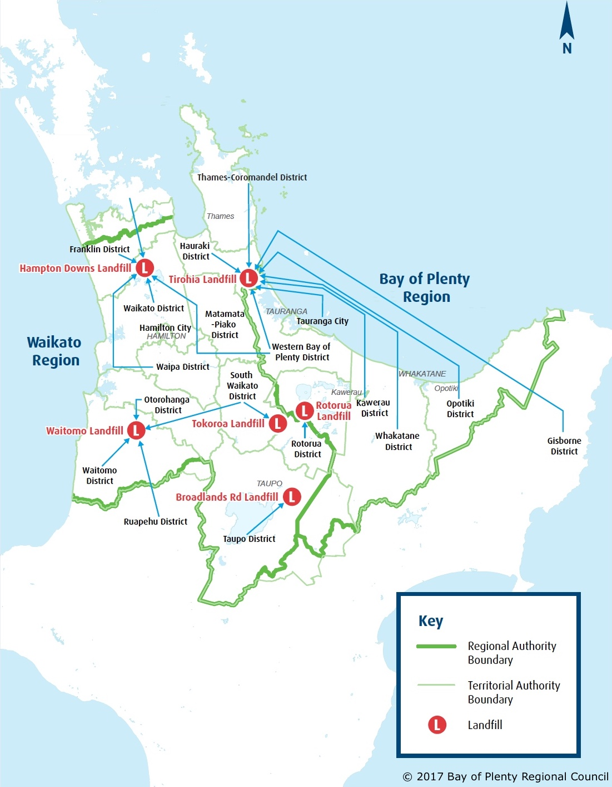

This map shows the location of some regional landfill systems.

Use the think/pair/share or a similar strategy to consider the following questions:

1. What surprises you about this image?
2. What are the benefits of having six landfill systems covering such a large area?
3. What are the drawbacks of having six landfill systems covering a large area?
4. With this image in mind, why is it important to minimise our wastes?
5. How do aspects of the refuse, reduce, reuse, recycle campaign work? Are some aspects more important than others?
6. What can we do to minimise wastes in our homes? At school?