ACTIVITY: Rock layers and relative dating

Activity idea

In this activity, students observe rock layers located near Whanganui, watch an animation about how they were formed and use relative dating to work out the order in which rocks were created. The activity offers literacy opportunities as well as practice using the science capability ‘Interpret representations’.

By the end of this activity, students should be able to:
- observe, discuss and compare rock layers in a photo and a diagram
- use reading skills to correctly label an interactive rock layer diagram
- use oral and written language skills to narrate a video animation about rock layer formations.

Background information for teachers
Teacher instructions
Student instructions

Background information for teachers

This activity explores the concept of relative dating – putting layers of rock in chronological order using a method called stratigraphy (layers of rock are called strata). Sedimentary rocks are normally laid down in order, one on top of another in a sequence with the oldest at the bottom and the youngest at the top. Most sedimentary rocks are laid down in flat, horizontal layers. These can later tilt and fold due to tectonic activity, and river cuttings can cause gaps among the layers. However, geologists use cues in the rocks to connect the strata.

The activity has four parts where students:
- use observation to discuss and compare a photo of rock layers with a diagram of rock layers
- watch an animation to find out how sedimentary rock layers near Whanganui were formed
- use reading and interpreting skills to complete a drag and drop relative rock layer labelling interactive
- use oral and/or written language to compose a narration of how the particular rock layers were formed the way they did.

The activity provides practice in using the science capability ‘Interpret representations’. Visit TKI for additional information about this capability.

Teacher instructions

Decide which of the four parts you want to do with your students. Each part can act as a stand-alone activity or can be done in a sequence of lessons. The student instructions are in Word so you can modify the document to suit student needs.

The activity works best if students are able to use the links to access the resource materials.

Follow up this activity with the interactive Relative rock layers.

Student instructions

Part 1
Look at the photo and the diagram of cliffs near Whanganui. Use them to help you answer the questions below. (Use the links if you want to see larger images on a screen.)

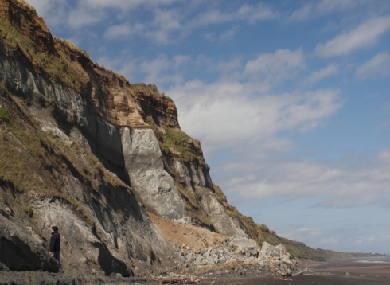

Sedimentary rocks, looking east towards Whanganui.

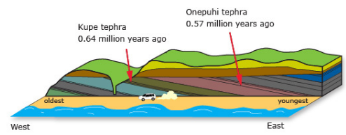

A diagram of the sedimentary rocks near Whanganui.

- Describe what you see in the photo and diagram.
- What does the photo show you?
- What does the diagram show you?
- What is the purpose for designing this type of diagram?
- Do you think that the diagram is an exact replica of the cliffs in the photo?
- What are some of the similarities or differences?
- Is there anything you would add to the diagram that might make it more useful?
- What statements can you make about the Whanganui cliffs based on the photo or diagram?
- How do you think the cliffs were formed?

Part 2

Watch the animated video Rocks and ice ages. It explains how the Whanganui cliffs were formed.

Look at this screenshot from the video. Use it to help you answer the questions that follow.

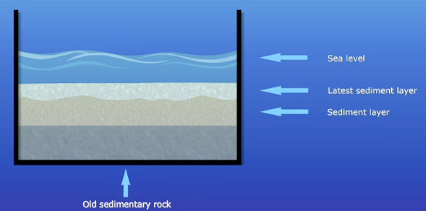

- What does this diagram show you?
- Are there any similarities or differences with the photo and diagram on the previous page?
- What is the purpose for designing this type of diagram?
- Is there anything you would add to the diagram that might make it more useful?

Part 3

Use the interactive Relative rock layers to work out and label the relative ages of some rock layers from youngest to oldest.

Read these articles to learn more about relative dating, New Zealand’s geological timescale and how scientists have been able to date the Whanganui rocks.

Part 4

Watch the animated video Formation of sedimentary rock layers.

It appears the animators forgot to add a voiceover. Write or record a voiceover for the video to explain how the individual layers are formed and what is happening to them.

These resources will give you some information and useful vocabulary:
- Relative dating
- Whanganui rocks and climate cycles
- Dating rocks near Whanganui

