ACTIVITY: Freshwater ecosystem

Activity idea

In this activity, students use resource materials to identify the features of a variety of freshwater species. By the end of this activity, students should be able to:
- use their observation skills to identify some New Zealand freshwater species
- use their literacy skills to identify key words and phrases about some New Zealand freshwater species
- create a basic food web.

Background information for teachers
Teacher instructions
Student instructions

Background information for teachers

New Zealand’s streams, lakes, rivers and wetlands support around 54 species of native fish including galaxiids, bullies, eels, lamprey, black flounder, torrentfish, smelt and mullet – and these are just the ones we know of that have been identified and classified! This ecosystem also provides a home for many other species, including ducks, insects and kōura.

Teacher instructions

- Provide students with a copy of the student instructions – which include the stream habitat image, freshwater species photo cards (cut into individual cards) and freshwater animals names and information table – as well as an A3 blank piece of paper.

Student instructions

- Look at the stream habitat image and discuss the places that animals could live – on the banks, on top of or under the water, under the rocks.

- Look at the animals on the photo cards. Discuss the animals’ names, physical features and any information you may have about them.

- Look at the freshwater animals names and information table. Discuss the information in the table.

- Use the stream habitat image to identify where each animal might live.

- Place the animals’ photo card in the appropriate locations of the habitat. Discuss why you think the animals might live there and how their life needs are met in this part of the habitat. You may need to place the photo cards outside the image and draw a line to where you think they might live.

- Refer to the freshwater animals names and information table to decide what animal eats what.

- Use the photo cards and the blank paper to create a food web. Draw arrows going from the animal being eaten to the animal that eats it, for example, insect → trout. This shows the flow of energy in the food web.

- Discuss what might happen if the food source disappeared, for example, very cold weather kills the insects or humans take all of the trout from the stream.

Stream habitat

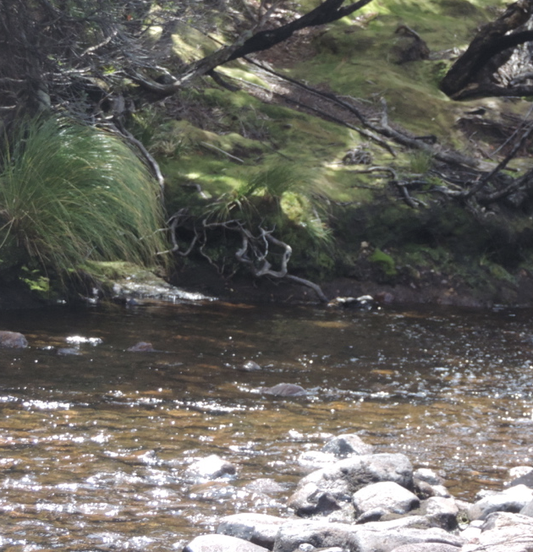

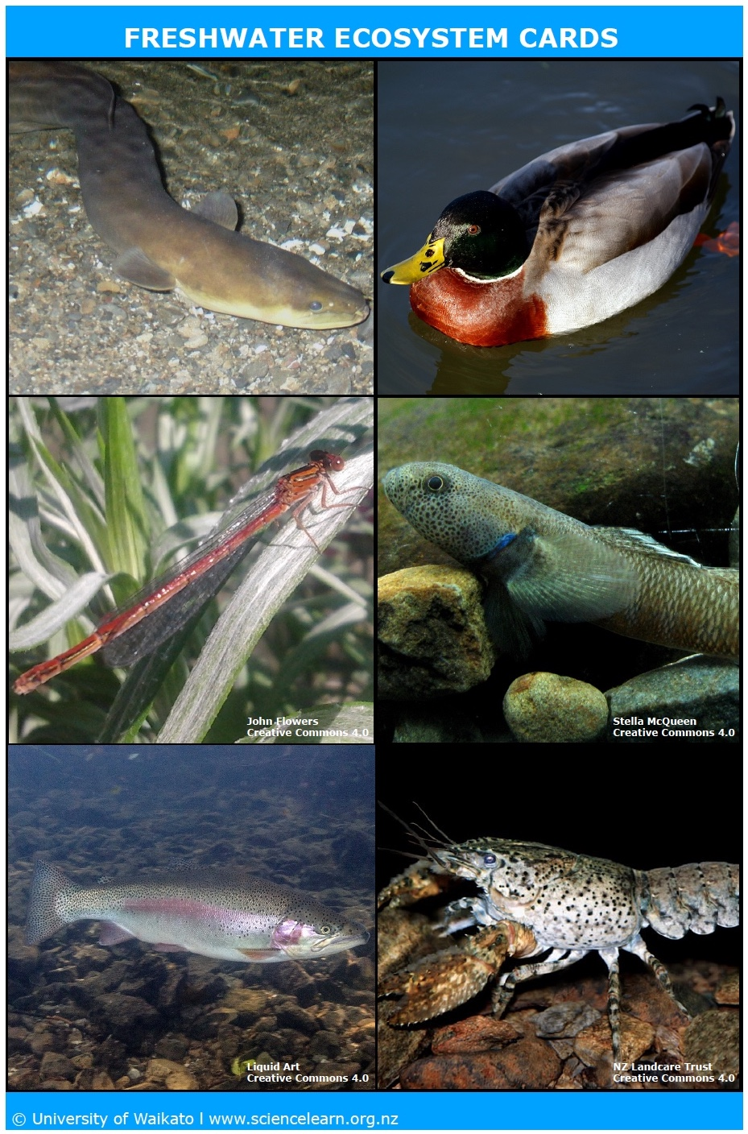
Freshwater animals names and information

Animal | Lives | Eats | Other things to know
Bully | Stream bed | Insects | Bullies get their name because they look like another fish called a bullhead. Bullies are colourful, and the names of different species reflect this. One is called the bluegill bully, and another is the redfin bully. This is an upland bully, which has orange stripes.
Duck | Top of water | Insects, bullies | The most common duck seen in New Zealand is the mallard. They come from the northern hemisphere originally. Learn about other New Zealand ducks at www.sciencelearn.org.nz/resources/2365-introducing-new-zealand-ducks.
Eel | Under the stream bank | Kōura, insects, bullies | Eels are predators (they eat everything else) and mostly come out at night. They can live for up to 80 years. Eels spend most of their lives in freshwater but travel into the Pacific Ocean (near Tonga) to lay their eggs. It takes 15 months for young eels to swim back to freshwater.
Trout | In the stream | Bullies, insects | Trout were introduced to New Zealand so that people could fish for them. Brown trout are common, but there are also rainbow trout in some places that are coloured just like their name says!
Kōura | Stream bed under rocks | Decaying plants and animals | Kōura are scavengers – they do an important job of cleaning up the ecosystem by eating plants and other animals after they die. Kōura are also an important indicator species because of this job. They can help tell scientists whether the stream is clean and healthy or in trouble.
Insect (invertebrate) | Everywhere | Each other, small algae | There are many different insects in New Zealand ecosystems. The one here is a damselfly. All of them are distant cousins of the kōura! Even though they are small, they are the most important part of the ecosystem. Why? Because they are eaten by everything else and they eat the smallest things in the ecosystem (called diatoms/algae). This means they are important for transferring energy to larger living things.

