ACTIVITY: What happens to our plastic bottles?

Activity idea

In this activity, students are introduced to the PET plastic recycling process. They track a plastic bottle as it is transformed from a waste product to a new food-grade package at the Flight Plastics plant.

By the end of this activity, students should be able to:
- use visual resources to gain information about the plastic recycling process
- discuss some of the steps involved in processing/recycling a PET plastic item
- place the steps in the order they are likely to happen
- consider how recycling fits into the use and reuse of plastics.

Background information for teachers
Teacher instructions
Student instructions

Background information for teachers
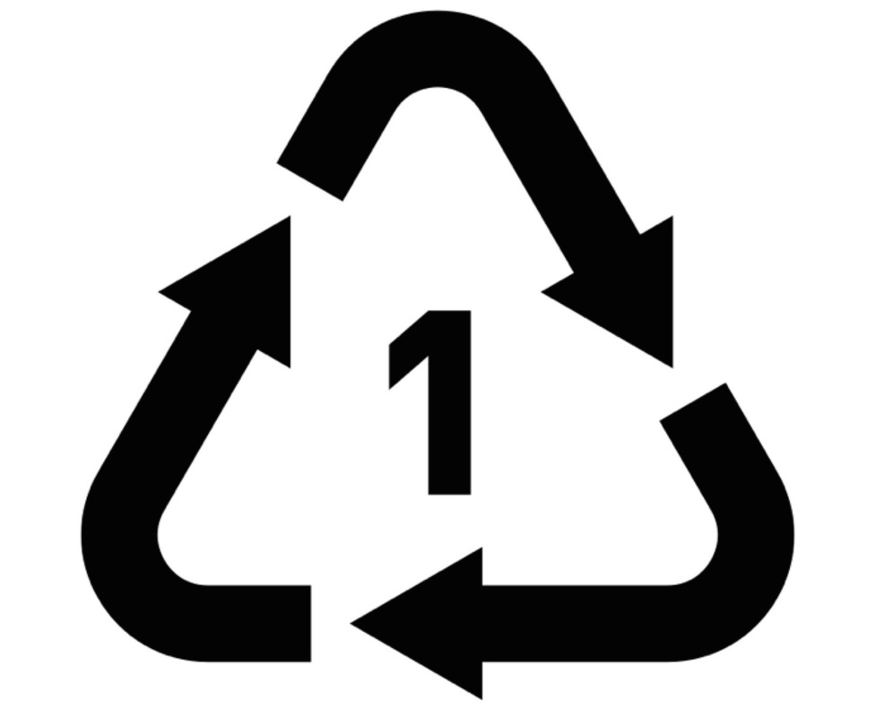
PET (or PETE) is a common type of plastic used for bottled drinks and food packaging. PET stands for polyethylene terephthalate and is a safe, non-toxic, strong, lightweight material that is 100% recyclable. It can be identified by the number 1 on the recycling stamp.

Until 2017, most of the plastics recycled in New Zealand have been shipped overseas for processing and reuse or they are dumped. The PET is processed into small flakes called RPET (recycled PET), and the flakes were shipped back to New Zealand for reuse. Flight Plastics opened the country’s first wash and recycling plant. The company turns some of the 20,000 tonnes of PET plastic New Zealanders discard each year into new food-grade packaging. Read the article Flight Plastics recycling technology for more detailed information.

Linking science with literacy

This activity uses books from the New Zealand Ready to Read series to introduce the topic of plastics and recycling – At the Beach (reading level: magenta) and What Does the Tide Bring In? (reading level: magenta).

What Does the Tide Bring In? is available as a big book, so it works well as an introductory activity for lower and middle primary classes. Most of the other suggested Ready to Read books are at the beginner level and may not be appropriate for older students. Substitute them with other readers or journals, if desired.

Students use their viewing skills to learn about the recycling process, with Flight Plastics’ animated video PET plastic recycling process.

A student handout accompanies this activity. It is a Word document and can be modified to suit student needs and abilities.

Follow-up activities

Follow up the activity with other Ready to Read books and a recycled craft activity – Make it! (reading level: magenta), Grandma’s Vase (reading level: red 1) and Don’t Throw That Out (reading level: yellow).

Students may also enjoy playing the Plastic – reuse, recycle or rubbish game.

Teacher instructions

- Read At the Beach and discuss/record what each person finds.

- Read What Does the Tide Bring In? Discuss the question on the book’s last page: What else does the tide bring in?

- Encourage students to draw parallels between the stories and elicit the types of things students find when they are at the beach.

- Show students the image of a discarded plastic bottle. Discuss how/why plastic bottles end up at beaches and waterways and what we can do to avoid bottles becoming pollutants.

- Discuss what the students know about plastic recycling to establish prior knowledge.

- Watch the video PET plastic recycling process.

- Watch it a second time, with pauses to discuss each step.

- Play the video a third time but scroll down so that students can see the written transcript. Students can read along while the video plays. If you have an IWB, highlight key vocabulary.

- Use different pages of the student instructions to order or retell the steps in the recycling process. They can be used in a variety of ways:
- Cut up the picture cards (first page) and glue them in the correct order on a larger sheet of paper. Use numbers or arrows to show the steps as bottles are collected and recycled into new items.
- Match the picture cards with the associated sentence cards (second page). Glue the cards in the correct order onto a larger sheet of paper.
- Laminate a set of picture and sentence cards for use as a memory game or for assessment purposes.
- If students choose to write about the steps (third page), consider using the video transcript as a word bank.
- Using the picture cards as visuals, write a narration/voiceover for a student video, similar to the PET plastic recycling process video. (Use the video to promote recycling or for assessment purposes.)

- Discuss how recycling fits into the other Rs: refuse, reduce, reuse and rubbish. Use PET products like Barry the water bottle and other single-use packaging to aid the discussion.

- Follow up the discussion by reading the books Make it!, Grandma’s Vase and Don’t Throw That Out. Students can make craft items using recyclable materials.

- Plastic – reuse, recycle or rubbish game is an active game that gets students thinking about how they use and reuse recyclable materials.

Student instructions

What happens to the plastic bottles?

What happens to the plastic bottles?

The plastic bottles are washed. | A truck picks up the recycling.
The plastic bottles go in the recycling bin. | Flight Plastics makes a new package.
The bottles go to Flight Plastics for recycling. | Fruit goes into the new package.
People buy and drink bottles of water. | The plastic is cut into small RPET flakes.

What happens to the plastic bottles?

Write or draw your answers in the boxes.

This happens before PET plastic bottles and packaging arrive at Flight Plastics for recycling.

This happens at the Flight Plastics factory.

This happens after the PET packaging leaves the Flight Plastics factory.

