ACTIVITY: Rearing moths to observe life cycles

Activity idea

In this activity, students rear moths to observe the life cycle process and compare it to other life cycles they have observed.

By the end of this activity, students should be able to:
- name the four stages of the Lepidoptera life cycle
- discuss why it’s more common to find Indian meal moths in summer seasons rather than colder seasons
- compare the moth life cycle with other Lepidoptera life cycles.

Background information for teachers
Equipment required
Student instructions
Extension ideas/prompting questions for teachers

Background information for teachers

Lepidoptera (butterflies and moths) follow the same life cycle stages – egg, larva, pupa and adult – but aspects differ from species to species. By rearing moths, students can observe the moth life cycle process and compare it to other life cycles they may have observed.

This activity uses either the common Indian meal moth or the greater wax moth. Both moth species are introduced rather than native.

Indian meal moth life cycle

The Indian meal moth (Plodia interpunctella) is also known as the pantry moth. It gets its common name from its larval food source - foods made from meals like flour or other cereals that are usually stored in the pantry.

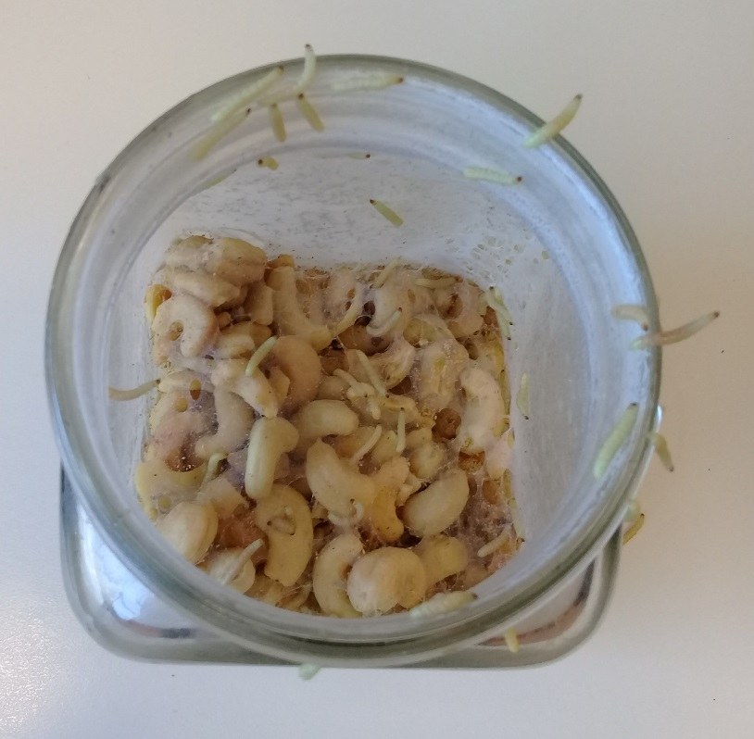
Like most insects, the meal moth life cycle is temperature dependent. Warm conditions hasten the time it takes to grow from egg to adult. The female moth lays up to 400 eggs on or close to a food source. The eggs hatch in 2–4 days and the larval stage lasts 2–41 weeks. The larvae burrow into foodstuffs through soft plastic packaging or cardboard. They spin webs as they grow and leave behind silk threads and droppings (frass). Fully grown larvae are about 1 cm in length. Larvae are capable of travelling a reasonable distance from their food source before pupating – one of the reasons why pantry moth infestations are difficult to eradicate. Larvae spin silken cocoons and emerge as adults 2–3 weeks later. Adult moths do not feed. They live for 1–2 weeks with the sole purpose of reproducing.

Greater wax moth life cycle

For beekeepers, the wax moth (Galleria mellonella) is a pest. Its larvae burrow into bee combs, leaving silk tunnels. Bee pupae can get trapped in the silk and die. Pet owners, on the other hand, purchase wax moth larvae as a food source for birds and reptiles. The wax moth life cycle shares many things in common with the meal moth. The life cycle is also temperature dependent, and adult moths do not feed. Female wax moths lay up to 600 eggs, which hatch within 5–8 days. They spend 6–7 weeks as larvae, growing to around 2 cm in length. They also spin cocoons and emerge as adults within 2–7 weeks. Adult moths die within 1–2 weeks.
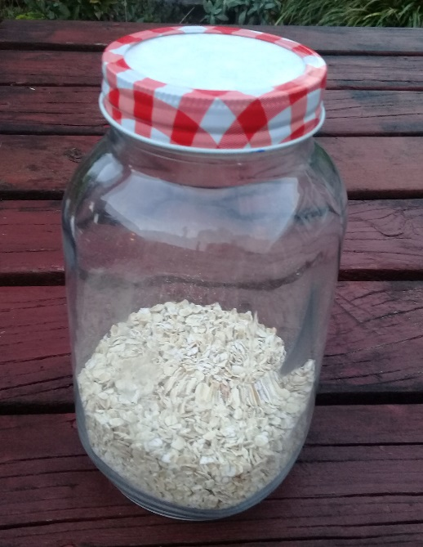
Equipment required

- Large preserving jar with a ringed lid
- Filter paper (coffee filter) or nylon stocking
- Egg carton
- Newspaper
- Waxed paper
- Oatmeal
- Wholemeal flour
- Honey
- Brewer’s yeast (optional)
- Wheat germ (optional)
- Kitchen sieve

Student instructions

To rear Indian meal moths

- Make the rearing container out of a large preserving jar. Clean and dry the jar. Cut a circle of filter paper or nylon stocking to cover the jar mouth. When it is time to seal the jar, using the filter paper and ring allows the air to move freely but keeps the insects in the jar.

- Make the bedding and feeding substrate. The simplest substrate is one cup of wholemeal flour. An alternative substrate is one cup of oatmeal with a pinch of brewer’s yeast and a pinch of wheat germ. Either substrate will work – choose from the materials on hand.

- Pour the mixture into the jar. Add a couple of segments torn from the egg carton.

- Source the meal moth eggs or larvae by checking stored, loosely bagged pantry items like oats, flour, rice or dog food. Their presence is often indicated by silk webs either inside the food stuff or on the packaging. Moth eggs are whitish-grey in colour but are very small - use a kitchen sieve to separate the eggs from foods like oats or rice. Larvae are bigger, so they are easier to locate in food products. Sometimes the larvae can even be found crawling along the shelf.

- Collect any eggs or larvae you find and place them in the jar.

- Make a cylinder of newspaper to wrap around the jar, darkening the habitat.

- Place the rearing jar in a warm place. Check it regularly to observe what is living/happening in the jar. Replace the bedding substrate occasionally.

- Check the egg carton for cocoons. If desired, move the pupae to a new rearing jar.

- If/when adults hatch, consider whether you will keep them to continue breeding/rearing moths or whether you will let them go.

To rear greater wax moths

- Make the rearing container as described above.

- Make the bedding and feeding substrate. Mix one cup of oatmeal with 2 tablespoons of honey. Spread the mixture on a plate and let it dry. When it is dry enough to crumble, add it to the jar along with a couple of segments torn from the egg carton.

- Visit a pet shop to purchase the wax moth larvae. A small container costs about $20.00

- Add the larvae and the commercial substrate to the rearing jar.

- Make a cylinder of newspaper to wrap around the jar, darkening the habitat.

- Place the rearing jar in a warm place. Check it regularly to observe what is living/happening in the jar. Replace the bedding substrate occasionally.

- Check the egg carton for cocoons. If desired, move the pupae to a new rearing jar.

- If/when adults hatch, consider whether you will keep them to continue breeding/rearing moths or whether you will let them go. If you choose to continue breeding, create an egg-laying nook by placing small pieces of concertinaed waxed paper in the rearing jar.

Extension ideas/prompting questions for teachers

- Why do you think there is such variation in the time it may take for a moth to complete its life cycle?
- Why are the jars kept in dark, warm places?
- Raise moths and butterflies at the same time to compare the many similarities and differences between them. The Hub has a white butterfly life cycle activity, complete with images and hints and the monarch butterfly life cycle interactive.

