ACTIVITY: Mixing and matching ducks

Activity idea

In this activity, students will use resource materials to identify the features of a variety of New Zealand duck species. This is one of a set of three activities that help students identify different duck species and is designed to be adapted to meet student requirements, age, level and ability. The other activities are Which duck is which? and Duck dominoes.

By the end of this activity, students should be able to:
- identify similarities and differences between some New Zealand duck species
- distinguish between native ducks and common introduced species
- use information cards to elicit specific information.

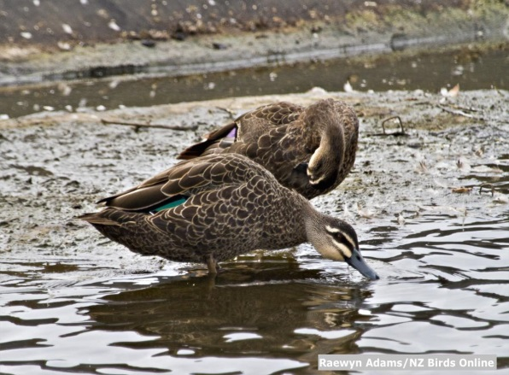
Background information for teachers
Equipment required
Student instructions

Background information for teachers

New Zealand is home to a wide variety of water birds, including many species of ducks. Most of these are native, many endemic, while others have naturalised here or have been introduced.

Different native duck species have become adapted to particular habitats in New Zealand and have co-existed by taking advantage of different ecological niches.

In order to engage students in conservation ideas, it is important that they know what organisms are involved and build an understanding of their features and needs.

Many people mistake ducks of different species. For example, the grey duck/pārera is often mistaken for the mallard, and although it is endangered, it remains on the game bird list due to people being unable to distinguish between the two species.

Building an understanding that all ducks are not the same can lead to discussions about classification, whakapapa, relationships, ecosystems, ecological niche, habitats and adaptations, endemic versus native etc.

This is primarily a literacy activity, asking students to sort and match keywords and phrases to identify the characteristics of different New Zealand ducks. Students will probably need to use the Duck information cards or complete (uncut) versions of the “Mix and match cards’ as resource materials for checking their facts.

You may have to clarify the difference between the terms endemic, native, naturalised and introduced with your students:
- Endemic – a species that is native to only one location. For example, species endemic to New Zealand naturally occur only in New Zealand but may have been introduced elsewhere in the world.
- Native – a species that lives naturally in a country as opposed to species that have been introduced by the activity of humans. Species can be a native of more than one country, for example, mānuka is native to both New Zealand and Australia.
- Naturalised – a species that has established a population naturally in a country other than where it originated. These organisms, once established, are considered native.
- Introduced – an animal or plant that has been transferred by humans, either on purpose or by accident, to somewhere it doesn’t live naturally.

Using the activity with your students

Prepare the cards for mix and match in sets in advance. Colour coding the sets won’t work as this will make the facts too easy to sort. They need to be cut up individually, and laminating them will make them more durable.

With younger students, sorting two sets of cards will be enough – possibly comparing an introduced duck such as the mallard with a native duck such as the blue duck.

The cards can be used in a variety of ways:
- You may use a different selection of sets of cards, depending on the context.
- The pictures themselves can be used to check students’ ability to identify different species from a visual identification or to classify ducks according to their characteristics.

Equipment required

- Cut up and shuffled Duck fact cards – one set per pair
- Complete (uncut) Duck fact cards or Duck information cards – one set per pair

Student instructions

- As a pair, sort the cards you are given to match the facts, names and picture of each different duck.

- Use the Duck fact cards or Duck information cards as reference material if you need to check which facts belong to each duck.
- What did you learn by doing this activity?
- What skills did you have to use?

