ACTIVITY: How does PCR work?

Activity idea

In this activity, students are asked to view a video and conduct their own research in order to develop an understanding of the polymerase chain reaction (PCR) process.

By the end of this activity, students should be able to:
- describe the steps involved in the PCR process
- explain the purpose of the PCR process.

Introduction/background notes
What you need
What to do
Group handout: PCR process
Student handout: PCR process

Introduction/background

PCR is shorthand for a simple but very useful procedure in molecular biology called the polymerase chain reaction. This activity will provide senior biology students with an opportunity to develop a basic understanding of the process, which in turn will provide them with a more in depth understanding for research into genetic technologies.

You may approach this activity using a range of different resources. However, the task is written for your students to view a short video, read some written material and record the information on the diagram provided. The video PCR – the polymerase chain reaction explained can be used to check the students understanding at the completion of the activity.

What you need

- Access to the video animation PCR – the polymerase chain reaction (no voice over)
- Access to the videos PCR: A scientist explains and PCR – the polymerase chain reaction explained, the article What is PCR? and the interactive What is PCR used for?
- A3 copies of group handout PCR process
- A4 copies of student handout PCR process

What to do

- As a class, watch the animation PCR – the polymerase chain reaction (no voice over)

- Give students 1 minute to think to themselves about what they saw.

- Students can then turn to their neighbour and, in pairs, discuss what they saw, recording on a sheet of paper any keywords and ideas they may have that they believe may be relevant to the PCR process (1–2 minutes).

- Each pair can then turn to another pair and, using an A3 copy of the group handout PCR process, jot down what they think was happening at each step (5–10 minutes).

- Ask for feedback from the class, eliciting discussion, prior knowledge and any questions. (This will obviously depend upon how much prior teaching and learning has occurred.)

- Show the video PCR: A scientist explains and give students another 2–3 minutes to add details onto their group handout.

- Again discuss as a class, rerunning the videos if necessary.

- Ask students to read the article What is PCR? and the interactive What is PCR used for? or conduct their own research.

- As a class, build a set of keywords that are used to describe the PCR process.

- Ask students to complete student handout PCR process to record their answers to the processing questions.

- Watch the video PCR – the polymerase chain reaction explained to check your student's understanding.

Group handout: PCR process
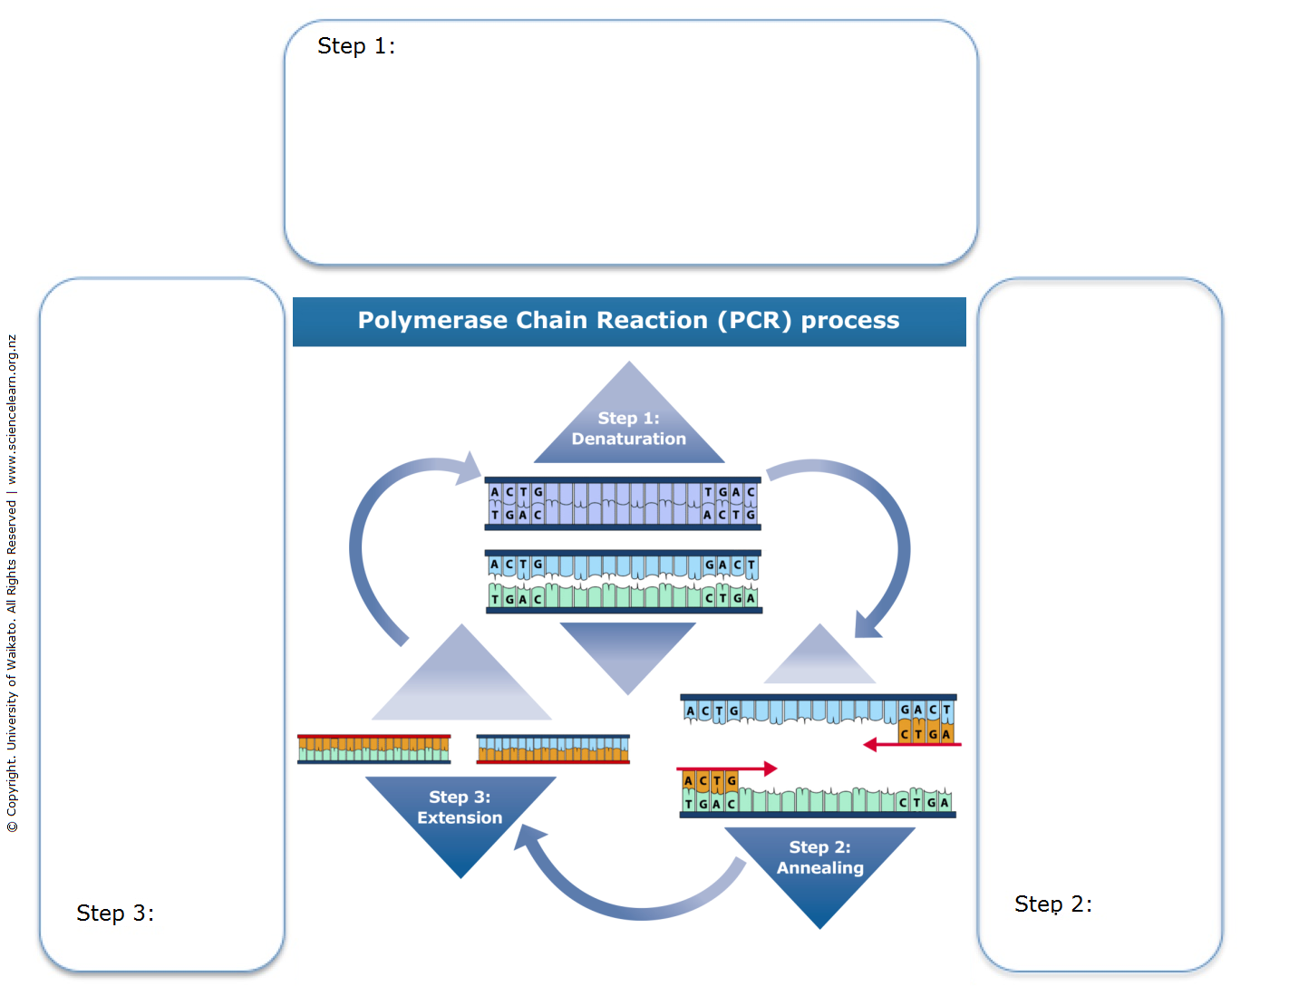
Student handout: PCR process

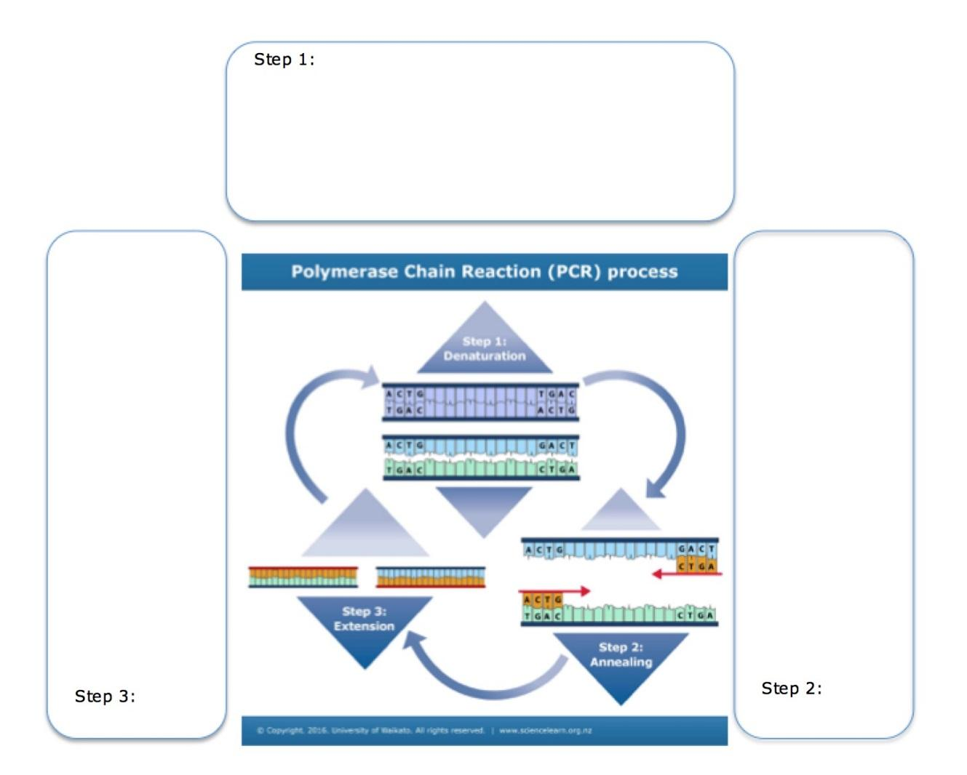

- In your own words, explain what happens at each of the 3 steps in the PCR process.

- What is the purpose of PCR?

- What is the purpose of each of the different ingredients in the DNA mixture that goes into the thermocycler?

- Give an example of a technology that uses PCR and why it is needed for that purpose.

