Noisy round robin

Main idea: This classroom management tool is useful for generating a great number of ideas using small groups.

Divide the class into small groups (3–5). Depending on the number of groups, have large sheets of paper, each with a different group that may be affected (harmed or benefited) by the issue in question.

For example, concerning the issue ‘Should chemical fire retardants be added to furniture?’, groups that might be affected by making the choice to have/not have chemical fire retardant furniture could include:
- me
- my family and others
- the scientists involved
- children
- furniture factory and store owners
- workers at the factory where chemical retardants are made
- the environment (think about the production of retardants)
- firefighters
- homes and buildings in the event of a fire.

The groups are spread out around the room, each with a different piece of paper.

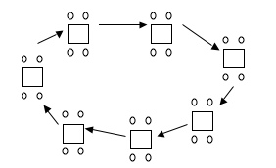

The teacher uses an appropriate word for the topic, in this example, ‘Fire’, that signals the students to move to the next piece of paper and write. The students have 2–3 minutes to think of an idea or two (through discussion – hence ‘noisy’ round robin). A writer for the group records the idea(s) on the sheet.

When the teacher calls ‘fire’ or a word associated with the issue again, the groups move to the next piece of paper (i.e., the paper stays at each station). The students are timed again and required to generate and write down their ideas. Because ideas cannot be repeated, students cannot write what is already there.

The students move on the teacher’s instructions around all the papers. The groups may then come together as a class to share and discuss their ideas.

Value could be added by each group taking their final sheet of paper and placing the consequences in order of most important to least important. The teacher can record the top 2–4 of each group’s list on the whiteboard for all to see and consider.

A report could be made as a written document, a poster, an advertisement etc.

