ACTIVITY: Making and using a quadrat

Activity idea

In this activity, students construct and use a 1 m² quadrat.

By the end of this activity, students should be able to:
- construct a 1 m² quadrat
- use the quadrat to monitor or observe species within a particular habitat
- discuss why it is important to use a field guide to identify the species present
- discuss why it is important to use standardised methods like quadrats when collecting data to be compared over time and place.

Background information for teachers
Equipment required
Setting up a quadrat
Student instructions
Extension ideas/prompting questions for teachers

Background information for teachers

Quadrats are used for sampling purposes. They are squares of a set size placed in a particular habitat such as a rocky shore or forest floor. Plant and animal species within the quadrat are identified and their numbers recorded. Photos of individual quadrats, along with the species information, often form baseline monitoring data or are used to measure changes in species and habitats over time.

This activity uses a 1 m² quadrat, but quadrats can be other sizes depending on the location or the species being sampled. Quadrats can be used alongside other methods of monitoring such as a transect line as in the Toheroa Abundance Project.

It is important to think about how data may be processed back in the classroom prior to the data-gathering activity – this may inform what information you direct your students to gather or observe and record. It can also inform where they gather their data, such as distance from the water’s edge.

Representation and reliability
Quadrats should be randomly placed to obtain a representative sample of a larger area. Using several quadrats from an area helps with reliability. Sometimes an unusual species exists in one quadrat but not others, so using multiple quadrats reduces the effect of uncommon species representation. The larger the sample size – the more quadrats that are observed – the more robust the data will be. Using standardised methods like quadrats means that collected data can be compared over time and place.

Correct species identification is crucial to any monitoring project. Use field guides or apps like Flora Finder to help with names. If you find a species you cannot identify, try uploading a photo to Nature Watch NZ. The website has a community of people willing to help.

New Zealand websites for quadrat data entry
This is a generic activity that explains how to set up a quadrat for monitoring or observation purposes. There are New Zealand websites that provide specific monitoring instructions, data collection sheets, field guides and data entry capabilities:
- Marine Metre Squared (Mm2) website has resources for conducting rocky shore and sandy and muddy shore monitoring.
- FORMAK website has resources for forest monitoring.
- Department of Conservation has resources for monitoring species and habitats in terrestrial, freshwater and marine environments.

Equipment required

- Brightly coloured string/wool (bright colours make it less likely to lose the string at field sites), 1 metre rulers or anything that can form a 1 metre straight line
- Identification guides suitable for the monitoring location
- Ruler
- Data sheets for recording information (your own or from Mm2 or FORMAK)
- Camera
- GPS app (optional)
- Ice cream container lids (optional)
- Internet access to upload data, if desired

Setting up a quadrat

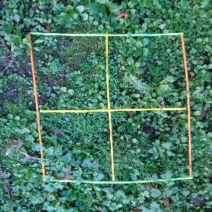
- Choose the location and the type of monitoring you wish to do. Consider any safety concerns associated with monitoring the site – especially when working within marine habitats.

- Make a 1 m² quadrat by measuring 4 m of string. Cut the string. Tie knots at 1 m intervals. The knots and string ends form the quadrat corners. Alternatively, use any objects that can form four straight 1 m sides. (This can be done prior to the EOTC).

- Place the quadrat(s) randomly in the area you wish to monitor.

- You can also mark out smaller sections to form four quarters within the 1 m² – this can make it easier to carry out a count in groups.

- Take a photo of the quadrat.

Student instructions

- On your data collection sheet, record observations about where the quadrat is located, any significant features (such as slope of the land, waterways, large rocks or trees), substrate and/or other location information (such as distance from water’s edge, distance from walkway or sand dunes).

- Use a GPS app or visual marker to record the quadrat location. Monitoring websites may ask for GPS references. If you intend to monitor the site again at a later date, this information will come in handy.

- Beginning in one corner of the quadrat, count and record the plants and animals you can see. Sometimes, you might need to gently lift an object, such as a rock, to see if an animal is underneath. Be sure to return the object to its original place.

- Record the information on the data collection sheet.

- If you find a species that you cannot identify, write a description of it and/or photograph it. Place a ruler next to the species to show its size.

- Return all living creatures to the place you found them.

- Complete as many other quadrats as possible.

Extension ideas/prompting questions for teachers
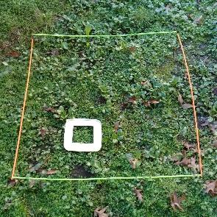
- Some record sheets ask for a percentage cover. The Mm2 site suggests using an ice cream container lid with a 10 cm² hole cut in the centre. This frame forms 1% of a square metre. If, for example, a patch of seaweed takes up 5 of the 10 cm squares, this is 5% coverage of the metre-squared quadrat.

- Data processing can involve averaging species numbers, comparing the abundance of different species, graphing numbers against the distance from a particular feature (such as the tide line, stream or walkway) or supporting students to make inferences about the location of quadrats, habitats and the species found.

- Use the GPS location and an identical monitoring protocol to conduct annual quadrat monitoring to view the impacts of local restoration projects.

- Simplify quadrats for on-the-spot observations. The students pictured below used cabbage tree leaves to mark a quadrat for observation. The quadrat helped them focus on a particular area to count the number of different species present. They moved the leaves vertically as they observed how the vegetation changed along a limestone rock face.

