ACTIVITY: Temperature, salinity and water density

Activity idea

In this activity, students investigate the impact of temperature and salinity on water density.

By the end of this activity, students should be able to:
- describe how temperature affects water density
- describe how salinity affects water density
- offer simple explanations of how climate change may impact the oceans’ chemical and physical properties.

Background information for teachers
Equipment required
Teacher instructions
Extension ideas/prompting questions for teachers

Background information for teachers

This activity explores the impact of temperature and salinity on water density.

Cold water is denser than warm water, so it tends to sink. This is because water expands when it warms up – heat energy makes its molecules move around more and take up more space. When water cools, it contracts, becomes denser and sinks.

Seawater is denser than freshwater. This is because seawater has additional chemicals like sodium chloride (NaCl – salt) dissolved in it. Salinity, temperature and depth all affect the density of seawater, as explained in the articles Ocean salinity and Ocean density.

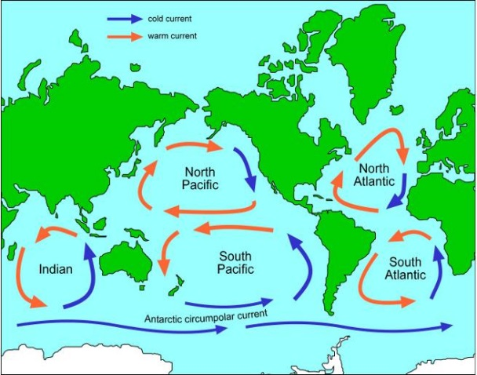
The ocean has a complex circulation system called the Global Ocean Conveyor. It moves water, heat, salt and nutrients around the world. Surface currents in the top 400 m are driven mainly by wind. Deeper currents are driven by changes in water density. Both types of currents work with the atmosphere to help shape the Earth’s climate. This process is explained in the article Ocean motion.

Melting land ice and increased rainfall – as consequences of climate change – have the potential to disrupt the oceans’ chemical and physical properties, which will impact this complex circulation system. Learn more in the article Climate change, melting ice and sea level rise.

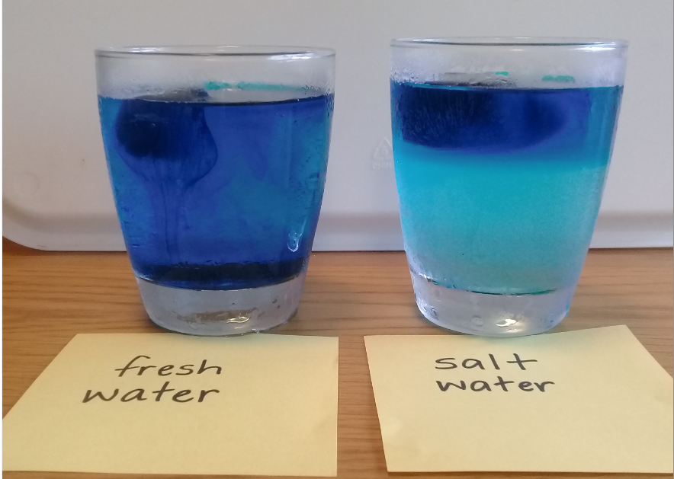
Equipment required

- 2 glasses – one labelled freshwater and the other saltwater
- 2 large ice cubes, made with fresh (tap) water and a few drops of food colouring
- Fresh (tap) water at room temperature
- Salt water at room temperature (approximately 7 teaspoons of salt added to 1 l of tap water)
- Camera or other recording device

Teacher instructions

- Label one glass freshwater and the other saltwater, and add equal amounts of water to the appropriate glasses.

- Place an ice cube in each glass.

- Observe, photograph and discuss what is happening in each glass at regular intervals.

Extension ideas/prompting questions for teachers

- As we set up the activity, what parts are set up the same?
The glasses, ice cubes and the amount and temperature of the water.

- What part of the activity set-up is different?
One glass has freshwater, the other has saltwater.

- Why do you think we have changed this one thing (a variable)?
To demonstrate the impact of temperature and salinity on water density.

- We are using the equipment to model the impacts of temperature and salinity on water density. What do the different parts of the model represent?
The glasses – a body of water. The ice – glacier, iceberg or other source of freshwater. Tap water – freshwater body/lake. Saltwater – seawater body/ocean.

- What do you think will happen in each model?
Answers will vary.

- Were the predictions correct?
Answers will vary.

- What differences did you observe in each glass?
Freshwater model: as the ice melted, the cold water sank to the bottom of the glass.
Saltwater model: as the ice melted, the freshwater floated on top of the saltwater.

- Why did the cold water sink to the bottom of the freshwater glass?
Cold water is denser than warm water.

- How could you tell the cold water was sinking?
Darker currents of coloured water moved down through the water.

- Why did the freshwater float on top of the saltwater although the freshwater was colder?
Freshwater is less dense than saltwater.

- What difference does freshwater make to the chemistry of the oceans?
It dilutes the seawater, making it less dense.

- What difference may this make to the Global Ocean Conveyor?
Dense water sinking below less dense water drives the Global Ocean Conveyor. The flow of warm freshwater onto the ocean surface warms the oceans, melts sea ice and disrupts the sinking of the cold, salty water. This may slow and/or alter the Global Ocean Conveyor.

- Why is climate change a factor in these changes?
Warmer temperatures lead to melting land ice and changes in rainfall, which add freshwater to the oceans. Sea ice reflects heat back into the atmosphere. Melting sea ice allows the darker ocean water to absorb the heat, warming the seawater. These changes in temperature and salinity affect density.

