ACTIVITY: Making an anemometer

Activity idea

In this activity, students will construct a simple anemometer.

By the end of this activity, students should be able to:
- build a simple anemometer
- collect data using their anemometer
- interpret and make meaning of their data
- discuss the reliability of their data.

Background information for teachers
Equipment required
Student instructions
Student extension ideas/prompting questions for teachers

Background information for teachers

English astronomer John Robinson invented the anemometer in 1846. Anemometers measure wind speed and have become one of the essential tools for weather forecasting.

‘Anemos’ is the Greek word for wind. Wind is the movement of air and will make the cups of the anemometer spin around. The speed of the spin depends upon the strength of the wind. Wind speed can be measured in knots, kilometres or metres per second or on the Beaufort wind scale.

The activity Making a weather vane and compass shows how to make a simple compass that will support this activity by letting students know which direction the wind is coming from.

This activity is part of a set of five activities supporting students to collect and interpret data about their world. Although each of these activities may be used within a variety of topics, they were designed to tie together under the topic of weather. The other activities are:
- Making a barometer
- Making a rain gauge
- Making a thermometer
- Making a weather vane and compass

They support the professional learning and development sessions Delving into data and Making sense of data. They support the development of the science capabilities, especially ‘Gather and interpret data’, Use evidence’ and ‘Critique evidence’.

Equipment required

- Tape
- Scissors
- 2 strong plastic drinking straws
- Stapler
- 4 small paper cups
- Pin
- Pencil with a new eraser

Student instructions
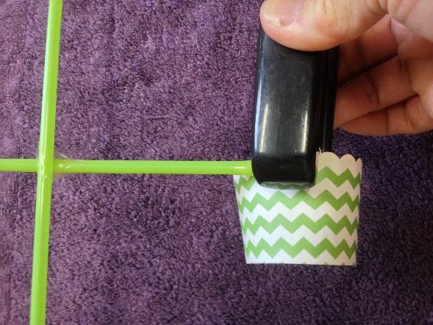
- Tape two plastic drinking straws into a cross shape.

- Staple or tape the topside of a small paper cup to the end of each straw, so the cups open the same way.

- Push a pin through the centre of the straws into the rubber on the top of the pencil.

- Put a mark on one of the cups to mark the beginning of a rotation (turn).

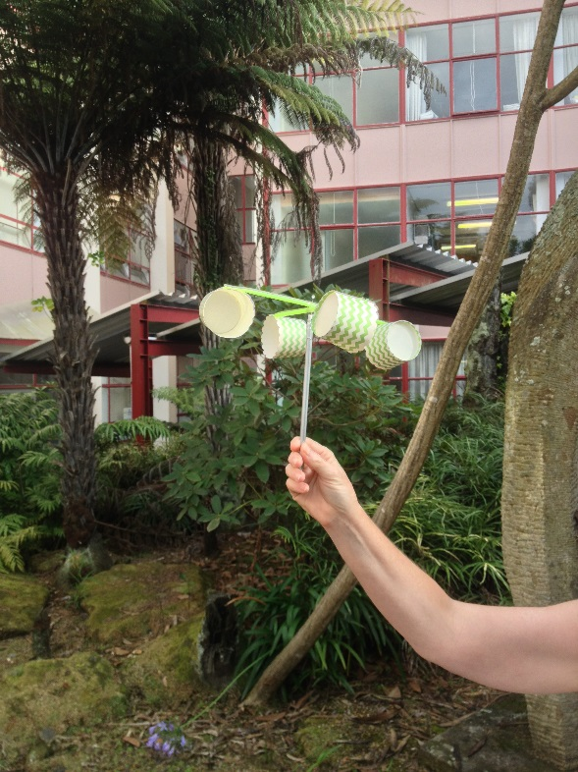
- Create a breeze with a fan or test it in the wind to see if it turns easily. If not, make any adjustments needed.

- Take the anemometer outside and, either holding it or poking it into the ground, count how many turns it makes in 1 minute.

Tip:
If the paper cups are too heavy, the straws will bend. Use strong straws and light paper cups.

Student extension ideas/prompting questions for teachers

Data collection with younger students

- Before you start recording wind speeds, you may wish to discuss what the different categories are. These might simply be no wind, gentle wind and strong wind. Discuss what the terms mean. For example, what are the criteria for a strong wind?

- Devise an appropriate table, chart or map that allows students to record their observational data. You may want to modify the one shown below for older students.

Data collection with older students

- Provide students with a chart like the one below to interpret and fill in, using observational data plus their anemometer to assess how many rotations it takes for the anemometer they have constructed to reach each category of wind speed. You may allow them to come up with their criteria/descriptions first.

Category | Description | Rotations per minute
Calm (little to no wind) | Dust/flour falls straight down when dropped and any smoke goes straight up
Light | Wind is felt on the face; weather vanes rotate
Moderate | Flags flap
Strong | Tree branches move
Gale force | Difficult to stand up straight

- For senior students, you may wish to add another column to the table that allows the students to calibrate their anemometer. They can do this by combining their observational data and anemometer rotation with known wind-speed data, thereby finding a rotation speed that corresponds with the descriptors and allows them to estimate wind speed in km/hr. For example, a wind that causes the anemometer to rotate 10 turns per minute, when it is also observed that flags are flapping could be estimated to be between 12 and 28 km/hr. This allows students then to extrapolate that any wind causing a rotation of 10 turns per minute is measuring winds between 12 and 28 km/hr. They might like to construct their own table for this.

Category | Description | Kilometres per hour | Rotations per minute
Calm (little to no wind) | Dust/flour falls straight down when dropped and any smoke goes straight up | 1
Light | Wind is felt on the face; weather vanes rotate | 2-11
Moderate | Flags flap | 12-28
Strong | Tree branches move | 29-49
Gale force | Difficult to stand up straight | 50 +

- Calibrate the anemometer against a commercial anemometer, and convert rotations per minute to km/hr.

- Experiment with different cups, different straws.

- Try to make an anemometer that turns the most easily. This can lead to a discussion about friction, wind resistance, balance etc.

- Categorise the wind speed at different times of day or days of the week and keep a longitudinal record. Are there any patterns?

- Map the wind speed at different locations around the school grounds. Are some locations windier than others? Why might that be? Is it always that way?

- Research the difference between speed and velocity.

- How can the accuracy and/or reliability of the data collected be improved? Discuss repeating measurements and processing averages.

- Add an electronic component to the anemometer. Commercial electronic devices are available that convert rotation to speed (electronics and hobby shops have these). Senior students interested in electricity could add one of these devices to their anemometer, and this data could be fed directly into a computer program.

- Can any patterns be seen in relating the wind direction data to other weather information/data that may have been collected such as observations, using a rain gauge, temperature (thermometer), air pressure (barometer).

- Write a weather report that outlines any findings and predictions.

