ACTIVITY: Making a weather vane and compass

Activity idea

In this activity, students will construct a simple weather vane and a simple compass.

By the end of this activity, students should be able to:
- build a simple weather vane
- build a simple compass
- collect data using their weather vane and compass
- interpret and make meaning of their data
- discuss the reliability of their data.

Background information for teachers
Equipment required
Student instructions
Extension ideas/prompting questions

Background information for teachers

The earliest weather vane we know about was in Greece in 48 BC, erected in honour of the Greek god Triton. It became quite popular for the houses of the wealthy Greeks around this time to have weather vanes erected on their roofs, and they were often very ornate.

Compasses are used to determine direction and have been used ever since their invention in China approximately 200 years BC. They were in common use as navigation devices as far away as Western Europe by the 1300s. Compasses work on the principle that the Earth has a magnetic field that the magnetic needle aligns to, enabling the direction to be determined.

Safety

When making the compass, younger students may just tape the needle onto the top of the cork disc so it is evenly balanced rather than poking it through the cork.

This activity is part of a set of five activities supporting students to collect and interpret data about their world. Although each of these activities may be used within a variety of topics, they were designed to tie together under the topic of weather. The other activities are:
- Making a barometer
- Making a rain gauge
- Making a thermometer
- Making an anemometer

They support the professional learning and development sessions Delving into data and Making sense of data. They support the development of the science capabilities, especially ‘Gather and interpret data’, Use evidence’ and ‘Critique evidence’.

Equipment required

- Ice cream container lid
- Straw
- Pin
- Skewer or wooden chopstick
- Scissors
- Tape
- Craft knife
- Cork
- Sewing needle
- Magnet
- Small plastic drink bottle
- Water
- Waterproof marker pen

Student instructions

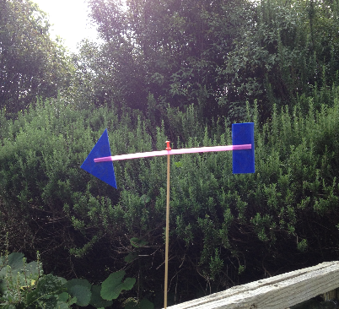
Weather vane

- Cut out a triangle and a rectangle from the ice cream container lid.

- Slit the straw 2–3 cm at each end. (First cut off the flexible end if it has one.)

- Slot the plastic shapes into the slits, one at each end.

- Push the pin through the straw in the middle and pin it onto the end of the skewer/chopstick. Make sure the hole is big enough to allow the straw to rotate.

- Poke the other end of the skewer/chopstick into the soil outside, or tape it onto a higher location where the vane can turn easily in the wind.

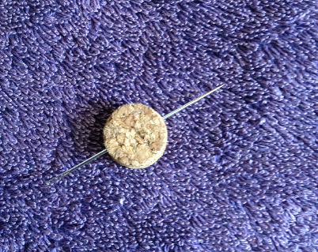
Compass

- Slice off a piece of the cork to make a flat circle of cork approximately 3 mm thick.

- Stroke the end of the needle across the magnet 50 times in the same direction to magnetise the needle.

- Poke the needle horizontally through the top of the cork until it pokes through equally on either side.

- Cut the bottom off the drink bottle. Discard the top.

- Half fill the bottom of the drink bottle with water and float the cork and needle on the top of the water.

- See if the compass works. If the needle is fully magnetised, the cork should rotate until the needle is pointing north-south. If it doesn’t, try magnetising the needle again. (The magnetism doesn’t stay for very long, and this step will probably need to be repeated each time the compass is used.)

- Find out which way is north. (Hint: The Sun is in the northern part of the sky at midday. Most smartphones have a compass function and can easily be used to check which end of the needle is pointing north.)

- Draw N, E, S, W onto the cork with a marker pen to indicate the directions on your compass.

- Use the compass to gauge the direction of the wind your weather vane is indicating.
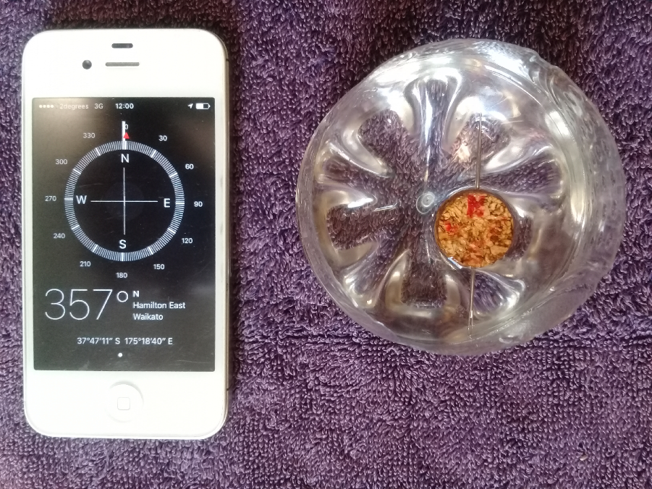

Extension ideas/prompting questions

Weather vane

- Experiment with different-sized plastic ends, different materials, different length straws and different locations.

- Does the material used for construction make a difference to how your weather vane works?

- Are there any things to control? For example, is the size or weight of the plastic ends important?

- Does the location of the weather vane make a difference to its function?

- How can the design be improved? (This discussion might raise concepts such as friction, centre of gravity, balance etc.)

- When comparing results, should all the weather vanes be the same or doesn’t it matter?

- Who can make the best weather vane? (What does ‘best’ mean?)

- Utilise different methods for recording results, for example:
- use the weather vanes in different parts of the school and map the directions onto a school map
- use with the compass and set up relevant charts for recording wind direction at different times of day, days of the week, locations etc.

- Questions to support interpreting results:
- Does the wind travel in the same direction around the school?
- Does the wind direction change throughout the day/week?
- What patterns can be seen?
- Is there a way of more accurately collecting data from the weather vane?
- How could the method of data collection and processing be improved?
- Can any patterns be seen in relating the wind direction data to other weather information/data that may have been collected such as observations, using a rain gauge, wind speed (anemometer), temperature (thermometer), air pressure (barometer).

- Write a weather report that outlines any findings and predictions.

Compass

- Does the material used for construction make a difference to how the compass works?

- How can the design be improved?

- Are there things that need to be controlled or experimented with? For example, wind interference, weight of the cork, type of needle, method of magnetising.

- When comparing results in class, would you expect to see all the compasses read the same? Is it important that the results agree or doesn’t it matter?

- Who can make the ‘best’ compass? (It is important to provide an opportunity to explore with the class what ‘best’ means. For example, will you define best as the most accurate, most beautiful, most robust? What criteria might you apply to determine what is ‘best’?

- Research how to find north without a compass.

