ACTIVITY: Making a rain gauge

Activity idea

In this activity, students will construct a simple rain gauge.

By the end of this activity, students should be able to:
- Build a simple rain gauge
- Collect data using their rain gauge
- Interpret and make meaning of their data
- Discuss the reliability of their data

Background information for teachers
Equipment required
Student instructions
Extension ideas/prompting questions

Background information for teachers

Rain gauges are one of the most ancient weather instruments. The ancient Greeks and people in India were the first known to keep rainfall records, about 400–500 BC. In 1441, Korea invented the first standardised rain gauge, the Cheugugi. It was 32 cm high and had a diameter of 15 cm. Since then, many other rain gauges have been invented, for example, the weighing precipitation gauge, the tipping bucket rain gauge, the optical rain gauge and the acoustic rain gauge.

This activity is part of a set of five activities supporting students to collect and interpret data about their world. Although each of these activities may be used within a variety of topics, they were designed to tie together under the topic of weather. The other activities are:
- Making a barometer
- Making a thermometer
- Making a weather vane and compass
- Making an anemometer
They support the professional learning and development sessions Delving into data and Making sense of data. They support the development of the science capabilities, especially ‘Gather and interpret data’, Use evidence’ and ‘Critique evidence’. The New Zealand annual rainfall map and the activity Using soil moisture maps might extend your students’ thinking.

Equipment required

- Small plastic drink bottle
- Small stones
- Ruler
- Waterproof marker pen
- Tape or paperclips

Student instructions
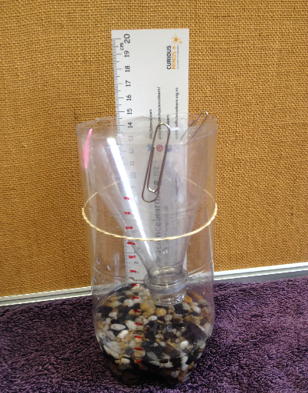
- Cut off the top of the bottle ¾ of the way up.

- Put some small stones in the bottom so it stays upright and fills up the non-uniform shape of the bottom of the bottle.

- Put the top inside the bottle upside down (like a funnel) and tape (or paperclip) it into place.

- Mark the bottle (using a ruler) every 1 cm up the bottle, starting just above the level of the stones, and/or tape a ruler onto the outside of the bottle.

- Pour water into the bottle up to the first mark.

- Put the rain gauge outside on a level surface where the rain can get into the gauge. Make sure it can’t be knocked or blown over.

- See how much the water rises when it rains and measure it on the scale.

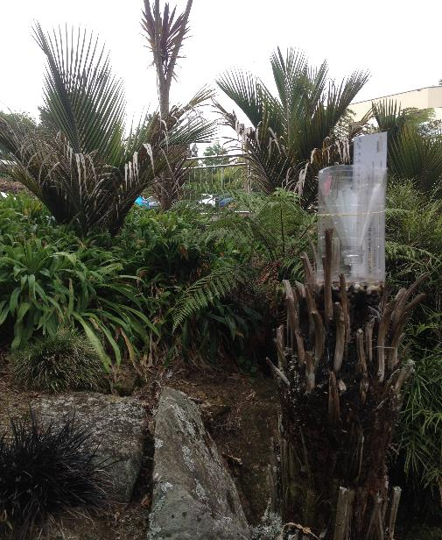
Extension ideas/prompting questions
- Discuss the accuracy of the rain gauge.

- Discuss ideas about how to modify the design to allow for more accurate measurements.

- Some ideas for improving the data collection:
- Experimenting with different construction methods and materials to develop the most accurate rain gauge.
- Removing the gauge from its location each time a measurement is wanted, and removing and measuring the amount of water collected using an accurate measure like a measuring cylinder or measuring cup. For accuracy, measure the amount of water covering the stones at the bottom below the start of the scale and subtract this from the total measured.
- Measuring the amount of water it takes to get from mark to mark on the scale before the gauge is set up outside. This way it is known how much water it takes to get from mark to mark, and the gauge doesn’t have to be emptied so often.

- Ideas for collecting rain information:
- Compare the amount of rain falling in a certain length of time with another. Does an equal volume of rain always fall in the same time?
- Collect rainfall data every day/week/month and create tables and graphs of this information, looking for patterns.
- Put the rain gauges in different locations around the school. Does the rainfall vary from place to place? If it does, what might explain that?
- Is it important to measure rainfall at the same time every day/week/month?

- How does the rain gauge data compare with the official rainfall statistics for your area? What might explain any differences?

- Some scientists don’t trust rain gauge measurements.
- What do they use instead?
- What are some potential limitations to using the rain gauge?
- How could the accuracy of the rain gauge be improved?

- Can any patterns be seen in relating the rain gauge data to other weather information/data that may have been collected such as observations, using a weather vane, wind speed (anemometer), temperature (thermometer), air pressure (barometer)?

- Write a weather report that outlines any findings and predictions.

