ACTIVITY: Making a barometer

Activity idea

In this activity, students will construct a simple barometer.

By the end of this activity, students should be able to:
- build a simple barometer
- collect data using their barometer
- interpret and make meaning of their data
- discuss the reliability of their data.

Background information for teachers
Equipment required
Student instructions
Extension ideas/prompting questions for teachers

Background information for teachers

Barometers work on the principle that the air pressure can change. High air pressure tends to indicate fair weather, and low air pressure can indicate poor or rainy weather. A barometer shows the relative difference in air pressure outside the barometer compared to inside. In this activity, the barometer is a sealed jar with a balloon lid, and the changes in air pressure can be seen by the shape of the balloon.

If the pressure of the air outside the jar is higher than inside (high pressure), it will push down on the balloon and the balloon lid will sink and the straw will point up. If the air pressure outside the jar is lower than inside (low pressure), the balloon will swell outwards and the straw will point down. The straw will move up or down just before a weather change since a change in weather typically coincides with a change in the atmospheric pressure. Students record these movements over time – choose a recording method suitable for the level of your students.

This activity is part of a set of five activities supporting students to collect and interpret data about their world. Although each of these activities may be used within a variety of topics, they were designed to tie together under the topic of weather. The other activities are:
- Making a rain gauge
- Making a thermometer
- Making a weather vane and compass
- Making an anemometer

They support the professional learning and development sessions Delving into data and Making sense of data. They support the development of the science capabilities, especially ‘Gather and interpret data’, Use evidence’ and ‘Critique evidence’.

Equipment required

- Balloon
- Glass jar
- Rubber band
- Straw
- Sheet of paper
- Marker pen
- Tape
- Scissors

Student instructions

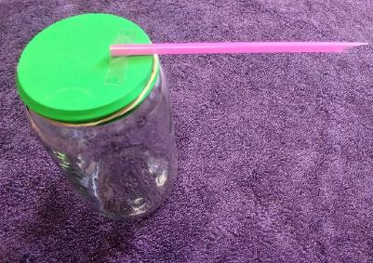
- Stretch the balloon by blowing it up and letting the air out again.

- Cut the neck off the balloon.

- Stretch the large (neckless) piece of balloon over the top of the jar and use the rubber band to hold it there. Make sure the rubber band is tight so it doesn’t let any air in or out.

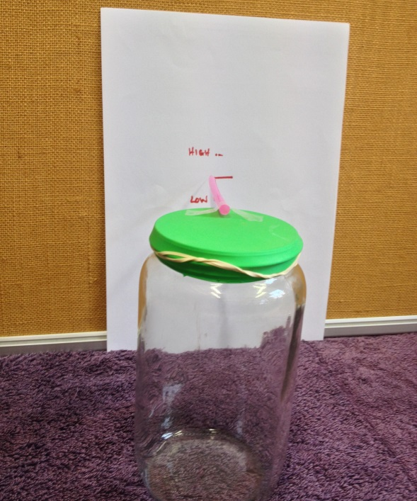
- Sit the straw on the balloon lid so about 2 cm sits on the lid and the rest out into the air. Tape it into place.

- Pin the piece of paper to the wall and place the jar next to it so the straw is close to the wall and aiming at the middle of the paper.

- Mark where the straw is aiming at on the paper. You could label this mark ‘moderate’.

- Make a mark 1 cm above and 1 cm below the first mark. Label these marks ‘high’ and ‘low’.

- Keep the barometer in the same place, ideally outside but somewhere where the temperature is fairly constant. Regularly record where the straw is pointing, and make marks to show this. Each time, note what the weather is like, either against the paper or in a chart.

Tips:
- Making the straw a little shorter may help so the changes are easier to see.
- Cutting a point on the end of the straw makes it easier to read where the straw is pointing against the scale on the wall.

Extension ideas/prompting questions

- How well does the barometer work? What changes to the design would make it more accurate? Try using different size jars, a plastic jar, shorter or longer straws or different brands of balloon.

- Make a chart that records the position of the straw and note the weather at the time. Are there any patterns?

- Collect data over a period of hours/days/weeks. Graph the results to make any patterns easier to see.

- Is it possible to predict the weather? How much data is needed to make weather predictions/forecasts?

- How might changing temperature affect the accuracy of the barometer?

- Can any patterns be seen in relating the barometer data to other weather information/data that may have been collected? e.g. observations, wind direction (weather vane), wind-speed (anemometer), temperature (thermometer), rain (rain gauge).

- Write a weather report that outlines any findings and predictions.

