Lesson 3: Investigate:
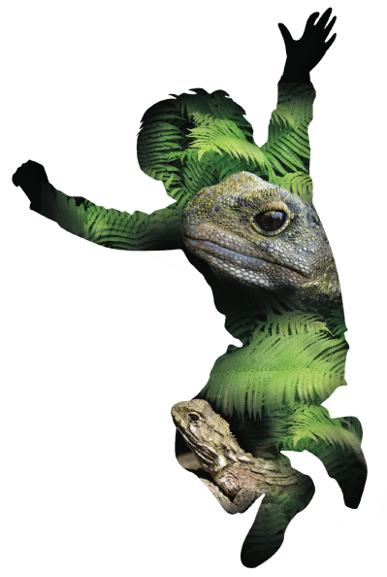
What is present ? (Part 2)
Overview:

Lesson Number: | 3 of 5
Key Competencies: | Thinking, Using language, symbols, and texts; Managing self; Relating to others; Participating and contributing.
Unit/Topic: | Primary focus: Science  Secondary focus: Technology
Te Reo/Tikanga Māori: | Names of animals in Māori. Pre- European Māori world view.
Values: | Excellence; Innovation, inquiry, curiosity; Diversity; Equity; Community and participation; Ecological sustainability; Integrity; Respect.
Science Strand: | Nature of Science  Living world
Level: | 3
Achievement Objectives:  Nature of Science: | Students will:  Investigating in science:  - Ask questions, find evidence, explore simple models, and carry out appropriate investigations to develop simple explanations.
Achievement Objectives:  Living World: | Students will:  Ecology:  - Begin to group plants, animals, and other living things into science-based classifications.
Technology Strand: | Technological Knowledge
Level | 2
Achievement Objectives:  Technological Knowledge: | Students will:  Technological systems:  - Understand that there are relationships between the inputs, controlled transformations, and outputs occurring within simple technological systems.
Lesson Objective: | Students will be able to gather data through the use of technology and use this data to draw conclusions and identify patterns. This will also allow them to classify flora and fauna into their science based classifications.
Resources:

- Laminates of NZ fauna and pests (from lesson one).
- iPads / tablets with pre-installed applications.
- Vocabulary list in English and Māori (see Te Tikanga lesson).
- Gotcha traps refills if required.
- Laptop to connect to projector.
- Excel sheet to record tracking tunnels info.
- A copy for each student of the final class tracking tunnel grid.
Resources online:

- http://www.pestdetective.org.nz/
- http://iNaturalist.org/observations/stteresasroom6
- http://iNaturalist.org./observations/room25kns
- http://www.rotokare.org.nz/uploaded_images/Education/Identifying-animal-tracks.pdf

Resources to set up:

- Prior to this session, all tracking tunnels should have been put in place the previous afternoon.
- Spreadsheets to record what you find (from lesson two).
- iPad or tablet logged in to NatureWatchNZ or iNaturalist ready to photograph any prints and log observations.
- Print off three or four copies of ‘What made these tracks?’ from lesson two folder.

Lesson Structure:

Introduction, overview, theme and content 50min
The first activity the students will be doing is checking their tracking tunnels. Walk around all the sites as a class and record what you find on the spreadsheet set up in the lesson two.
You will also need to take photos of any prints you find and attach them to your recording. If you have access to an iPad or tablet, the easiest way to log these observations is by using the iNaturalist app. It automatically records the GPS, time and date with your photo and a form for you to enter in other details
Before heading out to check tracking tunnels hand out two or three ‘What made these tracks?’ printed guides. Students can use these to try and identify the prints you may find in your tracking tunnels.
As described above, go to each tunnel with the class. Get the owner of the tunnel to check and write the recording of what is present or log these observations into the ZEALANDIA WWF Outreach project on iNaturalist. Students can use the print guide to try and identify what the print is.
As the ink pads are good for multiple uses, it is up to you whether or not you leave the tunnel out for further nights to repeat the process. If you do, make sure you re-bait as necessary. You can tape a fresh piece of paper/card over any existing prints so that you can gather new prints.
Alternatively, if you have made your own inkpads, refill the food colouring and replace the paper if you wish to collect more prints.
Wrap 10min
Once you have visited all of the tracking tunnels, return to class. Hand out a copy of the master tracking tunnel grid to every student. Talk through all of the observations and get students to mark on their map where prints were found and what species were present.
Along with the sets of print guides, get students to use the website http://www.pestdetective.org.nz/ . This is a great resource to explore and time should be allocated for this.
Repeat the above process as many times as you deem necessary to gain a good set of baseline data which your students can work from.
Additional Notes: If you have used iPads in the field, then you can log in to the project on a desktop computer to view your new observations back in class. If you did not use an iPad or tablet to enter your observations in the field you can do this as a class from a desktop computer by logging into the project and using the ‘Add Observations’ functions there (this includes the ability to upload photos from any camera you have used in the field). As a teacher you must have a good grasp of the project in NatureWatchNZ / iNaturalist and how to work these various options for data collection and analysis back in class. Choose the options that best suit your situation and available resources.

Points for Next Session:

Evaluation:

Points to Improve:

© 1986 Panda Symbol WWF – World Wide Fund For Nature (Formerly World Wildlife Fund)
® “WWF” is a WWF Registered Trademark

