Lesson 2: Investigate:

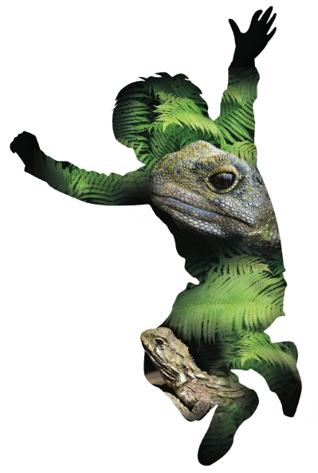
What is present ? (Part 1)

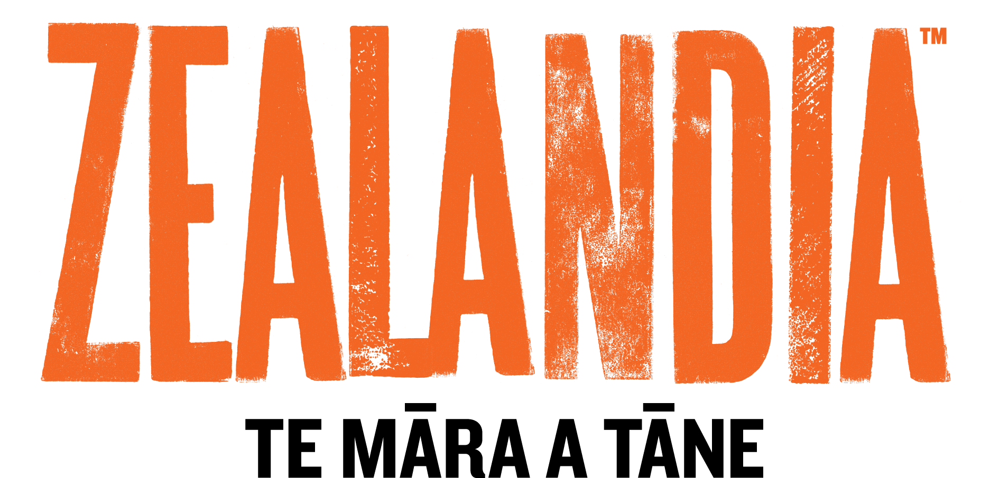

Overview:

Lesson Number: | 2 of 5
Key Competencies: | Thinking; Using language, symbols, and texts; Managing self; Relating to others; Participating and contributing.
Unit/Topic: | Primary focus: Science  Secondary focus: Technology
Te Reo/Tikanga Māori: | Names of animals in Māori. Pre- European Māori world view.
Values: | Excellence; Innovation, inquiry, curiosity; Diversity; Equity; Community and participation; Ecological sustainability; Integrity; Respect.
Science Strand: | Nature of Science  Living World
Level: | 3
Achievement Objectives:  Nature of Science: | Students will:  Understanding science:  - Identify ways in which scientists work together and provide evidence to support their ideas.
Achievement Objectives:  Living World: | Students will:  Ecology:  - Explain how living things are suited to their particular habitat and how they respond to environmental changes, both natural and human induced.
Technology Strand: | Nature of Technology
Level: | 2
Achievement Objectives:  Nature of technology: | Students will:  Characteristics of Technology:  - Understand that technology both reflects and changes society and the environment and increases people’s capability.
Lesson Objective: | Students will be able to investigate and construct a technological outcome which will enable them to record patterns in their community.

Resources:

- iPads/tablets with pre-installed apps. (NatureWatchNZ or iNaturalist).
- Vocabulary list – English and Māori (see He Tikanga lesson).
- Core flute (contact your local real estate agent who may be able to supply. you with old ‘Open Home’ signage to recycle).
- Gotcha Traps ink pads and tracking tunnels (for a school discount contact: Warren Agnew www.gotchatraps.co.nz).
- Tracking tunnel prints (printed off from NatureWatchNZ or iNaturalist).
- Duct tape or any strong adhesive.
- Example of a map of Victoria University trap lines marked on the site (in folder).
- “What made these tracks?” by Warren Agnew Gotcha Traps (in folder).

Resources online:

- http://iNaturalist.org/observations/stteresasroom6
(Shows some of the prints from the tracking tunnels)
- http://www.iNaturalist.org/observations/room25kns
- http://www.pestdetective.org.nz/
- http://www.rotokare.org.nz/uploaded_images/Education/Identifying-animal-tracks.pdf
- http://www.doc.govt.nz/conservation/threats-and-impacts/animal-pests/animal-pests-a-z/
- http://www.kcc.org.nz/threats-impacts

Resources to set up:

- NatureWatchNZ or iNaturalist log-on.
- Set up a spreadsheet to log the information about your prints and other relevant details. (see example in resource folder).
- Bird’s eye map (print off from Google Maps NZ) of your school for each student. One large class map on a board.
- Decide where in your school grounds the tracking tunnels will go. Mark these on a map of the school (see example in resource folder).
- Cut corflute to size (dimensions for tracking tunnels in resource folder).

Lesson Structure:

Introduction and overview 10min
To start the session, revisit the A3 posters or presentations the students made in their groups. Highlight the positive aspects of these endemic species and how unique they are.
The main component of this session is ‘to investigate which species we have present in our school’. Have a discussion with your students about how they could do this.
Introduce the investigation tool that they will be using throughout the programme. Show them the example of a tracking tunnel.
If you wish, you can give your students the opportunity to design their own tracking tunnel after discussion about its purpose and design requirements (see instructions for an alternate design in resource folder).
Explain that they will be in charge of gathering the evidence about what species are present in your school. As your students are citizen scientists they will need to record as much detail as possible.
Define what a ‘pest’ species is. Include plant and animal examples. Explain that they are not ‘bad’ animals, simply the wrong species in the wrong place that cause harm to our native New Zealand species.
Demonstrate, using role play, how the tracking tunnel works. Ask questions such as:
- What shall we use as bait?
- How, where and what do we record if we find something?
- What do you think we may find?
- Is everything we find going to be a pest?
- What are the limitations of this tool?
Theme and content 40min
Each student will receive a map of the school. As a class, get students to label important/main sites in the school. This will help them to orientate themselves.
Ask them to use a felt pen or marker and mark on the map the number and placement of the tracking tunnels which you are using. Ask them the following questions:
- If we bunch them together what will happen?
- Should we place them out in the open or in sheltered spots?
After your students have marked their proposed sites for the tracking tunnels on their school map, they will take a pre-cut tracking tunnel and write their name on it. They will also receive a Gotcha ink pad which they will need to name.
Alternatively you can use XLO sponge placed in an ice cream carton lid with a couple of tablespoons of food colouring, as your inkpad, with paper taped either side of it in the tunnel.
Note: If deciding on possible sites is too hard for your class, you can get your students to design and decorate their own tracking tunnel. If you choose this option simply provide them with a map with the locations of where you want the tracking tunnels placed.

Wrap 10min
Although you will not be placing the tracking tunnels out with the class today, it is important that the class as a whole decides where their tracking tunnels will be placed. Look at the large class map together and have a discussion about where you will site the tracking tunnels.
Make sure students hand in their proposal for the tracking tunnel grid of the school. It is important you have the final class plan mapped out and ready to go before the tunnels are put in place.

Prior to the third session
You will need to place the tracking tunnels out in their designated areas the day before the third session. Talk to the students about the timing of the placement. (This is often best done at the end of the school day)
For the first tracking session it is suggested that peanut butter be used. (Ensure allergies are taken into consideration.) You may want to get a few students to inform other classes in your school of what they are doing. Ask them not touch the tracking tunnels as they head home that day or the following morning.

Points for Next Session:

Evaluation:

Points to Improve:

© 1986 Panda Symbol WWF – World Wide Fund For Nature (Formerly World Wildlife Fund)
® “WWF” is a WWF Registered Trademark

