Marine theme:
Marine biodiversity

Marine biodiversity refers to the variety of life in coastal and ocean environments. New Zealand’s marine environment provides a habitat for an estimated 65,000 species of plants, animals and microorganisms.
In order to protect our marine biodiversity an important step is to classify as many species as possible. More detailed species information helps inform decision-making about conservation and determines marine biosecurity risks.
This topic planner offers a suggested pathway through Science Learning Hub education resources and connects to relevant programmes offered by NZ Marine Studies Centre. Click on the links below to create your own personalised teaching unit. Feel free to use this material in any combination or order.
Images from https://www.sciencelearn.org.nz/

Exploring the theme

Focus question: Why do we need to know how many marine species are in the sea?

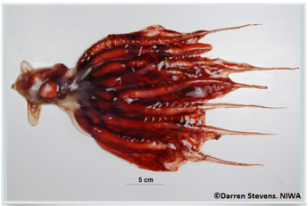 | 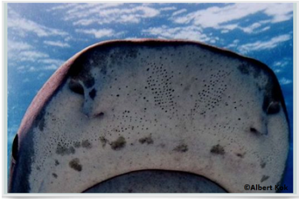 | 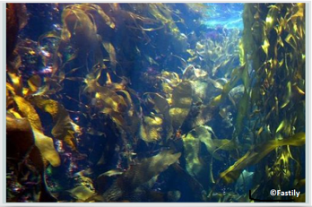 | 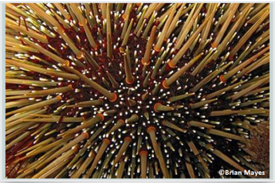

- NIWA news story > New Zealand’s marine biodiversity

Activities – use these activities to expand on the focus question:
- Develop a classification system

Understanding the theme

Focus question: What do scientists look for when they classify marine organisms?

- Key terms > See biodiversity and classification
- Article > Classifying marine organisms
- Video > What are bryozoans?
- Article > Bryozoans

Applying the theme
Focus question: How do you think marine biodiversity might be affected if bryozoans are no longer able to make a shell and form structures on the mid-shelf?

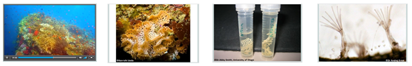

- Video > Bryozoans’ role in the ecosystem

- Article > Bryozoans and ocean acidification

Experiencing the theme
Activities – use these activities to expand on the focus question:

- Ocean acidification and eggshells

New Zealand Marine Studies Centre field trips (available in Otago & Nelson) include explorations of the coastal environment, laboratory sessions, boat trips and aquarium adventures.
W: www.marine.ac.nz

- Creature features
- Might mollusc
- Fish, fins and fun
- Seashore scramble
- Suckers and tentacles
- The Marine Road Show
- How big?
- Pirates and the ocean treasures
- The Voyage of Discovery

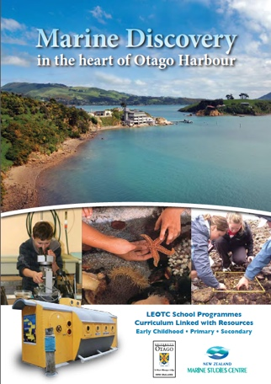 | 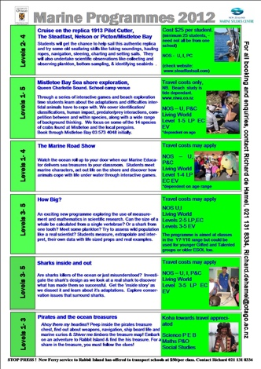

This resource supports NZC Science Level 3/4
NATURE OF SCIENCE: UNDERSTANDING ABOUT SCIENCE: Appreciate that science is a way of explaining the world and that science knowledge changes over time.
- LIVING WORLD: EVOLUTION: Begin to group plants, animals and other living things into science-based classifications.
- LIVING WORLD: ECOLOGY: Explain how living things are suited to their particular habitat and how they respond to environmental changes, both natural and human induced.
- LIVING WORLD: LIFE PROCESSES: Recognise that there are life processes common to all living things and that these occur in different ways.

Contact details

This resource supports NZC Science Level 3/4

The New Zealand Marine Studies Centre, University of Otago, offers marine education programmes and resources for primary and secondary schools in southern New Zealand.  T: 03 479 5826  E: marine-studies@otago.ac.nz  W: www.marine.ac.nz | The Science Learning Hub is a national project funded by the New Zealand Government to make examples of New Zealand science, technology and engineering more accessible to school teachers and students.  E: enquiries@sciencelearn.org.nz  W: www.sciencelearn.org.nz

