Marine theme: Marine habitats

A habitat is the area where an organism or group of organisms live and breed. One habitat will be distinct from another due to its particular environmental conditions.

New Zealand’s marine environment is incredibly diverse and made up of a large number of habitats. Important marine habitats are found in estuaries, fiords and on the continental shelf.

This topic planner offers a suggested pathway through Science Learning Hub education resources and connects to relevant programmes offered by NZ Marine Studies Centre. Click on the links below to create your own personalised teaching unit. Feel free to use this material in any combination or order.
Images from www.sciencelearn.org.nz

Exploring the theme

Focus question: These photos show different marine habitats. What makes one habitat different to another?

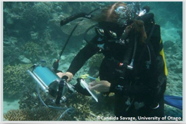 | 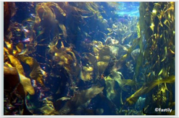 | 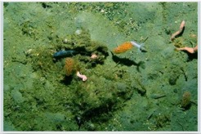 | 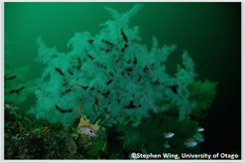

- Candida Savage diving
- Kelp
- Antarctic ice cod
- Black coral

Understanding the theme
Focus question: Describe some key features of an estuary. Why do you think they are an important marine habitat?

Key terms > See ecosystem, habitat, land-use change and water column
Article > Marine habitats
Article > Environmental conditions affecting the sea

Activities – use these activities to expand on the focus question:
Estuary metaphors

Focus question: How does human activity on land affect marine habitats?

Applying the theme

- Article > Estuaries and farmland run-off

- Video > Farmland run-off into estuaries

Activities – use these activities to expand on the focus question:

- Nutrient impact experiment

- Bird hotel

Experiencing the theme

New Zealand Marine Studies Centre field trips (available in Otago & Nelson) include explorations of the coastal environment, laboratory sessions, boat trips and aquarium adventures:
W: www.marine.ac.nz

- Seashore scramble
- Deep sea denizens
- Voyage of Discovery

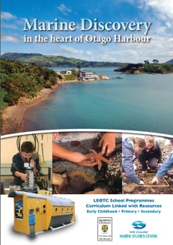 | 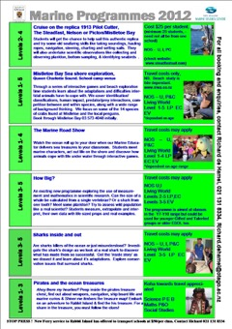

This resource supports NZC Science Level 3/4
NATURE OF SCIENCE: UNDERSTANDING ABOUT SCIENCE: Appreciate that science is a way of explaining the world and that science knowledge changes over time.
- LIVING WORLD: ECOLOGY: Explain how living things are suited to their particular habitat and how they respond to environmental changes, both natural and human induced.
- LIVING WORLD: LIFE PROCESSES: Recognise that there are life processes common to all living things and that these occur in different ways.

Contact details
The New Zealand Marine Studies Centre, University of Otago, offers marine education programmes and resources for primary and secondary schools in southern New Zealand.  T: 03 479 5826  E: marine-studies@otago.ac.nz  W: www.marine.ac.nz | The Science Learning Hub is a national project funded by the New Zealand Government to make examples of New Zealand science, technology and engineering more accessible to school teachers and students.  E: enquiries@sciencelearn.org.nz  W: www.sciencelearn.org.nz

