Marine theme: Adaptation

Adaptation is an evolutionary process whereby an organism becomes increasingly well suited to living in a particular habitat. Marine organisms have adapted to a great diversity of habitats and distinctive environmental conditions.

This topic planner offers a suggested pathway through Science Learning Hub education resources and connects to relevant programmes offered by NZ Marine Studies Centre. Click on the links below to create your own personalised teaching unit. Feel free to use this material in any combination or order.
Images from https://www.sciencelearn.org.nz/

Exploring the theme

Focus question: Look closely at one of these marine species and identify similarities and differences with humans.

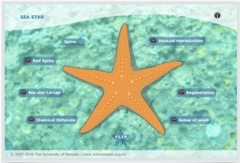 | 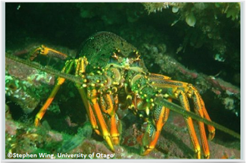 | 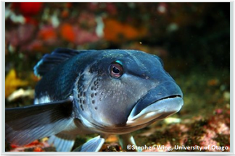 | 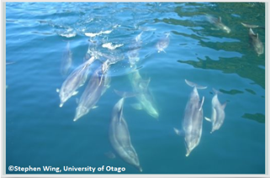

- Sea star
- Large crayfish
- Blue cod
- Bottlenose dolphins

Activities – use these activities to expand on the focus question:

- Develop a classification system

- Seashore drama

Understanding the theme

Focus question: How are different marine organisms adapted to the environmental conditions in the sea?

- Key terms > See adaptation

- Article > Adaptations of marine organisms

- Article > Environmental conditions affecting the sea

- Article > Cockles

- Article > Sea stars

- Video> Antarctic icefish
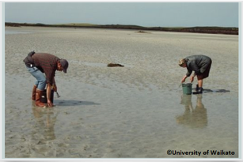 | 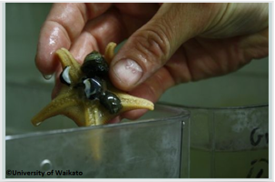 | 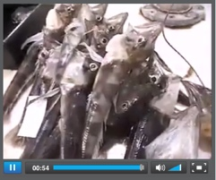

Activities – use these activities to expand on the focus question:
- Survivor seashore

Applying the theme

Focus question: In this video scientists are challenged by the ability of sea stars to drop limbs. How would this adaptation help the sea star to survive life in the sea?

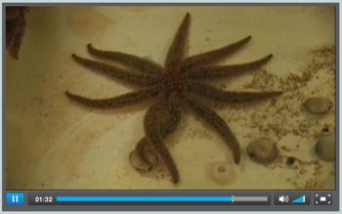

- Video > How do you electronically tag a starfish?

Focus question: Think about the environmental conditions in the sea. Describe which sensory systems are most important in that environment and why.

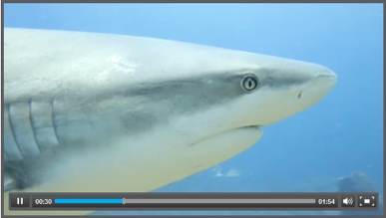

- Video > Non-visual sensory systems

Activities – use these activities to expand on the focus question:

- Animal and plant adaptations
- Hiding in plain sight
- Design a seashore species > page 28

New Zealand Marine Studies Centre Programmes and field trips (available in Otago & Nelson) include explorations of the coastal environment, laboratory sessions, boat trips and aquarium adventures.

Experiencing the theme
W: www.marine.ac.nz

- Suckers and tentacles
- Fish, fins and fun
- Creature features
- Sharks, Inside and Out
- Seashore scramble
- Marine roadshow
- How big?

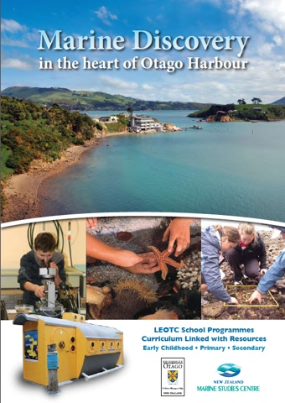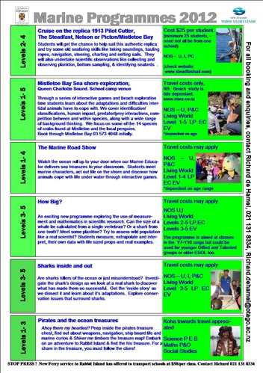

This resource supports NZC Science Level 3/4

NATURE OF SCIENCE: UNDERSTANDING ABOUT SCIENCE: Appreciate that science is a way of explaining the world and that science knowledge changes over time.
- LIVING WORLD: ECOLOGY: Explain how living things are suited to their particular habitat and how they respond to environmental changes, both natural and human induced.
- LIVING WORLD: LIFE PROCESSES: Recognise that there are life processes common to all living things and that these occur in different ways.

Contact details
The New Zealand Marine Studies Centre, University of Otago, offers marine education programmes and resources for primary and secondary schools in southern New Zealand.  T: 03 479 5826  E: marine-studies@otago.ac.nz  W: www.marine.ac.nz | The Science Learning Hub is a national project funded by the New Zealand Government to make examples of New Zealand science, technology and engineering more accessible to school teachers and students.  E: enquiries@sciencelearn.org.nz  W: www.sciencelearn.org.nz

