Ethics of saving the takahē

This class case study provides an example of introducing ethical thinking into the classroom to explore a controversial issue in science. It shows how the ethical frameworks in the Ethics thinking tool and a range of classroom activities can be used to scaffold ethical thinking. In this example, year 5 and 6 students considered the ethics of spending money and effort on conservation.

This classroom example formed part of the research prior to developing the Ethics thinking tool and, as such, uses ideas that informed the development of the tool and not the tool itself. The Ethics thinking tool provides additional support to help structure students’ thinking and decision-making using ethical frameworks.

Introduction

As part of a science unit focusing on an endangered New Zealand bird, the takahē, year 5 and 6 students considered the ethics of spending money and effort on conservation.

The ethics were explored near the end of the lesson sequence, which included:
- physical characteristics and habitat of the takahē
- its status as an endangered New Zealand native bird
- main threats to its survival
- key conservation efforts.

Science focus

- Ecology (level 3): Explain how living things (the takahē) are suited to their particular habitat and how they respond to environmental changes, both natural and human-induced (for example, the introduction of predators and competitors).
- Evolution (level 3): Appreciate that some living things in New Zealand are quite different from living things in other areas of the world (for example, the takahē is a flightless bird).
- Participating and contributing (level 3): Use their growing science knowledge (of endangered species and conservation strategies) when considering issues of concern to them. Explore various aspects of an issue and make decisions about possible actions (for example, whether to fund conservation efforts).

Learning objectives

- To identify key stakeholders affected by conservation efforts (for example, the takahē, other endangered birds, deer who compete for the tussock grass, predators, tourists, scientists, the environment).
- To consider the consequences (harms and benefits) of conservation efforts for each stakeholder group.
- To identify and weigh up various points of view regarding the costs (money, time, land) associated with conservation efforts.
- To develop and be able to justify a personal view.

Using ethical approaches to guide decision-making

Ethicists use a range of ethical approaches to make decisions about what is right or wrong. Here, the teacher chose to focus on consequentialism: considering the harms and benefits associated with a particular decision or action. Issues of rights and responsibilities were raised. (What rights do the takahē have? What rights do other animals, like predators, have?) A virtues approach was introduced when students considered whether supporting conservation efforts made one a ‘better’ person.

See the article Frameworks for ethical analysis.

Teaching and learning activities

Whole class discussion
- The meaning of consequences.
- Identification of key stakeholders, recorded on a large table.
- Identification of the consequences of conservation efforts for each stakeholder group. (See example.)

Worksheets
- Worksheets completed using a round robin format (small groups of students move around various stations in the class) to identify possible harms and benefits for each stakeholder group. (See example.)

Debate
- Students were assigned to affirmative and negative teams.
- Students were encouraged to consider alternative views and take up different positions during the debate, regardless of their personal views.

Report
- Each student presented and justified his or her personal position in a written report. (See template.)

Key messages

- Science knowledge learned in the earlier part of the unit provided a sound base for ethical discussion.
- Students initially associated consequences with negative effects of actions or decisions, but this view was easily expanded to include positive effects.
- The teacher experienced a tension between wanting students to consider alternative views (the ‘ethics’ focus) whilst engendering in students a concern for native species (the ‘science’ focus).
- The teacher deliberately played down emotive language, for example, she queried the assumption that ‘saving the takahē wastes money’.

Acknowledgements

This classroom programme formed part of a project funded by Toi te Taiao: the Bioethics Council. We thank the teacher and students for participating in this programme.
Example of stakeholders and consequences table

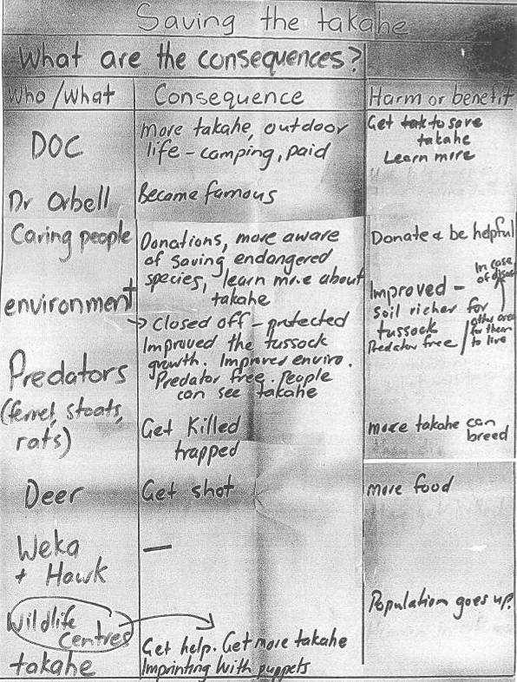

Example of harms and benefits worksheet

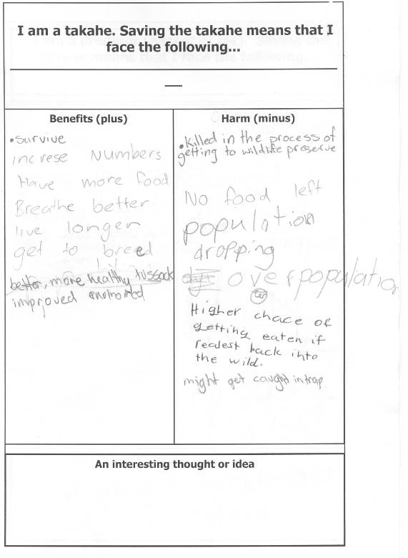
Write a report on the takahē

Paragraph 1:
What is it?
What does it look like?
Where does it live (normally)?
What is its habitat like?
What does it eat?
What does it do (behaviour)?

Paragraph 2:
How did the takahē become endangered? (What is its history, including who discovered it?)

Paragraph 3:
What is happening to save the takahē?
- In the Murchison Mountains.
- In the wildlife centres (Burwood, Te Anau, Mt Bruce).
- Predator-free islands

Paragraph 4:
What do you think about the saving of the takahē? Why?

