ACTIVITY: Tea tasting

Activity idea

In this activity, students learn about tea tasting and compare different types of tea by conducting sensory testing. The activity involves comparing the appearance, aroma and taste of four different types of teas.

By the end of this activity, students should be able to:
- conduct a sensory assessment of teas
- identify and describe the appearance and sensory qualities of the dried tea leaves and infused liquid of a range of different teas
- record the results of their tasting and determine their tea preference.

Introduction/background notes
What you need
What to do
Student handout: Tasting tea

Introduction/background

Although all tea is produced from the same plant, Camellia sinensis, there are numerous different teas available. There are six main types – white, yellow, green, oolong, black and post-fermented. However, four types are more common – white, green, oolong and black. In New Zealand and other Western countries, we may be more familiar with black and green tea.

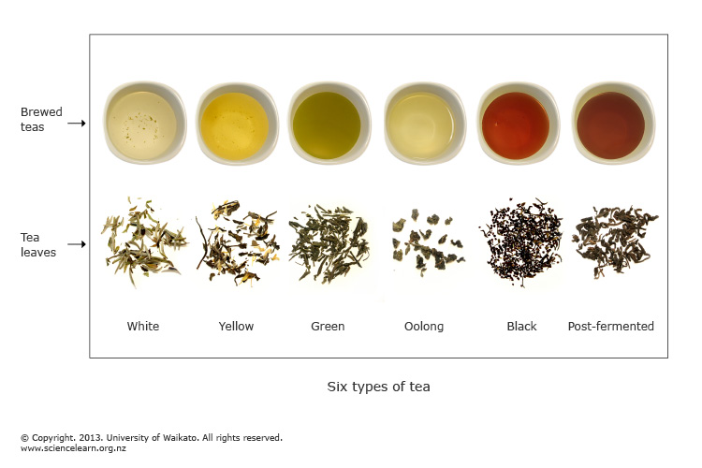

Different types of tea are created by varying the processing steps – mainly the degree of oxidation. These variations in processing create differences in the colour and taste of teas. However, there are many other factors that can create subtle and more obvious differences in the taste and appearance of teas, for example, the climate, soil type and condition, farming practices, time and method of harvesting, which leaves are used, flavour additives and blends.

Much like wine, the qualities and flavour of a tea are closely linked to the environment it is grown in – this is known as ‘terroir’. Hence, certain brands and regions become associated with high-quality tea, and connoisseurs are able to detect subtle differences in flavour and identify the region of origin.

Try this tea-tasting activity with your students as an introduction to the different types of tea before exploring the Zealong resources to learn more about the differences and how they are created.

Before beginning the sensory testing, it may be useful for the students to read The Connoisseur’s Guide to Tea Tasting and view the YouTube clip on tea tasting.

Safety
- Care will be needed with placement and handling of jugs or urns containing boiling water.
- Hygiene – ensure bench surfaces are clean, students wash their hands before beginning and don’t share cups.

What you need

- Online access to the images Six types of tea and Camellia sinensis
- Copies of the student handout Tasting tea
- Packets of four different teas – white, green, oolong and black
- Scales
- Electric jugs or urns – 1 per group
- Glass measuring jugs
- Small bowls or dishes to display the dried tea leaves – 1 for each type of tea
- Porcelain teapots or jugs – 1 per group (rinse out between each tea)
- Tea strainers
- White or light-coloured porcelain cups – narrow shape is preferable

What to do

- Discuss drinking tea. Who drinks it? (For example, is it associated with culture, age, health?) When and why do people drink it?

- Ask students how many different types of tea they know of – record these on the board. Can they be grouped in any way? Introduce the image Six types of tea and ask students which ones they are familiar with. Do they know where tea comes from? Discuss the fact that all these teas come from the same plant and show the image Camellia sinensis.

- Divide the class into small groups for sensory testing. Hand out copies of the student handout Tasting tea and assist students to gather the equipment and materials they need and conduct the tasting.

- Discuss the results.

Extension ideas

- Students could try increasing the infusion time for each of the teas and note any change in colour, aroma and taste. Compare the degree of change for each type of tea – is it the same for each one?
- Read the article The science of tea and explain the reasons for the differences between the teas.
- Try tasting different brands of their preferred type of tea. Are there differences? Investigate what factors may create these differences.
- Conduct a class survey about drinking tea. You could investigate the most popular type of tea among students in the class, the time of day when tea is most often consumed, the range of views on procedures for infusing tea.
- Research the history of tea, including the origin of the different types of tea and the cultural value of tea in different countries.
- Read the article Zealong: a unique New Zealand tea. Discuss other teas that are associated with New Zealand and why/how they are linked to New Zealand. Students could research and present a report, poster or PowerPoint presentation identifying these teas, where are they grown, packaged and so on, and why/how they are associated with New Zealand.
Student handout: Tasting tea

You will be conducting a sensory assessment of four different types of tea. Record your observations on the Tea tasting results sheet.

For each tea:

- Before infusing the tea leaves, describe the appearance of the dry leaves. Are they whole or broken? Are the leaves twisted or flat, regular or uneven? Are there stalks or other particles present? Describe the colour and texture.

- Weigh the tea leaves, using 3 g for each infusion, and place in teapot. Pour over 150 ml boiling water, cover with lid and steep for 3.5 minutes. Pour a small amount into individual cups for tasting.

- After infusing and before tasting the tea, describe the aroma of the liquid. Try closing your eyes and thinking about what you associate with the aroma and how it may taste.

- Describe the colour of the infused tea liquid. Look at the colour and transparency. A cup with a white interior shows colour best – darker tea colour may indicate fuller flavour; murkiness or sediment may indicate lower quality. Is the tea dark or light? Is it clear or murky? What is the colour, for example, yellow, yellow-green, green-yellow, brown, red, red-brown, black, grey etc?

- Describe the taste of the infused liquid. Slurp the tea while tasting to spread it all over your tongue and mouth – don’t worry about making loud noises. What flavour do you detect? Is it bitter, sweet, strong, astringent, grassy, smoky etc? How does it feel in the mouth – is it creamy, oily, thin, does it leave the mouth feeling dry or moist?

- Swallow the tea and describe the aftertaste. Do the flavours last in your mouth for a while, or do they dissipate quickly? What flavours remain? To note aftertaste, open your mouth slightly after swallowing.

- Look at the tea leaves after brewing and compare the different types of tea – are there differences?

- Rate the pleasantness of each tea on a 1–5 scale (based on your taste perception) and decide on your preferred tea.

Tea tasting results
 | White tea | Green tea | Oolong tea | Black tea
Appearance – dry leaves

Aroma

Colour

Taste

Aftertaste

Appearance – tea leaves after infusion

Rating
On a 1–5 scale, what is your opinion of the pleasantness of each tea? (1= least pleasant)
Which is your preferred tea?

