Lesson 1: Investigate:
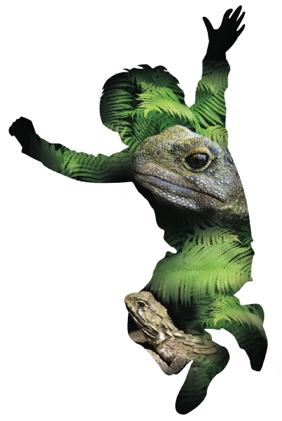
Why do we need to help?

Overview:

Lesson Number: | 1 of 5
Key Competencies: | Thinking; using language, symbols, and texts; managing self; relating to others; participating and contributing.
Unit/Topic: | Primary focus: Science  Secondary focus: Social studies  Understand how people make decisions about access to and use of resources.
Te Reo/Tikanga Māori: | Names of animals in Māori. Pre- European Māori world view.
Values: | Excellence; Innovation, inquiry, curiosity; Diversity; Equity; Community and participation; Ecological sustainability; Integrity; Respect.
Science Strand: | Nature of Science  Living world
Level: | 3
Achievement Objectives:  Nature of Science | Students will:  Understanding science:  • Appreciate that science is a way of explaining the world and that science knowledge changes over time.  Investigating in science:  - Build on prior experiences, working together to share and examine their own and others’ knowledge.
Achievement Objectives:  Living world | Students will:  Ecology  • Explain how living things are suited to their particular habitat and how they respond to environmental changes, both natural and human induced.
Lesson Objective: | Students will be able to identify the factors both natural and human that affect the unique biodiversity that we have in New Zealand.

Resources in folder:

- Examples of photographs of New Zealand fauna and introduced pest species which can be printed and laminated for use in class.
- Pre/post assessment test of knowledge, with marking rubric.
- Vocabulary list in English and Māori (see Te Tikanga lesson).

Resources online

Essential resources:
- https://www.youtube.com/watch?v=dt5I_v_tkNg how to set up an iNaturalist or NatureWatchNZ account.
- https://www.youtube.com/watch?v=2K4pIuSPNpM how to use the iNaturalist or NatureWatchNZ account to make observations.
- https://prezi.com/nt88y5rxtnze/how-to-make-your-school-a-nw-place/ how to make your school a ‘place’ on iNaturalist or NatureWatchNZ.
- https://prezi.com/87qusejflekl/a-plan-to-bring-endemic-and-native-birds-to-wellington-schools/ a tool for introducing the concept of biodiversity.
Additional resources:
- EDGE classification
http://www.edgeofexistence.org/edgeucation/default.php KS4 Science: EDGE Methods Resource Pack.
- ‘Plant me instead’ booklet http://www.doc.govt.nz/about-us/science-publications/conservation-publications/native-plants/plant-me-instead/
- Five Minute bird counts
http://www.wildaboutnz.co.nz/2010/12/5-minute-bird-counts/
- http://youngbirdersnz.wix.com/youngbirdersnz a birding website set up by young people for young people.
- http://nzbirdsonline.org.nz/
- http://www.doc.govt.nz/conservation/native-animals
- http://www.doc.govt.nz/about-us/science-publications/conservation-publications/nz-threat-classification-system/

Resources to set up:

- Print and laminate photographs of New Zealand fauna introduced pest species.
- Set up a log-in name for the class at www.iNaturalist.org (follow the log-in instructions on the home page).
- iPads or tablets with pre-installed iNaturalist app (both iOS and Android apps are available).
- Pest and trap props.
You can use the following presentation as a tool for introducing the concept of biodiversity: https://prezi.com/87qusejflekl/a-plan-to-bring-endemic-and-native-birds-to-wellington-schools/
The first component of the presentation is about inspiring the students by exploring a special place (ZEALANDIA, Kaitoke, Wellington Zoo etc.).
You can also use your local school as your special place. By surveying the flora and fauna present, then thinking about what could be done to improve biodiversity and protect the species present, students will gain a sense of kaitiakitanga.
Becoming a ‘place’ on NatureWatchNZ/iNaturalist
Using NatureWatchNZ or iNaturalist and Google Earth, it is possible to set up your school (and include your local community if you wish) as a ‘place’, which can also be displayed on the Google map. The benefits of making your school a ‘place’ are:
- All observations that anyone makes in the area are collected and logged for your ‘place’.
- Data is gathered and can be analysed easily for your ‘place’.
- Various filters and add-ons can help to give clarity and ease of access to data.
- Other schools can view and compare your place to theirs. This helps to extend the sense of online community for your students and a sense of working with others for a common goal.
A crucial element for this success of this programme is to inform parents of the action the school is taking. Sending a letter home to parents explaining about tracking and trapping is important prior to any actual work being done. It also can outline what they can start to do at home and what their children may bring home (e.g. tracking tunnels). This letter can also include how to use the tracking tunnels and how to log their observations to the ZEALANDIA WWF Outreach project on iNaturalist.
Lesson Structure:

Introduction and overview 10min
Give a quick overview of the unit. Use the titles of each of the five sessions and discuss what they could mean. It is important to highlight the ‘inspire, investigate, instigate and evaluate’ model. These concepts are at the heart of any conservation education programme.
It is important for the students to see the connection between ‘learning about’ something and being able to take action and make a real world difference.
You will see these key themes of investigate, instigate and evaluate coming through the lesson plans. Explain that you will:
- Use our project in iNaturalist to log observations of species found around your school.
- Use the bird count and bird identification sheets to survey your school. (optional).
Theme and content 40min
Start off by introducing the pre-test and explaining the importance of it for gathering information about the class’ prior knowledge.

This pre and post-test is to evaluate the shift in knowledge over the five sessions. This activity can be done individually/pairs or in groups.

Run through the key vocabulary in the test so that everyone understands what is being asked. Allow about 20 mins for the test.

Follow this by a group learning session. Split class into groups of three. Allocate each group an endemic animal. Show them how to research their animal using the ‘Explore’ resources on the NatureWatchNZ/iNaturalist site.
Each group will have 20 minutes to explore this unique New Zealand animal. They will present to the class about their animal with key facts on large A3 paper or some other feedback method such as Prezi or PowerPoint. In their groups, the students will answer “why is it important to protect our animal?” The content and the way they wish to use the information is up to them.
There is also a tradable NZ bird game ‘Survival’ which you can print and set up.
This is a fun way for students to learn about what bird species we have in New Zealand and why we need to protect them.
Wrap 10min:
To finish the session, using a large screen, show your students the iNaturalist website and an example of a class who has used iNaturalist to log their conservation action.
http://iNaturalist.org/observations/room25kns
http://iNaturalist.org/observations/stteresasroom6
http://iNaturalist.org./observations/makaraschool
If you have already set up an iNaturalist log in and can put this on a screen, log in with your class and explore how it works. You may like to ask for a species to search. A great way to engage parents in iNaturalist is to send your class iNaturalist page home as a hyperlink.

Points for Next Session:

Evaluation:

Points to Improve:

© 1986 Panda Symbol WWF – World Wide Fund For Nature (Formerly World Wildlife Fund)
® “WWF” is a WWF Registered Trademark

