ACTIVITY: Developing observation skills in younger students

Activity idea

In this activity, students carefully observe an object then make an observational drawing.

By the end of this activity, students should be able to:
- make oral and written observations
- deepen their observation skills through drawing.

Introduction/background notes
What you need
What to do
Extension ideas

Introduction/background

Observation is fundamental to science. It is a skill that improves with practice and knowledge. Students learn to observe more scientifically when:
- observations are prompted by appropriate questioning
- observations are connected with growing background knowledge on the subject or object under observation
- they are given the opportunity to share, discuss and debate observations.

This activity will help build observation skills using an object from a classroom science table or other item of interest. Students first work together to observe and discuss the object, using the activity What do we see?, then learn how to do an observational drawing.

Drawing is a meaningful way to practise and enhance observation skills and can be introduced to students at a very young age.

Observational drawing tips

When introducing observational drawing, start with a simple object – for example, a leaf rather than an entire flower – and add complexity as students gain experience. Use graphite pencils for the first few drawings as this helps to keep the focus on detail and removes the distractions of colour. Finally, use real objects rather than photographs. This allows students to view the object from different perspectives.

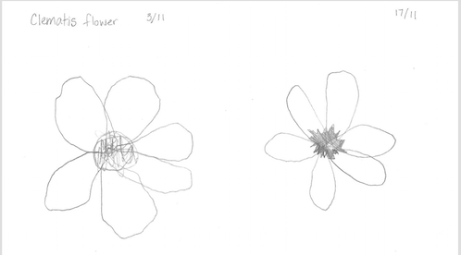
Like other skills, observational drawing improves with practice. The level of detail is likely to grow as students gain additional background knowledge about the object.

Keep a supply of drawing paper, pencils and interesting objects on the classroom science table. Encourage students who finish their printing, story writing or other tasks to engage in scientific drawing as a meaningful, quiet activity.

Additional resources

The articles Observation and science and The role of observation in science provide background information for teachers.

What you need

- Items to observe – enough for each group/table of students
- Pencils
- Paper
- Flip chart or other large piece of paper

What to do

- Choose a simple item to observe. Ideally, have a number of the same items to spread among small groups of students.

- Use the What do we see? activity format, which directs students to work together to make careful observations. Modify the activity for very young students. Adults or students from buddy classes can record the written observations.

- Introduce observational drawing. Use the flip chart to model a drawing and discuss the process as you draw. Begin by drawing the object’s basic form or shape.

- Ask the students to suggest features or details to add. If the students mention colour, model how shading is used to differentiate colour in black and white drawings. Add a title and the date.

- Give students the opportunity to make their own observational drawings. Encourage patience – detailed drawings require time and effort.

- Choose a few drawings and place them side by side. Provide feedback.

- Place one or two drawings alongside the object on a science table or other display area.

- Practise making observational drawings. Choose drawings to make a timeline for the classroom, showing how skills and observations have improved with practice.

Extension ideas

- Encourage students to add labels to their drawings.
- Show the students how to draw the object from different perspectives – side view, top view and so on.

