ACTIVITY: What do we see?

Activity idea

In this activity, students work together to make careful observations.

By the end of this activity, students should be able to:
- explain what an observation is
- record and discuss their observations.

Introduction/background notes
What you need
What to do
Discussion questions
Extension idea

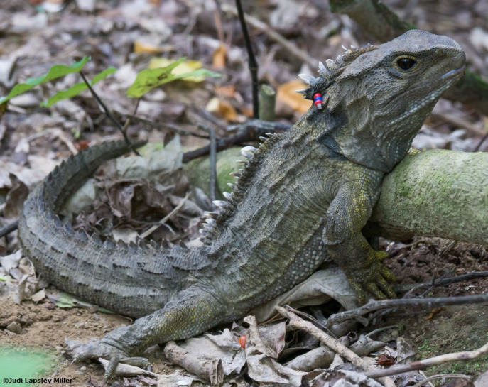
Introduction/background

This activity engages students in a literacy task in a science context, focusing on observation as a skill. Students can complete the task in a co-operative or competitive way.

Observation is key to the investigative process.
The science capability Gather and interpret data states “Learners make careful observations…” and “Science knowledge is based on data derived from direct, or indirect, observations of the natural physical world….”

Eberbach and Crowley (2009) suggest that we can help our students to observe more scientifically and make appropriate inferences if:
- their observations are connected with drawing on and increasing background knowledge related to the subject or object or their observation
- they are given the opportunity to share, discuss and debate their observations with others
- their observations are guided by appropriate prompt questions
- they have the opportunity to create and revise their own recording or notational system.

This activity may be adapted in a variety of other ways to suit your programme, depending on context/topic, resource materials, age of the students, prior knowledge and competency andexperience of students doing co-operative tasks. You can also use a video, object or experience in lieu of the photo.

Supporting the differences between observation and inference
It is important to note that students often need support when differentiating between observations and inferences. The science capability Gather and interpret data states “an inference is a conclusion you draw from observations – the meaning you make from observations. Understanding the difference is an important step towards being scientifically literate.” An observation that may be made from the activity photo is that there appear to be coloured beads attached to the back of the creature’s neck. An inference is that this tuatara has tracking gear attached to it.

Additional observation resources
There are many ways to incorporate observation activities into your programmes. There is a range of other activities on the Science Learning Hub that engage students in observational tasks, for example Observing earthworms and Observation: learning to see.

There are also several articles that provide background information for teachers working with students, for example Observation and science and The role of observation in science.

What you need

- A photo – the image of the tuatara above can be displayed online or the photo below copied and distributed, one per team
- Piece of paper and two pens or a whiteboard with two markers per team

What to do

- Put students in teams. Pairs work best for this, although groups of 3 are also OK.

- Provide each student with a pen/pencil (or marker) and each team with a piece of paper (or small whiteboard).

- Provide each team with a copy of the same photo or display the photo on a screen that all the students can easily see.

- Give the teams 2 minutes to study the photo.

- Ask each team to write down all the observations they can, one at a time, taking turns and without speaking. (Teacher keeps time: 3 minutes is a good length of time.)

- After 3 minutes, ask the teams to put their pens down and tally the observations they made. Record that total.

- Ask the teams to spend another 2 minutes discussing their observations and adding any more they can come up with. Record the new total.

- As a class, record the observations on the class board. The teams share their observations one at a time, until they have no more observations to record. As each observation is shared, any team who also recorded that observation crosses it out.

- Use the opportunity to introduce the idea of observations differing from inferences. Have students identify any inferences, and note these on the board.

- There are two winners here – if you choose to make it a competition:
- The pair with the most observations overall.
- The pair with the highest number of unique observations.

Discussion questions

- How did you make your observations?
- What other tools might have made your observing easier?
- Why do you think different teams made different observations?
- Did it make a difference when you were able to talk to your team-mate? Why/Why not?
- Were some of your observations actually inferences?
- What do you think you learned doing this activity?

Extension idea

Use prompting questions to elicit ideas about inference versus observation. Ask the students to repeat the activity, making deliberate inferences after research and/or discussion.

