ACTIVITY: Building homes for tree wētā

Activity idea

In this activity, students consider the life requirements and natural habitat of tree wētā and design a house to meet some of these needs.

By the end of this activity, students should be able to:
- name three or more requirements wētā need to stay alive
- identify the area(s) on the school grounds that would make the most suitable wētā habitat
- design a house that meets some of the life requirements of tree wētā.

Introduction/background notes
What you need
What to do
Student handout: Design a wētā house

Introduction/background

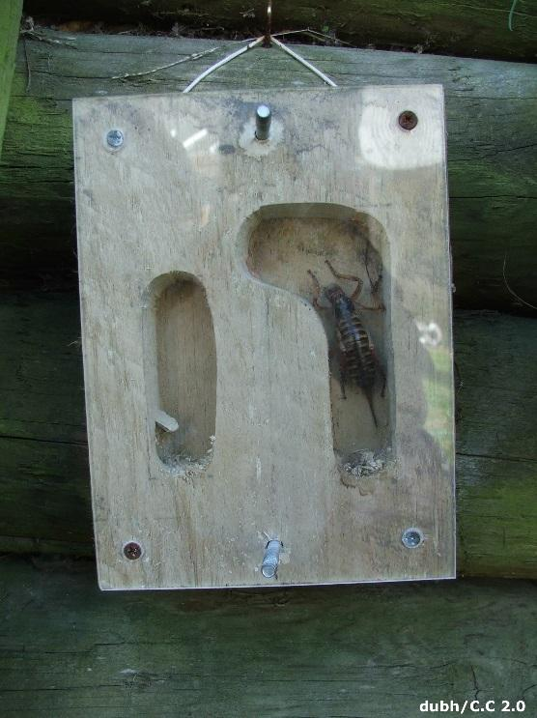
The wētā is an insect people love to hate. Tree wētā have some pretty intimidating defence mechanisms – including hissing, biting, scratching and waving their hind legs – but it’s safe to say that they are more afraid of humans than we should be of them! If going for a wētā hunt at dusk isn’t your thing, consider building a wētā house. They protect wētā from predators and are a gentle, non-invasive way to observe wētā during the day.

Wētā are elusive, nocturnal creatures. As their name implies, tree wētā live in holes in trees – often in holes created by other creatures. They also live under stones or in fallen logs. Tree wētā are omnivores, feeding mostly on leaves, but they do eat flowers, fruit and other insects.

Designing a wētā house is a practical way for students to consider the life processes and habitat of tree wētā. The designs can be simple or elaborate, but there are a few standard requirements. House entrances should be narrow – about 15–18 mm to keep out predators – and the houses should be positioned in shady areas close to food sources.

Before beginning the project, consider the degree of effort and expense you wish to put into building the wētā house. Designs range widely in complexity and cost.

The simplest design uses bamboo or flax flower stems, wire, a saw and a drill. Watch the YouTube video How to build a wētā motel or view the Kiwi Conservation Club wētā house instruction sheet.

The Department of Conservation has plans for both intermediate and multi-unit wētā houses.

Predator Free NZ also has links to numerous types of wētā and insect houses.

The Department of Conservation reports that, in a bush setting, wētā move in within 3 months. After a year, there are about four wētā in each house. Other insects, such as beetles, spiders or cockroaches, may occupy the houses instead of wētā.

What you need

- Lengths of bamboo or flax stems, small willow or pine logs
- Wire
- Tools – saw, drill, chisel (optional) and router (optional)
- Perspex or other plastic sheeting (optional)
- Student handout: Design a wētā house

What to do

- Read the articles Wētā and, if appropriate, Wētā poo and DNA with students. Watch the short ‘Meet the Locals’ video Suburban Backyard. Discuss what makes up a desirable wētā habitat (food sources and protection from direct sunlight and predators).

- Walk through the school grounds or other local area to determine where tree wētā are likely to live.

- Ask students to research different types of wētā houses.

- Discuss:
- Why do people build wētā houses?
- What are the merits of the various designs?
- How do the houses replicate natural tree wētā habitats?
- What features are likely to make the house appealing to wētā?
- How long might it take for wētā to find and colonise the wētā house?
- How many wētā do you think may occupy it?
- Do you think other creatures might occupy it instead?

- Ask students to complete the handout Design a wētā house using their own designs. (The handout is a Word document – alter it to meet student needs.)

- Construct houses for the school grounds or other nearby areas.

- Monitor the houses over several months to observe how the occupation and/or occupants change.

Student handout: Design a wētā house

I think tree wētā need these things to live:

This is my wētā house design:

I will place the wētā house in this location:

I chose this design because:

My wētā house will make a good wētā habitat because:

Materials I will need to make this wētā house:

My predictions about how this house will be used:

