Activity: A comparison of home-made marinades

In this experiment, students measure and compare the protein-digesting activity of five fruits or vegetables commonly used in marinades. This would suit years 9–12 and needs to be left overnight.

By the end of this activity, students should be able to:
- identify the presence of enzymes in a range of fruit and vegetables
- better understand the function of enzymes.

Introduction/background
What you need
What to do
Extension activity

Introduction/background

Homemade marinades sometimes contain fruits such as papaya, mango, pineapple and kiwifruit. These ingredients all contain enzymes called proteases that break down the large meat proteins. This tenderises the meat, making it less chewy and easier to eat. In this experiment, students can determine which ingredients are best at breaking down proteins and are likely to make the best marinades.

Gelatin is a protein. It is the ingredient in jelly that makes it set. Gelatin will be used as a model protein in this experiment.

Before doing this experiment, it will be helpful for students to have a basic understanding of the function and uses of enzymes. Consider reading the articles Enzymes in washing powders, Fruit enzymes tenderise meat and Fruit enzyme uses.

What you need

- Jelly crystals
- The freshly squeezed juice of four fruits or vegetables that are found in marinades (for example, mango, kiwifruit, papaya, pineapple, lime, tomato, apple)
- 10 test tubes (or an ice block tray)
- Boiling water
- Measuring cup
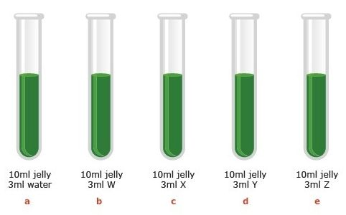
- Fridge
- Pipette

What to do

- Make up the jelly according to instructions.

- Pour 10 ml jelly into each test tube.

- Add 3 ml liquid to each of the test tubes as shown in the diagram, where W, X, Y and Z are the four selected marinade juices.

- Place in the fridge overnight.

- Check to see which jelly-fruit mixtures have set. Record your observations.

Results

Liquid added | Jelly set? (Yes/No) | Protease present in liquid? (Yes/No)
- Water
- W
- X
- Y
- Z

Note: Jelly mixtures that do no set are evidence of the presence and activity of proteases.

Conclusions

- Which of the fruit/vegetables tested would make the best meat tenderisers?

Extension activity

Design an experiment to investigate the effect that temperature has on protease enzyme activity.

