ACTIVITY: Muscle dissection

Activity idea

In this activity, students compare red and white muscle flesh and relate this to muscle function and look at muscle by dissecting a chicken thigh and leg.

By the end of this activity, students should be able to:
- discuss the colour of muscle and how it is related to muscle function
- locate and describe the various tissues and structures of the leg and thigh of a chicken
- use some of the specialised vocabulary related to anatomy
- discuss some of the similarities between the chicken leg and thigh and the human leg.

Introduction/background notes
What you need
What to do
Student handout: Muscle dissection

Introduction/background

A chicken leg and thigh are similar in construction to the human leg. In this dissection, students will locate and describe the various tissues and structures of the leg and thigh of a chicken. Refer to the articles Muscle types and Muscle structure – muscles under the microscope for more information about muscle.

Health and safety
Before conducting this experiment, please check your school’s health and safety guidelines. Handling uncooked chicken products does carry the risk of contracting bacterial infections like salmonella and campylobacter. Appropriate safety procedures must be adhered to.

What you need

- Access to the article Muscle structure – muscles under the microscope
- Small pieces of beef steak, chicken thigh, chicken breast or white fish – alternatively, use images from the internet
- Disposable gloves
- Copies of the student handout Muscle dissection
- Chicken leg with thigh
- Blunt and sharp dissecting probes
- Scalpel
- Forceps
- Dissecting pan
- Scissors
- Plastic bag with tie-wrap
- Antibacterial hand soap
- Antibacterial spray for surfaces
- Paper towels

What to do

- Discuss the health and safety procedures involved with this activity.
- Wear gloves.
- Don’t do any ‘hand to mouth’ activities (putting a pen in your mouth, chewing gum)
- Wash your hands at the end of the dissection with plenty of antibacterial soap and hot water.
- Dry your hands thoroughly afterwards.
- Wipe surfaces with antibacterial spray.

- Discuss the article Muscle structure – muscles under the microscope with the students. Discuss the Type I and II muscles and how they differ in structure, function and colour.

- Ask students to examine a small piece of different types of meat (muscle). Alternatively, display images from the internet.
- Discuss the colour of each these muscles and relate the colour to the structure of the muscle and the function of the muscle.
- What broad generalisation can the students draw between the colour of a muscle and the function it performs?

- Hand out copies of the student handout Muscle dissection and distribute the materials required.

- Work through the dissection with the students.

- Supervise disposal of the chicken pieces and clean up of the students’ hands and work spaces.

Student handout: Muscle dissection

A chicken leg and thigh are similar in construction to the human leg. In this dissection, you will locate and describe the various tissues and structures of the leg and thigh of a chicken.

Safety
- Wear gloves.
- Don’t do any ‘hand to mouth’ activities (putting a pen in your mouth, chewing gum)
- Wash your hands at the end of the dissection with plenty of antibacterial soap and hot water.
- Dry your hands thoroughly afterwards.
- Wipe surfaces with antibacterial spray.

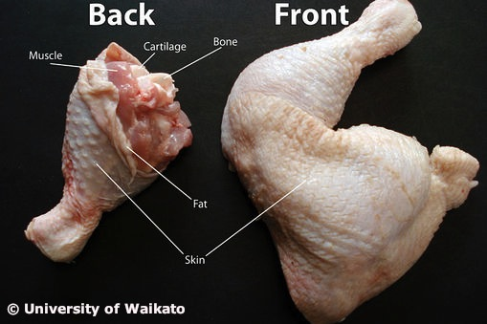

What to do

- Put on the disposable gloves.

- Place the chicken leg quarter on a dissecting tray.

- Take a look at your chicken leg. Which leg are you examining – right or left?

- Find the following parts in your chicken leg quarter:
- The lower leg of the chicken is called the drumstick. It is the equivalent of the lower leg of the human and includes the bones called the tibia (the fat one) and fibula (the skinny one).
- The upper leg of the chicken is called the thigh, just as it is in humans. Its bone is the femur.
- The bones above the thigh are part of the hip and backbone of the chicken.

- Look at the skin (epithelial tissue). The little dimples (goose bumps) show where feathers were attached to the skin.

CAUTION: Scalpels are very sharp. Use extreme care. Only cut downwards and away from your body.

- Carefully remove the skin by pulling it down and off the end of the lower leg. You can cut it off if it is too difficult to remove, but do not cut any muscle fibre.

- The yellowish-white material under the skin is fat. Is there more fat in the thigh or the leg?

- Now that the skin and fat are off, you can see the muscle – the ‘meat’. Muscles work in bundles. Examine the muscle and separate the bundles of muscles with your fingers. Begin the dissection by inserting your thumb into the muscle of the lower leg. You will need to push quite hard through the shiny lining (called fascia) that is over the muscle, but it will give way at the natural separations between the muscle bundles. Continue separating the muscle into bundles by forcing your thumb and fingers through the muscle until you are able to see several separate bundles.

- At both ends of the muscles, you will see the strong, white cords, called tendons. These hold the muscle to the bones.

- Carefully remove all the muscles with the scalpel. Look closely for blood vessels. These are deep within the muscle tissue. Arteries are generally thicker than veins. Follow the artery as far as you can and locate as many branches as possible.

- Also look for nerves. Nerves are generally thin, threadlike white strands found between the muscle and the nearest bone.

- Using the dissection scissors, cut across the tendons that join the muscles to the bones. Be careful not to cut any ligaments that attach bone to bone.

- Bend the specimen at the joints. Find the joint that is a hinge joint like our knee.

- Rotate the femur in all directions to see that that this joint is a ball and socket joint like our hip.

- Take a look at the bones. Look at the shapes of the ends of the bones and how they fit together. The bones can move in one direction but not in any other – like a door on a door hinge. This is a hinge joint.

- Break one bone in half. (Take care with the sharp edges of the bone.) Inside you will see the soft red marrow. This is where blood cells are made.

- Dispose of the chicken in a plastic bag. Secure the bag with a twist tie.

- Make sure to clean up and wash your hands thoroughly with plenty of antibacterial soap and water. Wipe down all surrounding surfaces.

