ACTIVITY: Measuring grip strength

Activity idea

In this activity, students examine and graph data for a sample of people tested for grip strength when the wrist is held at different angles.

By the end of this activity, students should be able to:
- investigate the effect of wrist position on grip strength
- interpret and graph data.

Introduction/background notes
What you need
What to do
Extension idea
Student handout: Grip strength for three positions of the hand
Grip strength for three positions of the hand – answers

Introduction/background

When we talk about the strength of muscles, we are describing the maximum force a muscle can exert. This force is measured in newtons. The article Muscle performance discusses the concepts of strength, power and endurance.

In this activity, students investigate grip strength and how it is affected by wrist position. As the wrist moves from flexion to extension, the wrist muscles lengthen. As the muscle lengthens, the number of cross bridges that interact increases. An increase in number of cross bridges interacting leads to an increase in muscle tension, so there is a greater grip force exerted.

Students use data taken from 10 people who recorded their grip strength using a bulldog clip meter. The positions in which their strength was measured were flexion (wrist bent forward), extension (wrist straight) and hyper-extension (wrist bent back). The 10 people who carried out these measurements were all adults – 8 right handed and 2 left handed, 5 males and 5 females.

What you need

- Access to the article Muscle performance
- Copies of the student handout Grip strength for three positions of the hand
- Bulldog clips or clothes pegs

What to do

- Discuss muscle strength as described in the article Muscle performance.

- Hand out copies of the student handout Grip strength for three positions of the hand and discuss the three wrist positions displayed in the images. Pass out bulldog clips or clothes pegs for students to practise with to gain a better understanding of the wrist positions.

- Have students work through the handout and discuss the results – see Grip strength for three positions of the hand – answers.

Extension idea

- Provide large bulldog clips, bamboo skewers, ice block sticks, tape, cardboard and felts to students. Ask them to view the images and make their own bulldog clip meters. Students then use these meters to collect their own data on grip strength and wrist positions.

Student handout: Grip strength for three positions of the hand

 | 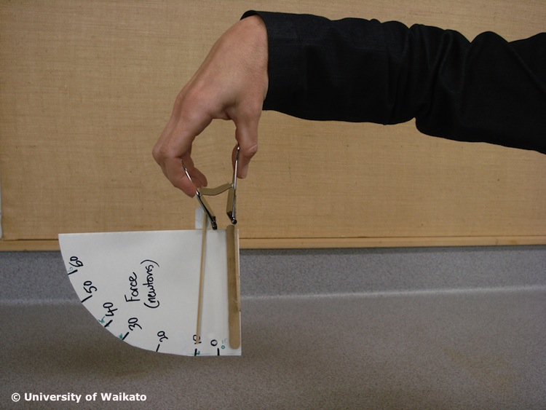 | 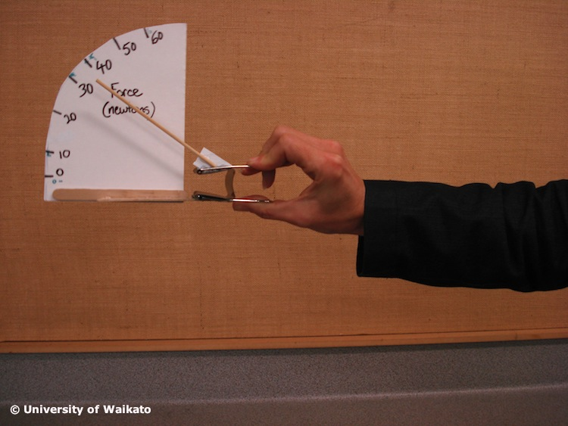 | 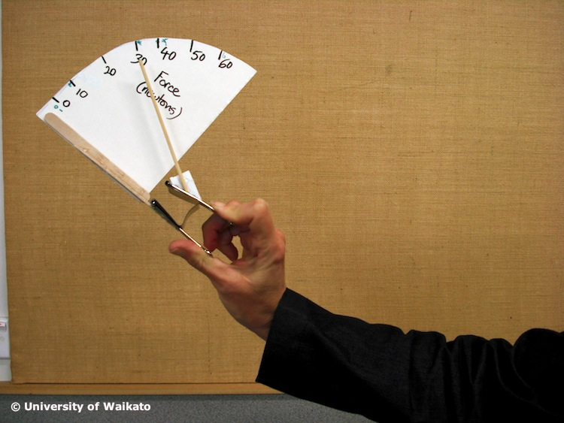
 | Flexion | Extension | Hyper-extension
Person | Force (newtons)
1 | 30 | 55 | 40
2 | 30 | 55 | 40
3 | 20 | 25 | 18
4 | 30 | 60 | 30
5 | 30 | 50 | 37.5
6 | 35 | 40 | 27.5
7 | 40 | 50 | 35
8 | 40 | 60 | 50
9 | 27 | 35 | 25
10 | 30 | 65 | 40

- Draw a bar graph showing the relationship between grip strength and hand position for each person.

- Average the forces for the 10 people in each of the three hand positions and graph these values.

- Which person has the strongest hand?

- Which wrist position provides the strongest grip?

- What is the general trend between the three values for each person?

Are there any variations to this pattern?

What could cause the variations you have identified?

- Participants have used their preferred hand to carry out this activity. Predict how the measurement would change if they use their other hand. Design an experiment to test this.
Grip strength for three positions of the hand – answers

- Draw a bar graph showing the relationship between grip strength and hand position for each person.

- Average the forces for the 10 people in each of the three hand positions and graph these values.
- Which person has the strongest hand?
Taken over all the hand positions, person number 8 has the greatest strength. However, if you are just looking for maximum grip strength in any hand position, then person number 10 is strongest.

- Which wrist position provides the strongest grip?
In all cases, the extension hand position gave the strongest grip.

- What is the general trend between the three values for each person?
Looking at the graph of average grip strength in question 2, the general trend for strongest to weakest grip strength positions is: extension, hyper-extension, flexion. However this is debatable – see next answer.

Are there any variations to this pattern?
Half of the people involved had greater flexion grip strength than hyper-extension.

What could cause the variations you have identified?
The variations could be due to variations in how much people flexed or hyper-extended their hands. It might help for people to practise the hand positions before measuring their grip strength in these positions. It would also help to repeat the measurements a number of times after a short rest period to see if the results are consistent.

- Participants have used their preferred hand to carry out this activity. Predict how the measurement would change if they use their other hand. Design an experiment to test this.
We would expect their less preferred hand not to be as strong and so all the measured grip strength values should be less. Repeat the procedure but measure the less preferred hand as well. After a few minutes’ rest, repeat for both hands to check for consistent results.

