ACTIVITY: Finger marathon

Activity idea

In this activity, students investigate muscle fatigue using the action of opening and closing a clothes peg. Extension ideas include graphing, averages and further investigations into fitness and recovery times.

By the end of this activity, students should be able to:
- investigate how muscles use energy during exercise
- discuss the link between repetition and muscle fatigue
- accurately record and display the data they collect.

Introduction/background notes
What you need
What to do
Extension ideas
Student handout: Fast fingers

Introduction/background

The aim of this activity is to demonstrate muscle fatigue. In the early stage of this activity, the cells are using energy generated from aerobic respiration (using oxygen and releasing carbon dioxide). The muscle fibres that carry out this oxygen-involving respiration are called slow twitch muscle fibres.

After a while, oxygen can’t be delivered fast enough to these muscle fibres and fast-twitch muscle fibres are recruited, which are able to release energy through anaerobic respiration (respiration that doesn’t need oxygen). The downside of this reaction is that less energy is produced and the waste product is lactic acid. When lactic acid accumulates in the muscle, it interferes with muscle contraction – students become aware of a ‘burn’ as lactic acid builds up.

In the recovery stage (when students are having a rest), oxygen is restored to the muscles and the lactic acid is removed from the muscles cells by the blood.

Most people don’t exhaust their supply of energy because muscular fatigue and pain usually cause them to stop their activity. Marathon runners may push beyond pain and sometimes they collapse because there is no more energy to keep their muscles moving.

What you need

- Access to the articles Energy for exercise and Marathon versus sprint
- Spring-operated plastic clothes pegs
- Stopwatch or cell phone for timing
- Copies of the student handout Fast fingers

What to do

- Review the articles Energy for exercise and Marathon versus sprint for either your own or students’ understanding.

- Organise the students into pairs and give them copies of the student handout Fast fingers.

- Have the students carry out the activity, then discuss the results:
- Do the graphs show any difference in the number of squeezes students were able to do? (Younger students may like to use individual bar graphs or stem and leaf graphs.)
- Ask students to describe the feeling in their finger muscles during the different stages.

Extension ideas

- Using their graphs, students predict the interval (in blocks of 30 seconds) when they would no longer be able to squeeze the clothes peg, then carry out an experiment to test this prediction. Record the class results and average the results at each 30 s interval. Students then add the average class results to their individual graphs and compare their individual results with the average.

- Design an experiment to answer one of the following questions:
- Is there a difference between the writing hand and the non-writing hand?
- How long a period of rest do finger muscles need before individual students can repeat the experiment and get the same results as their first trial?
- Is there a gender difference in finger muscle fatigue?
- Do the fittest students in the class also have the fittest fingers?
- Do the musicians in the class have the fittest fingers?

Student handout: Fast fingers
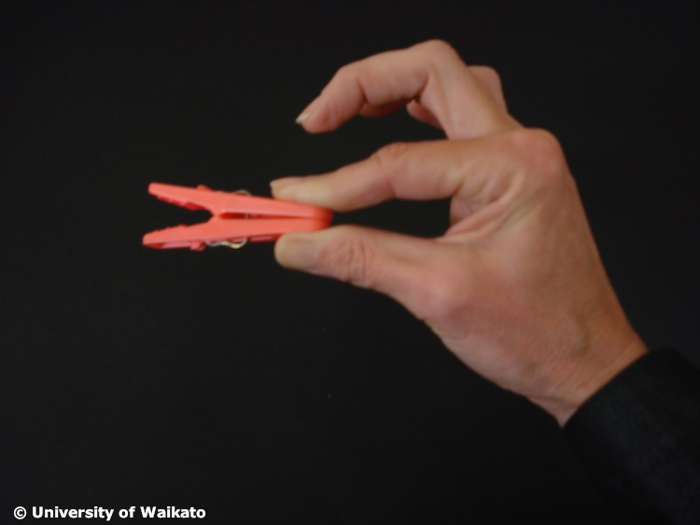
- Work in pairs. One of you will open/close the peg and one will keep the time, then you will change roles.

- Hold the clothes peg comfortably with the thumb and forefinger of the hand you write with.

- Practise quickly opening and closing the clothes peg for a few seconds. (Make sure you open it all the way each time.)

- Your timekeeper will count the number of times you can open the clothes peg in 30-second intervals. When the timekeeper says go, open and close the peg as fast as you can and count out loud each time you open the peg. Write the score here.

Person’s name | 30 seconds | 60 seconds | 90 seconds

- Switch roles and write the score above.

- Draw and plot a graph of the two sets of results.
- x axis = 30 s, 60 s, 90 s
- y axis = number of squeezes per 30 s interval

