**ACTIVITY: Precision and accuracy**

**Activity idea**

In this activity, students analyse sets of data and decide whether the measurements are precise and/or accurate.

By the end of this activity, students should be able to:

* define the terms ‘precision’ and ‘accuracy’
* use the terms ‘precision’ and ‘accuracy’ in a scientific setting
* analyse a measurement data set and judge its precision and accuracy.

Introduction/background notes

What you need

What to do

Student worksheet: Analysing data

Answers to student worksheet

**Introduction/background**

In this activity, student analyse sets of data and make statements about precision and accuracy.

When taking scientific measurements, the goals are to measure accurately and with precision.

* Accuracy indicates the closeness of the measurements to the true or accepted value.
* Precision is the closeness of the results to others obtained in exactly the same way.

**What you need**

* Copies of the student worksheet: Analysing data

**What to do**

1. Hand out copies of the student worksheet: Analysing data. Read through the first page together and discuss.
2. Have students work through the data analysis activities and discuss the results.

**Analysing data**

When taking scientific measurements, the goals are to measure accurately and with precision.

* Accuracy indicates the closeness of the measurements to the true or accepted value.
* Precision is the closeness of the results to others obtained in exactly the same way.

In this image, the bull’s-eye represents the accepted true value. Each cross represents a repeated measurement of the same quantity.

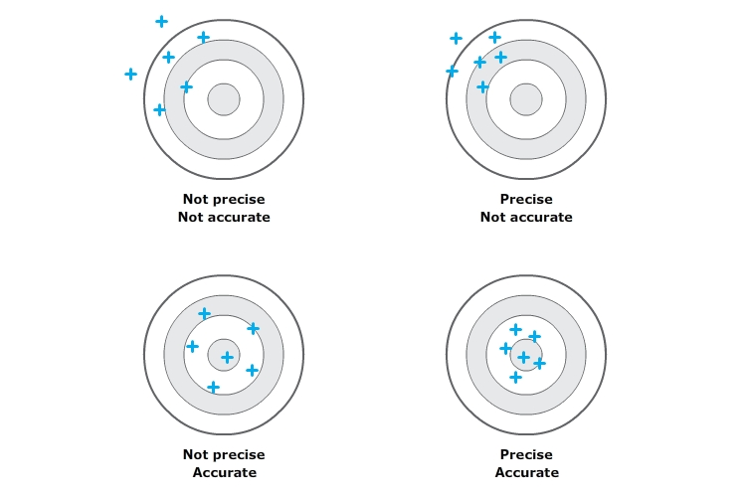

In certain situations in the laboratory, you may be measuring a quantity that has an accepted value. The difference between the measured result and the accepted value is the error in the result.

* error = measured value - accepted value
* % error = (error in measurement/accepted value) x 100

For example, the accepted value for the mass of a new golf ball is 45.93 g. A student weighs a golf ball and finds it to be 46.45 g. The % error is:

% error = (error in measurement/accepted value) x 100

= [(46.45 – 45.93)/45.93] x 100

= [0.52/45.93] x 100

= 1.13%

Rather than measuring once, it is common practice to take a number of separate measurements. This eliminates any ‘outlier’ results (results that do not fit the expected outcome) and allows for an average value to be taken.

For example, a student weighs a golf ball on five separate occasions, and the results are: 45.89 g, 45.91 g, 46.06 g, 36.98 g and 45.94 g. On looking carefully at the results, it is clear that the result ‘36.98 g’ does not fit in with the other results. It is an ‘outlier’ and is discarded.

The average mass is calculated as:

(45.89 + 45.91 + 46.06 + 45.94)/4 = 45.95 g

***Coin diameter***

A gold coin has an ‘accepted’ diameter of 28.054 mm.

Two students are asked to measure the diameter of four gold coins. Student A uses a simple plastic ruler. Student B uses a precision measuring tool called a micrometer.

|  |  |
| --- | --- |
| **Student A – plastic ruler** | **Student B – micrometer** |
| 27.9 mm  28.0 mm  27.8 mm  28.1 mm | 28.246 mm  28.244 mm  28.246 mm  28.248 mm |

1. Calculate the average value for each set of measurements

|  |  |
| --- | --- |
| **Student A – plastic ruler** | **Student B – micrometer** |
|  |  |

1. Calculate the % error for each set of measurements.

|  |  |
| --- | --- |
| **Student A – plastic ruler** | **Student B – micrometer** |
|  |  |

1. Compare the average value for each set with the accepted value:

* Which student’s data is more accurate?
* Which student’s data is more precise?

1. Compare the percentage error for each set:

* Which student’s data is more accurate?
* Which student’s data is more precise?

1. Explain any odd findings:

***Aluminium bar density***

Two students are given a small cylinder of aluminium of known mass and asked to determine its density. (The ‘accepted’ density of aluminium is 2.702 g/cm3.) Since density is mass/volume, the students need to calculate the volume of the cylinder. To do this, the height and diameter of the cylinder need to be measured.

Student A is told to use a simple plastic ruler and to make four independent measurements for each dimension. Student B is told to use a precision measuring tool called a micrometer.

|  |  |
| --- | --- |
| **Student A – plastic ruler** | **Student B – micrometer** |
| 2.2 g/cm3  2.3 g/cm3  2.7 g/cm3  2.4 g/cm3 | 2.703 g/cm3  2.701 g/cm3  2.705 g/cm3  5.811 g/cm3 |

1. Calculate the average value for each set of density values, making sure that any ‘outliers’ are not included.

|  |  |
| --- | --- |
| **Student A – plastic ruler** | **Student B – micrometer** |
|  |  |

1. Calculate the % error for each set of values.

|  |  |
| --- | --- |
| **Student A – plastic ruler** | **Student B – micrometer** |
|  |  |

1. Compare the average value for each set with the accepted value:

* Which student’s data is more accurate?
* Which student’s data is more precise?

1. Compare the percentage error for each set:

* Which student’s data is more accurate?
* Which student’s data is more precise?

1. Explain any odd findings:

**Answers to student worksheet**

***Coin diameter***

A gold coin has an ‘accepted’ diameter of 28.054 mm.

Two students are asked to measure the diameter of four gold coins. Student A uses a simple plastic ruler. Student B uses a precision measuring tool called a micrometer.

|  |  |
| --- | --- |
| **Student A – plastic ruler** | **Student B – micrometer** |
| 27.9 mm  28.0 mm  27.8 mm  28.1 mm | 28.246 mm  28.244 mm  28.246 mm  28.248 mm |

1. Calculate the average value for each set of measurements

|  |  |
| --- | --- |
| **Student A – plastic ruler** | **Student B – micrometer** |
| *27.9 + 28.0 + 27.8 +28.1*  *4*  *= 27.95*  *= 28.0 mm* | *28.246 + 28.244 + 28.246 + 28.248*  *4*  *= 28.246 mm* |

1. Calculate the % error for each set of measurements.

|  |  |
| --- | --- |
| **Student A – plastic ruler** | **Student B – micrometer** |
| *(28.0 – 28.05) x 100*  *28.05*  *= 0.18%* | *(28.246 – 28.05) x 100*  *28.05*  *= 0.86%* |

1. Compare the average value for each set with the accepted value:

* Which student’s data is more accurate?  
  *Student A, because the average value of 28.0 mm is closer to the accepted value of 28.05 mm.*
* Which student’s data is more precise?  
  *Student B, because each measured value sits closer to the average value.*

1. Compare the percentage error for each set:

* Which student’s data is more accurate?  
  *Student A, because the percentage error of 0.18% is smaller than Student B’s value of 0.86%.*
* Which student’s data is more precise?  
  *It is not possible to decide this from percentage error alone. The range of values is important in establishing precision.*

1. Explain any odd findings:  
   *Although Student B had access to a precision measuring tool, called a micrometer, it did not have high accuracy in this experiment. Perhaps it was not calibrated correctly. One would have expected Student B’s accuracy and precision to both be better than Student A.*

***Aluminium bar density***

Two students are given a small cylinder of aluminium of known mass and asked to determine its density. (The ‘accepted’ density of aluminium is 2.702 g/cm3.) Since density is mass/volume the students need to calculate the volume of the cylinder. To do this, the height and diameter of the cylinder need to be measured.

Student A is told to use a simple plastic ruler and to make four independent measurements for each dimension. Student B is told to use a precision measuring tool called a micrometer.

|  |  |
| --- | --- |
| **Student A – plastic ruler** | **Student B – micrometer** |
| 2.2 g/cm3  2.3 g/cm3  2.7 g/cm3  2.4 g/cm3 | 2.703 g/cm3  2.701 g/cm3  2.705 g/cm3  5.811 g/cm3 |

1. Calculate the average value for each set of density values, making sure that any ‘outliers’ are not included.

|  |  |
| --- | --- |
| **Student A – plastic ruler** | **Student B – micrometer** |
| *2.2 + 2.3 + 2.7 +2.4*  *4*  *= 2.4 g/cm3* | *2.703+ 2.701 + 2.705 (exclude 5.811)*  *3*  *= 2.703 g/cm3* |

1. Calculate the % error for each set of values.

|  |  |
| --- | --- |
| **Student A – plastic ruler** | **Student B – micrometer** |
| *(2.4 – 2.702) x 100*  *2.702*  *= 11.12%* | *(2.703 – 2.702) x 100*  *2.702*  *= 0.04%* |

1. Compare the average value for each set with the accepted value:

* Which student’s data is more accurate?  
  *Student B as the average is close to the accepted value.*
* Which student’s data is more precise?  
  *If the outlier result of 5.811 g/cm3 is excluded (it is very far removed from the other results), Student B. However, if all results are taken into account, Student A’s measurements would be more precise.*

1. Compare the percentage error for each set:

* Which student’s data is more accurate?  
  *The percentage error for Student A is large by comparison with the very low value for Student B, only if the outlier value of 5.811 g/cm3 is excluded.*
* Which student’s data is more precise?  
  *It is not possible to decide this from percentage error alone. The range of values is important in establishing precision.*

1. Explain any odd findings:  
   *When analysing data sets, it is important to recognise outlier results. Clearly, the value 5.811 g/cm3 is not in keeping with the other measured results and can be confidently eliminated.*