ACTIVITY: Multibeam seafloor survey

Activity idea

In this activity, students create a model seafloor and create a map of it through taking depth readings.

By the end of this activity, students should be able to:
- understand the concept of underwater mapping of the seafloor
- construct a model to simulate a seafloor and take readings
- plot the results and use these to create a map.

Introduction/background notes
What you need
What to do
Student handout: Mapping the seafloor

Introduction/background

How can we make a map of the seafloor that is kilometres below the surface of the water and that we can not see? Scientists on board the Tangaroa are tackling this challenge using technology called the multibeam. The multibeam measures the time it takes for a sound signal to reach the bottom of the seafloor and come back again, and from this, it measures the water depth.

This activity allows students to build their own seafloor and then simulate being in a boat and using the principle behind the multibeam to determine if they can create a map of the seafloor.

What you need

- Copies of the student handout: Mapping the seafloor
- Cardboard box (such as a photocopy paper box)
- Two sheets of cardboard cut the same size as the box (or two box lids)
- Polystyrene or similar foam like structure
- Dowel wood (height of the box plus 5 centimetres)
- Ruler
- Permanent marker pen
- Paper

What to do

- Hand out copies of the student handout Mapping the seafloor and assist students to gather the materials they need and conduct the activity.

- Discuss the results:
- Was there much difference in the readings between the larger and smaller grid?
- Which one do you think gives you a better reading?

Student handout: Mapping the seafloor

You have just been asked to join the IPY (International Polar Year) Ross Sea voyage on board the Tangaroa. You will be working with the multibeam team, using the beam to create a map of the seafloor. By measuring the time it takes for a signal to be sent from your boat to the seafloor and back, you will be able to determine the various depths – but first you need to build your equipment.

What you need

- Cardboard box (such as a photocopy paper box)
- Two sheets of cardboard cut the same size as the box (or two box lids)
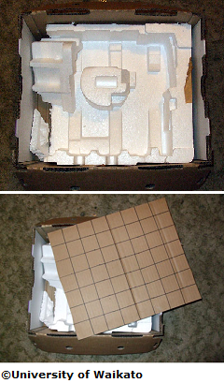
- Polystyrene or similar foam like structure
- Dowel wood (height of the box plus 5 centimetres)
- Ruler
- Permanent marker pen
- Paper

What to do

- Cut the polystyrene into several square pieces and glue them to the cardboard. Make sure that you ‘build’ an uneven seafloor with mountains.

- On one of the cardboard sheets, draw up a grid of 50 x 50 mm squares and punch holes big enough to allow the dowel to pass through in the centre of each square.

- On the second cardboard sheet, draw up a grid of 20 x 20 mm squares and again punch holes in each square.

- Prepare a template for each box lid. Use two sheets of paper and draw the two grids (50 x 50 mm and 20 x 20 mm). These templates will be used to map your readings. You may find it easier to label each box lid with a number, name or symbol.

- Using a ruler and pen, mark and label the dowel rod every 10 mm from the bottom of the rod. Each 10 mm represents the time it takes to reach the seafloor and back to the surface, with 10 mm equalling 0.7 seconds (round trip). Later, you will use this information to work out the seafloor depth – 0.7 seconds is equal to 500 m for the multibeam.
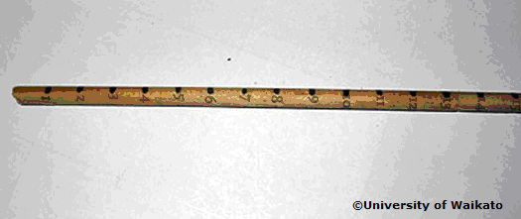
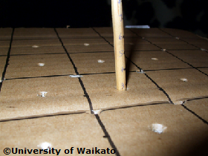
- Now that you have built your equipment, you can begin to survey the seafloor. Using the box and the larger (50 x 50 mm) cardboard grid, insert the dowel into the first hole until it hits the seafloor.

- Record the mark (representing the time) from the dowel in the data table. Repeat until all holes have been measured.

- Change box lids (cardboard grid) to the smaller 20 x 20 mm grid and again measure the seafloor depth.

- Using the data table of your recorded data, convert millimetres into seconds and into meters (10 mm dowel rod = 0.7 seconds round trip = 500 m depth to seafloor using the multibeam).

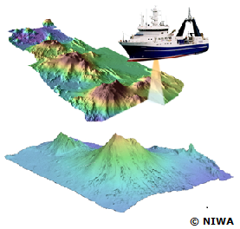
- This picture is from NIWA and shows how the multibeam is used to create maps of the seafloor. You can see that a 3D image is created with different depths appearing to be different colours. You can do something similar by making a depth colour table. It is possible to create a 2D map that gives you 3D information. A depth colour table assigns a range of depths to a colour. Looking at your data table and template, colour in each square according to the depth.

Depth (m) | Colour
0–500 | White
500–1000 | Red
1000–1500 | Blue
1500–2000 | Green

Data table

Hole  number | Rod reading (mm) | Time  (s) | Depth (m) |  | Hole  number | Rod reading (mm) | Time  (s) | Depth (m)

