ACTIVITY: Radioactive decay

Activity idea

In this activity, students model the radioactive decay process for carbon-14 by flipping coins. Each coin represents a carbon-14 atom, and if it lands tails up when flipped, this indicates radioactive decay.

By the end of this activity, students should be able to:
- appreciate the randomness of radioactive decay
- describe the concept of half-life
- explain the exponential nature of radioactive decay
- relate the radioactivity features of half-life, exponential decay and randomness to C-14 dating of artefacts.

Introduction/background notes
What you need
What to do
Student worksheet: Investigating radioactive decay
Answers to student worksheet

Introduction/background

This activity is designed to model the radioactive decay of C-14 by flipping coins. For any given radioactive isotope, the decay process is random and the rate of decay unique to that particular isotope. For example, in a 1 gram sample of carbon from living material, it has been discovered that the rate of decay of the very small amount of C-14 present (most of the carbon is present as C-12) is 14 disintegrations per minute. This means that, in each minute, any 14 of the billions of C-14 atoms present decay to form nitrogen atoms.

With C-14, the time taken for half the atoms present to decay is 5,730 years. This is known as the half-life.

If an excavated sample of plant or animal origin from an archaeological site had a measured activity of 7 disintegrations per minute (dpm), the age of the sample could be fixed at about 5,730 years ± 40 years. At 3.5 dpm, the age would be about 11,640 years and so on. After 50,000 years, the activity of C-14 in the sample would be extremely low, making it difficult to accurately date the sample.

What you need

- Copies of the student worksheet: Investigating radioactive decay
- 30 x 20c coins for each group (for a class of 10 groups) supplied by students
- 10 x 2-litre ice cream containers with lids
- Access to the interactive C-14 carbon dating process

What to do

- Divide the class into 10 groups and give each a number from 1–10.

- Hand out copies of the student worksheet: Investigating radioactive decay and discuss.

- As students conduct the experiment, create a master table on the board to record the results of the coin shaking.

- Discuss the students’ answers to the questions on the worksheet.

Investigating radioactive decay

- Your teacher will give your group a number – circle this on the results table below.

- Put 30 coins in the ice cream container and replace the lid. Shake the container for 5 seconds and carefully remove the lid. The coins will have settled out as either a head or a tail. Carefully remove all of the tails and count the number of heads that remain.

- Record your result in the table below under your group number, and record other groups’ results under their group numbers.

- Add up the results and complete the ‘Total C-14 remaining’ column.

- In the decay grid, randomly shade the appropriate number of boxes that correspond to the total column in the table above. For example, if there are 243 C-14 atoms remaining, 57 boxes should be shaded.

- Repeat steps 1–4 with the remaining coins until five shaking cycles have been completed.

Results table

Time period | Group |  |  |  |  |  |  |  |  |  | Total C-14 remaining
 | 1 | 2 | 3 | 4 | 5 | 6 | 7 | 8 | 9 | 10
0 | 30 | 30 | 30 | 30 | 30 | 30 | 30 | 30 | 30 | 30 | 300
1
2
3
4
5

Decay grid

Each clear box represents a C-14 atom. By shading a box, this indicates that C-14 has decayed to nitrogen by β particle emission.

- Plot the results table on the graph below. The vertical axis is C-14 atoms remaining and the horizontal axis is the time period. Draw a curve through the points you have plotted.

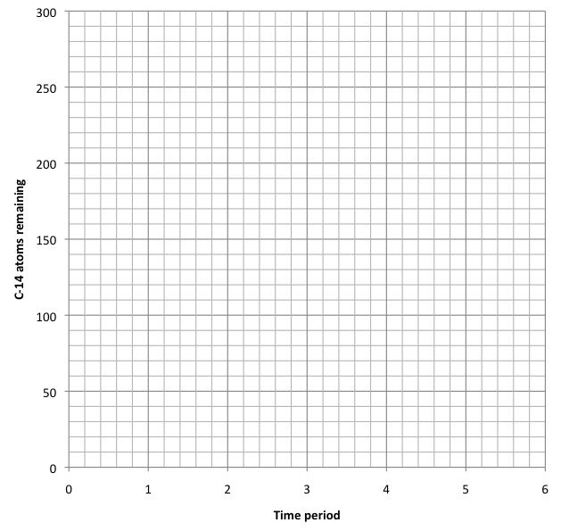

- Compare the graph you have drawn above with this graph from the NZ Research article Carbon-14 dating artefacts. What is your conclusion?

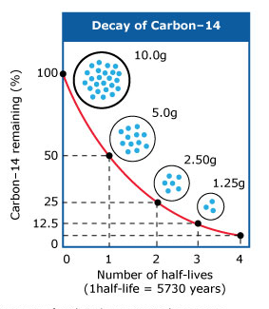
- Answer the following questions:

- How is C-14 produced in the Earth’s upper atmosphere?

- When a C-14 atom undergoes radioactive decay, what does it decay into?

- How do C-14 atoms get into living material?

- If all humans living today have radioactive C-14 present in their bodies, why do they not all suffer from radiation damage?

- Over what time range is the C-14 dating of artefacts such as bone fragments reliable?

View the C-14 carbon dating process interactive and answer the following questions.

- What must the piece of moa bone contain before it can be successfully dated using the C-14 method?

- After initial cleaning and chemical processing, the remaining bone material is subjected to a series of chemical steps. These steps are shown in the diagram below. Beneath each of the chemical formulas, write in the name of the chemical.
combustion lithium water catalyst
C + O₂ → CO₂ → Li₂C₂ → C₂H₂ → C₆H₆

- How does the scintillator chemical (butyl-BPD) that is added to the C₆H₆ work?

- Explain how the radiocarbon age established through analysis of the results from the liquid scintillation spectrometer is converted to a calendar age for the sample.

- The moa bone analysis gave a radiocarbon date of 580 years plus or minus 40 years. The calendar age was established at AD 1390–1435. What does AD stand for?

Answers to student worksheet
- How is C-14 produced in the Earth’s upper atmosphere?
Neutrons present in cosmic radiation that bombards the Earth’s upper atmosphere are captured by nitrogen atoms. This results in the production of C-14 atoms.
₇N¹⁴ + ₀n¹ → ₆C¹⁴ + ₁H¹

- When a C-14 atom undergoes radioactive decay, what does it decay into?
Radioactive decay of C-14 involves the ejection of a β particle leaving behind a nitrogen atom. ₆C¹⁴ → ₇N¹⁴ + -₁β⁰

- How do C-14 atoms get into living material?
Once formed, the C-14 reacts with oxygen to form ¹⁴CO₂. This enters the carbon cycle, circulating through the atmosphere, oceans and biosphere. Plants absorb the CO₂ and convert it to organic compounds, and in this way, C-14 becomes incorporated into living tissue. When the plant dies, C-14 will no longer be taken up. Radioactive decay still continues, however, with the C-14 activity decreasing over time.

- If all humans living today have radioactive C-14 present in their bodies, why do they not all suffer from radiation damage?
Carbon is about 23% of the body weight. Only a very, very small percentage of this carbon is made up of C-14 – about 1.6 x 10⁻⁸ g. This very small dose poses little threat to the body.

- Over what time range is the C-14 dating of artefacts such as bone fragments reliable?
Pre-1950 samples that are less than 100 years old or older than 60,000 years cannot be accurately dated. The reason for this has to do with the concentration of C-14 in living materials as well as the half-life of the C-14 isotope.

- What must the piece of moa bone contain before it can be successfully dated using the C-14 method?
Protein must be present.

- After initial cleaning and chemical processing, the remaining bone material is subjected to a series of chemical steps. These steps are shown in the diagram below. Beneath each of the chemical formulas, write in the name of the chemical.
combustion lithium water catalyst
C + O₂ → CO₂ → Li₂C₂ → C₂H₂ → C₆H₆
carbon dioxide lithium carbide acetylene benzene

- How does the scintillator chemical (butyl-BPD) that is added to the C₆H₆ work?
The C-14 atoms present in the benzene decay at a certain rate. The scintillator chemical butyl-PBD picks up each decay event and emits a tiny flash of light that the spectrometer is programmed to detect and count. In addition to the moa sample, control samples are also measured at the same time. The decay events for each sample are measured over a week.

- Explain how the radiocarbon age established through analysis of the results from the liquid scintillation spectrometer is converted to a calendar age for the sample.
The results from the liquid scintillation spectrometer are carefully analysed and provide a radiocarbon age for the sample. To obtain a calendar age for the sample, this radiocarbon age needs to be compared against samples of known age by means of a calibration curve using a specially designed computer software application. This application uses a terrestrial calibration curve to calculate the calendar age.

- The moa bone analysis gave a radiocarbon date of 580 years plus or minus 40 years. The calendar age was established at AD 1390–1435. What does AD stand for?
AD stands for ‘Anno Domini’ which translated means ‘in the year of our Lord’. It means the number of years since the time of Jesus Christ. To avoid Christian references, AD is often replaced with CE which means ‘common era’. AD 1390 can be written as CE 1390.

