ACTIVITY: Bone strength

Activity idea

In this activity, students create artificial bones made of paper to compare the relative strength of solid bones with hollow bones.

By the end of this activity, students should be able to:
- describe the main anatomical features of a large load-bearing bone like the femur
- compare the load characteristics of hollow versus solid paper ‘bones’
- explain the advantages of hollow versus solid in terms of bone construction.

Introduction/background notes
What you need
What to do
Student worksheet 1 – Basic bone anatomy – match photos with correct caption
Answers to student worksheet 1
Student worksheet 2 – Basic bone anatomy – questions
Student worksheet 3 – Bone strength – solid versus hollow

Introduction/background

Hydroxyapatite minerals help to give bone its strength. The way bones are constructed also plays a part, for example, the main load-bearing bones of the body are not solid as one might expect but hollow.

The long bones of the body like the femur (thigh bone) are hollow, and for most of the length of the bone, the cross sectional shape is a circle. This hollow cylindrical structure gives the bone added strength as well as reduction in mass.

This activity compares the relative strength of solid bones with hollow bones. Instead of using real animal bones, artificial bones are constructed with A4 paper. The load-bearing capabilities of these bones are then compared.

Before completing the hollow versus solid test, students will complete a preliminary exercise dealing with basic large bone anatomy.

What you need

- Student worksheets
- Sheets of A4 paper
- Sticky tape
- Cardboard box lid (A4 photocopy paper box lid is ideal)
- Supply of booklets or textbooks to act as weights

What to do

- Hand out copies of worksheet 1 and have students complete it. Discuss the results.

- Hand out copies of worksheet 2 and have students complete it. Discuss the results.

- Hand out copies of worksheet 3 and make sure students have the necessary materials. Have students complete the activity. Discuss the results.

Student worksheet 1 – Basic bone anatomy – match photos with correct caption

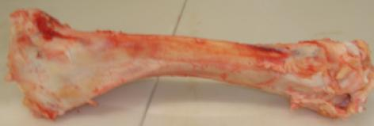 | Cross-section shows compact bone with the medullary canal at the centre.
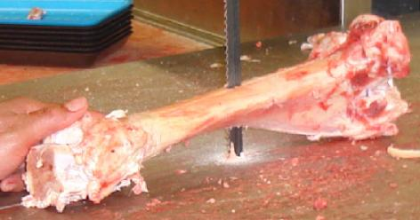 | Running through the middle of the bone is a hollow section called the medullary canal. It contains yellow bone marrow rich in fat.
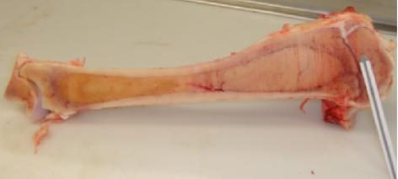 | The butcher is using a band saw to cut the cow shinbone in cross-section.
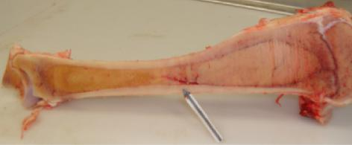 | The butcher is using a band saw to cut the cow shinbone longitudinally.
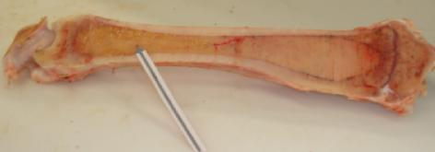 | The outer bone layer is known as compact bone. It is a thicker around the middle part of the bone than at the ends.
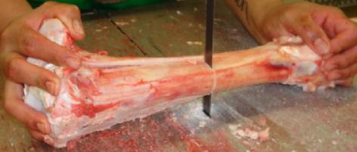 | This cow shinbone is free of any attached tissue. Each end is known as an epiphysis, and the middle section in between is called the diaphysis.
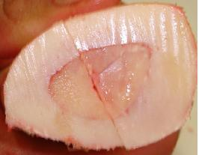 | Within the epiphysal region, there is a region of spongy bone known as cancellous bone.
Answers to student worksheet 1

This cow shinbone is free of any attached tissue. Each end is known as an epiphysis, and the middle section in between is called the diaphysis.
The butcher is using a band saw to cut the cow shinbone longitudinally.
Within the epiphysal region, there is a region of spongy bone known as cancellous bone.
The outer bone layer is known as compact bone. It is a thicker around the middle part of the bone than at the ends.
Running through the middle of the bone is a hollow section called the medullary canal. It contains yellow bone marrow rich in fat.
The butcher is using a band saw to cut the cow shinbone in cross-section.
Cross-section shows compact bone with the medullary canal at the centre.
Student worksheet 2 – Basic bone anatomy – questions

- The terms longitudinal and cross-section are frequently used in the field of anatomy. With reference to the cow shinbone photos, explain clearly what these terms mean.

- What is the difference between cancellous bone and compact bone?

- Where is the epiphysal region of the bone located?

- Where is the medullary canal located and what is its main function?

- The main shaft of the shinbone is hollow. Can you think of a reason for this?

- Read the Science Ideas and Concepts article ‘Bone and tooth minerals’ paying particular attention to the bone structure diagram given. Describe in simple terms what compact bone is made up of.
Student worksheet 3 – Bone strength – solid versus hollow

- Roll up a sheet of A4 paper (short side to short side) into a hollow cylinder of 2.5cm diameter. Tape the roll top and bottom to hold it in place. Make 3 more.  - Tightly fold up a sheet of A4 paper to make a solid cylinder (5 folds, short side to short side). Tape it top and bottom to hold it in place. Make 3 more. | 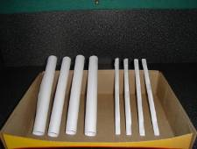
- Tape each of the cylinders into a corner of the upturned cardboard box lid.  - Stand the lid on the four hollow cylinders on a table so that they will act as legs to support the lid. | 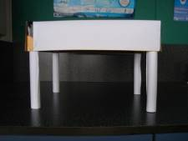
- Add weights (books, wooden blocks or 250g masses) ono the top of the lid until the legs buckle. Note the number/mass needed to buckle the legs. | 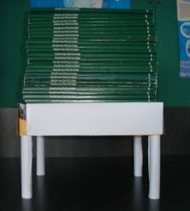
- Repeat this procedure with the solid legs.  - Compare your results. What do you conclude? Can you think of a possible explanation for the result you obtained? | 