ACTIVITY: Measuring the specific gravity of quartz

Activity idea

In this activity, students measure the specific gravity of a sample of the mineral quartz – another physical property of minerals that can be used in mineral identification.

By the end of this activity, students should be able to:
- explain the meaning of the term specific gravity
- calculate the specific gravity of a mineral sample from selected data
- recognise how specific gravity can vary from one mineral sample to another
- relate physical properties such as specific gravity as an aid in the identification of minerals.

Introduction/background notes
What you need
What to do
Discussion questions
Extension ideas
Student worksheet

Introduction/background

In this activity, the specific gravity of quartz – one of the minerals present in granite – is determined. This is then compared to other granite minerals like mica, plagioclase feldspar and orthoclase feldspar along with gold and iron pyrites (fool’s gold).

The specific gravity of a substance is the ratio of its density to the density of a reference material, which is normally taken to be water. The density of a substance is its mass per unit volume. For example, with water, a mass of 1,000g of water has a volume of 1 litre or 1,000cm³. Its density is therefore 1g/cm³.

Specific gravity has no units. For example, if a substance has a specific gravity of 10, it means that the substance is 10 times denser than water.

What you need

- Small sample of quartz
- Small samples of the minerals mica, plagioclase feldspar and orthoclase feldspar (and, if available, iron pyrites and gold)
- Spring balance 0–500g
- Large bowl or glass trough
- Light string
- Copies of the student worksheet

What to do

- Make sure each student has samples of quartz, the necessary equipment and a copy of the student worksheet.

- Discuss the concept of specific gravity.

- After step 5 of the student worksheet, discuss the students’ findings. (The specific gravity of quartz is 2.65.)

- Hand out samples of the other minerals. After step 7 of the student worksheet, discuss the students’ findings.

Discussion questions

- Iron pyrites is known as ‘fool’s gold’ because of its similar appearance to gold. Imagine when tramping in a rocky area of New Zealand you come across a gold-coloured rocky material. How could you tell if it was gold? What follow up tests in a school laboratory could you do to confirm your opinion?
- How would the specific gravity of gold-bearing quartz rock like that found at the Waihī gold mine in the North Island compare with pure quartz found elsewhere?

Extension ideas

- There are many other applications in which specific gravity can be used. Find out about any two of these and explain reasoning behind the use.
- Is the solid silver dinner service your parents inherited from a close relation indeed solid silver? Could it just be common electroplated nickel silver? Using the science ideas from this activity, design an experiment that would enable you to determine an answer to this question.
Student worksheet – Specific gravity of quartz

The specific gravity of a substance is the ratio of its density to the density of a reference material, which is normally taken to be water.

Specific gravity has no units. For example, if a substance has a specific gravity of 10, it means that the substance is 10 times denser than water.

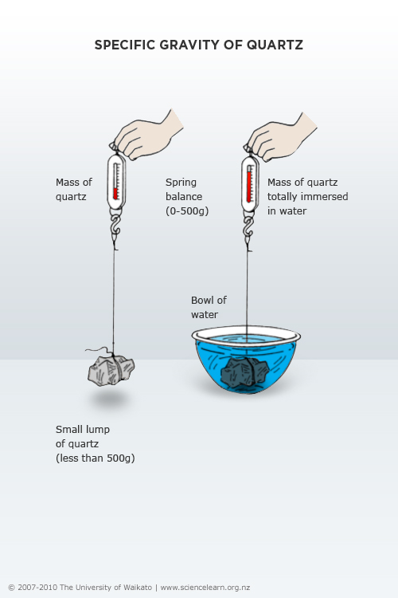

- Attach a length of string to the quartz sample.
- Suspend the quartz from a spring balance and determine the mass of the quartz.
- Lower the suspended quartz into a bowl of tap water making sure that the quartz is completely submerged and not touching the bottom or sides of the bowl.
- Determine the mass of the quartz submerged in tap water
- Calculate the specific gravity (SG) of the quartz by applying the following formula:
SG = mass of quartz in air/(mass of quartz in air – mass of quartz in water)

Mass of quartz in air |  | grams
Mass of quartz in water |  | grams
Difference in mass (mass of quartz in air – mass of quartz in water) |  | grams
Specific gravity (mass of quartz/difference in mass)

- Compare the specific gravity of quartz with those for mica, plagioclase feldspar and orthoclase feldspar as well as iron pyrites and gold.

Mineral name | Specific gravity
Quartz
Mica | 2.88
Plagioclase | 2.6–2.8
Orthoclase | 2.6
Iron pyrites (fool’s gold) | 5.0
Gold | 19.3

- Inspect similar sized samples of mica, plagioclase feldspar and orthoclase feldspar as well as gold and iron pyrites (if available) and note how heavy/light they feel compared to quartz.

