ACTIVITY: Seeing the invisible

Activity idea

In this activity, students collect and record data and use it to create 2D and 3D images of an unseen surface. They will then understand some of the processes involved in mapping the unknown.

By the end of this activity, students should be able to:
- use a probe to scan data points of a hidden surface
- create a data sheet for the hidden surface
- use the data to create 2D and 3D images of the hidden surface
- briefly explain how nanotechnologists use tools to create images of things at the nanoscale.

Introduction/background notes
What you need
What to do
Discussion questions
Student handout: Mapping a mystery box

Introduction/background

Nanotechnologists face some of the same problems as people trying to map the surface of Venus – they can’t see what they are mapping. Astronomers can’t see the surface of Venus because it is permanently hidden below cloud. Nanotechnologists can’t see nanoparticles because they are so small. Each group of scientists has had to develop tools to ‘see’ their subject from a distance – a concept called remote sensing.

Nanotechnologists have a variety of tools they can use to create an image of things at the nanoscale, including electron microscopes and scanning probe microscopes.

The activity is analogous to the workings of an atomic force microscope. In this type of microscope, a probe with a very narrow tip, often just one atom wide, is dragged across the surface of material being studied. The mechanical force between the probe and the surface is measured. A computer is used to translate the data into images of the surface at the atomic level. In a similar way, students use a probe to ‘scan’ rows of data points on a hidden surface. They then create a 2D image, a physical 3D image and, if a suitable spreadsheet is available, a computer generated 3D image.

What you need

- Previously prepared mystery boxes for each small group of students
- Copies of the student handout: Mapping a mystery box
- Materials for physical models e.g. mini marshmallows, Lego

What to do
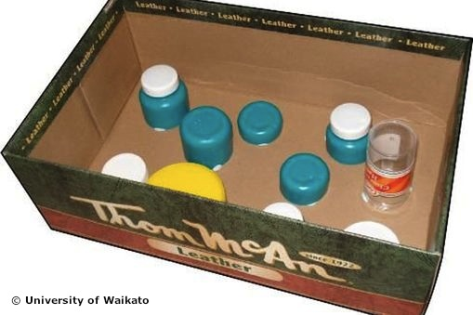
Preparation before class
- Before the lesson, make up some ‘mystery boxes’. These need to contain a ‘landscape’ or surface with high and low points that the students will try to map without being able to see. Shoe boxes are a good size and have a lid. Make the landscape out of material that is not easily pierced by wooden kebab skewers. The example shown uses cut up plastic bottles, though you may prefer to create a landscape with less abrupt boundaries between highs and lows.

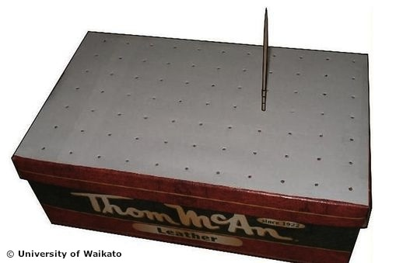
- Tape the lid on the box. This means that students will not be able to ‘cheat’ and look inside the box, but it also means that they will not be able to check their results against the contents. Not knowing if they are ‘right’ may be frustrating, but it is the reality of remote sensing. How much can you rely on the image you create? How can you increase accuracy (for example, more points on grid)? Of course, the lids can be removed for checking if you prefer.

- Attach paper with a regular grid marked on it, then punch a grid of small holes with a nail. The grid in the example shown uses points 3 cm apart. The holes should be just big enough to fit a wooden kebab skewer through.

- Prepare a wooden kebab skewer for each box, marked at intervals of 1 cm.

- An alternative to preparing the boxes yourself would be to get the students to do it, if you have time in class. Each small group of students could prepare a mystery box for another group.

In class

- Give the students copies of the handout: Mapping a mystery box and get them to complete the experiment

- After collecting and transforming data, students should be able to build a physical model of the hidden surface, perhaps using mini marshmallows, Lego blocks or similar, and pile up the objects they are using at points on a grid that corresponds to the grid on the box.

- Encourage students to discuss how reliable their models might be. How could you make them more accurate?

Discussion questions

The whole point of remote sensing like this is that you can’t see if you have got it ‘right’. You can’t see the actual surface of Venus, you can’t actually see atoms.

- How do you know how close your models are to the actual contents?
- How sure are you of your results?
- What could you do to make your measurements more accurate?

At this point, you might let the students look inside the box.
Student handout: Mapping a mystery box

This activity will help you explore how scientists carry out remote sensing – mapping something that they cannot see.

Astronomers might use radar to map the surface of Venus, hidden below permanent cloud. Nanoscientists might use tiny probes one atom wide to measure the structure of atoms.

You have been given a sealed box. Inside is a surface that you need map.

- Draw up a data sheet for the box – you will need the same number of rows and columns as the arrangement of holes in the lid of the box.

- Data needs to be collected systematically, in effect scanning the inside of the box row by row. Start in one corner. Push the skewer through a hole until it touches the surface inside.

- Hold the skewer with fingers at the point where it emerges from the lid. Pull the skewer out and record the height to the nearest centimetre.

- Carry on until the grid has been completed.

Example of a completed data sheet

12 | 12 | 12 | 12 | 12 | 11 | 12
12 | 12 | 4 | 4 | 11 | 11 | 12
12 | 7 | 12 | 12 | 12 | 12 | 12
12 | 12 | 12 | 10 | 12 | 8 | 12
12 | 12 | 12 | 12 | 12 | 12 | 12
12 | 10 | 12 | 12 | 12 | 12 | 12
12 | 12 | 8 | 12 | 9 | 9 | 9
12 | 12 | 7 | 12 | 9 | 9 | 9
12 | 8 | 12 | 12 | 12 | 12 | 12
12 | 6 | 12 | 12 | 11 | 12 | 12
12 | 12 | 12 | 12 | 12 | 12 | 12

Handling the data

- What you have measured is the distance from the lid to the surface at each point. How do you get the height of the surface above zero, the base of the box?

- Data has to be transformed, by subtracting the original data points from the total height of the box. This should be done by completing a second data sheet of transformed data.

Transformed data sheet based on the original data above and a box height of 12 cm

0 | 0 | 0 | 0 | 0 | 1 | 0
0 | 0 | 8 | 8 | 1 | 1 | 0
0 | 5 | 0 | 0 | 0 | 0 | 0
0 | 0 | 0 | 2 | 0 | 4 | 0
0 | 0 | 0 | 0 | 0 | 0 | 0
0 | 2 | 0 | 0 | 0 | 0 | 0
0 | 0 | 4 | 0 | 3 | 3 | 3
0 | 0 | 5 | 0 | 3 | 3 | 3
0 | 4 | 0 | 0 | 0 | 0 | 0
0 | 6 | 0 | 0 | 1 | 0 | 0
0 | 0 | 0 | 0 | 0 | 0 | 0

- You should now be starting to visualise the hidden surface.

- Colour in each cell of the transformed data so that all points of the same height are the same colour.

0 | 0 | 0 | 0 | 0 | 1 | 0
0 | 0 | 8 | 8 | 1 | 1 | 0
0 | 5 | 0 | 0 | 0 | 0 | 0
0 | 0 | 0 | 2 | 0 | 4 | 0
0 | 0 | 0 | 0 | 0 | 0 | 0
0 | 2 | 0 | 0 | 0 | 0 | 0
0 | 0 | 4 | 0 | 3 | 3 | 3
0 | 0 | 5 | 0 | 3 | 3 | 3
0 | 4 | 0 | 0 | 0 | 0 | 0
0 | 6 | 0 | 0 | 1 | 0 | 0
0 | 0 | 0 | 0 | 0 | 0 | 0

- Create a mental image of the hidden surface and share your ideas within the group.

- Now create a physical 3D model of the hidden surface. Your teacher will provide details.

- You could use a computer spreadsheet, such as Microsoft Excel, to create a 3D column graph of the hidden surface.

