ACTIVITY: Probing fridge magnets

Activity idea

In this activity, students investigate the pattern of magnetic fields on a fridge magnet. This will give them an idea of the principle behind scanning probe and magnetic force microscopes.

By the end of this activity, students should be able to:
- briefly explain how a magnetic force microscope works
- understand that the probe in a magnetic force microscope senses changes in the magnetic structure of the surface at the atomic level
- create an image of the magnetic structure of a fridge magnet.

Introduction/background notes
What you need
What to do
Student handout: Probing a fridge magnet

Introduction/background

The hidden structure of a fridge magnet can help explain how some hi-tech tools used by nanoscientists work.

The magnetic force microscope is a type of scanning probe microscope – an important new tool that allows scientists to ‘see’ things at the nanoscale. It is used for such things as studying the magnetic bits of computer hard disks as scientists try to make the bits as small as possible.

In a magnetic force microscope, a very fine probe, just one atom wide at the tip, is scanned across a sample surface. The probe senses changes in the magnetic structure of the surface at the atomic level.

You can get an idea of how this works with a simple fridge magnet.

Students cut a narrow strip (5–10 mm) from a fridge magnet, and this strip becomes the ‘probe’. The idea is to hold the probe very gently between finger and thumb, as shown in the diagram in the student handout, and drag the probe slowly across the surface of the remaining magnet, firstly from end to end, then from side to side.

The probe tip should move up and down slightly, in a regular pattern. It will only behave like this when dragged in one direction, not the other.

This is not explained in the student instructions, as they are expected to make their own observations of the probe’s behaviour.

If the probe does not behave in the way described, students could try the following:
- Change how they are holding the probe.
- Try turning the probe over. It normally works best when held as shown in the diagram– dark back of the fridge magnet facing up, dark back of the probe facing down.
- They may need to experiment with probes – strips cut from the long and short sides of the fridge magnet. Only one will work.
- If all else fails, throw the fridge magnet away and try another one!

What you need

- A rectangular fridge magnet for each student/pair of students
- Scissors
- Copies of the student handout: Probing a fridge magnet

What to do

- Give each student or pair of students a copy of the student handout Probing a fridge magnet.

- Have them carry out the experiment.

- Discuss the results.

Student handout: Probing a fridge magnet
- Cut a thin strip (5–10 mm) from the long edge of a fridge magnet. This is your ‘probe’. If the following procedure does not work, try cutting a strip from the short edge of the magnet.

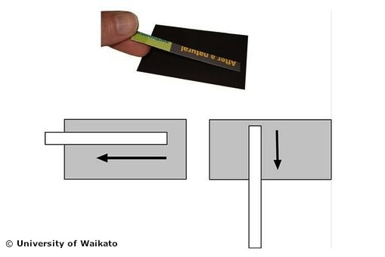
- Hold the probe very gently between finger and thumb, as shown in the picture. Drag the probe slowly across the back surface of the fridge magnet, first from end to end, then side to side, as shown in the diagram.

- You have used your probe to create an image of the magnetic structure of a fridge magnet. Based on what you feel, which of the four diagrams below best represents the layout of the magnetic field in the fridge magnet? Is the magnetic field:
A – same all over
B – in stripes running lengthwise
C – in stripes running side to side
D – in a chessboard pattern?
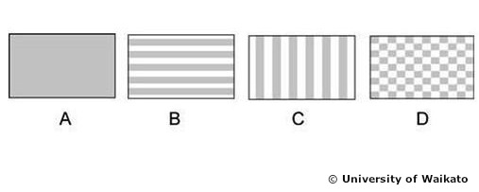
Imagine that the probe is smaller, just one atom wide at the tip. Imagine that you can move this tiny tip across the surface and can measure changes in magnetic force, atom by atom. You could build up a picture of the atoms. That’s how a magnetic force microscope works.

