ACTIVITY: Measure a molecule

Activity idea

In this activity, students create a single layer of detergent molecules on water, and use measurements and calculations to determine the length of the molecules

By the end of this activity, students should be able to:
- briefly explain the difference between hydrophilic and hydrophobic parts of a detergent molecule
- explain how to get a single layer of detergent molecules on a water surface
- use simple measurements and mathematical equations to calculate the length of a detergent molecule.

Introduction/background notes
What you need
What to do
Student handout: Calculate the length of a detergent molecule

Introduction/background

In this activity, students will use simple measurements and calculations to determine the size of detergent molecules. The activity can be done in a single period.

Molecules are very small, so it is hard to measure their size. There are specialist devices for measuring atoms and molecules, but these are not normally found in schools. There is a simple way of estimating the size of detergent molecules – if you drop a small amount of detergent onto water, it spreads out until it is only one molecule thick, and some simple measurements and maths will enable you to calculate that thickness.

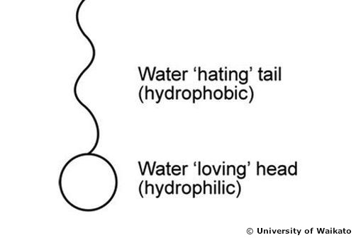
What is happening?
Detergent molecules have two distinct parts. There is a hydrophilic head, which is attracted to water, and a hydrophobic tail, to which water has a very low attraction. When you add detergent to water, the hydrophilic end is attracted to the water and dissolves in it. The hydrophobic end is not attracted by the water and ‘stands up’ on the surface. So when you add a drop of detergent to water, in effect, you get a single layer of molecules the same thickness as the length of the molecules.

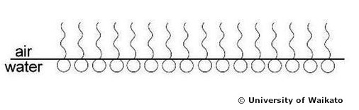

This activity can be done individually or in pairs.

What you need

- Copies of the student handout: Calculate the length of a detergent molecule
- Water
- Large, shallow containers, such as oven trays
- Liquid detergent – washing-up liquid works well, though it will need to be a fairly viscous one so that it keeps its drop shape easily for measurement, for example, Palmolive seems to work better than Sunlight – you could turn this into an investigation of its own.
- A fine powder, such as white pepper or chalk dust (e.g. from blackboard duster, if you still have one)
- Transfer pipettes or droppers
- Rulers
- Calculators

What to do

- Give each student/pair of students a copy of the handout Calculate the length of a detergent molecule.

- Demonstrate the process of sprinkling powder on the water in the tray and letting a single drop of detergent fall from the tip of the pipette onto the water.

- Explain what happens when you add the drop of detergent onto the water and how this results in a single layer of detergent molecules.

- Have each student or pair of students carry out the experiment and record their results on a table in their handouts.

- Discuss the results.

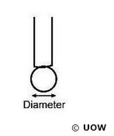
Student handout: Calculate the length of a detergent molecule

- Pick up a small amount of detergent in the pipette.

- Hold the pipette vertically and allow a single drop to form at the tip of the pipette (don’t let it fall).

- Measure the diameter of the drop, and record it in the data table below.

- Put water in the tray, and sprinkle powder in a light, even coating on the surface.

- Hold the pipette tip close to the surface and let a single drop of detergent fall onto the water near the centre of the tray. Watch what happens to the powder as the detergent spreads out until it is one molecule thick.

- Quickly measure and record the diameter of the layer of detergent.

Form of detergent | Diameter (mm) | Radius (mm)  (half diameter) | Volume (mm³) | Height (mm)
Drop (sphere)
Layer (cylinder)

- Calculations (record results in data table above)

Assume that the drop on the end of the pipette is a sphere. Use the following equation to calculate the volume of the detergent.

The volume of a sphere = 4/3 x π x (radius)³
- Multiply the radius by itself twice (e.g. 3 x 3 x 3).
- Multiply that number by 3.14 (an approximation of π).
- Multiply that number by 4.
- Divide that number by 3.

The layer of detergent on the water looks flat, but it does have some thickness – the thickness of a molecule – so you can treat the layer as a cylinder. It has the same volume as the drop you measured on the pipette.

The volume of a cylinder = height x π x (radius)²

Since you know the volume, but not the height, the equation can be rearranged to:
Height of cylinder = volume/(π x (radius)²)
- Multiply the radius of the detergent circle by itself once (e.g. 3 x 3).
- Multiply that number by 3.14.
- Divide the volume by the answer.
- Record the height of the cylinder in the data table – this is the approximate length of a detergent molecule.

