ACTIVITY: Catalyst nanoparticle shapes

Activity idea

In this activity, student use modelling clay to construct difference shapes (sphere, cube, cylinder) and calculate surface area:volume ratios with the aim of trying to develop a more efficient shape.

By the end of this activity, students should be able to:
- understand the importance of the shape of catalysts when they are in the form of nanoparticles
- explain what is meant by surface area
- use mathematical formulae to calculate surface area:volume ratios
- explain which shape is the most efficient.

Introduction/background notes
What you need
What to do
Discussion questions
Extension idea
Student handout: Investigating catalyst nanoparticle shapes

Introduction/background
When developing nanoparticles as catalysts, their shape is very important. For a certain volume of material, nanoparticles make the best catalysts when they have a large surface area. This means that plenty of atoms are available to help the reaction along.

Hydrogen could be the fuel of the future. It is already used in fuel cells for cars and other vehicles. Obtaining hydrogen from water and using hydrogen to create electricity are processes that need catalysts to make them efficient. Many materials become catalysts when they are in the form of nanoparticles, but the shape of the particles is very important. As many atoms as possible are needed to take part in the reactions.

The best materials are very expensive (much more expensive than gold), so the challenge to students as chemical engineers is to find a shape that has the largest surface area for its volume. They will do this using models and maths.

When developing a new shape, students will need to measure or estimate its surface area. One example might be a tube – with an inside surface as well as an outside one – which will have a much larger surface area than a cylinder.

This activity can be done individually or in pairs.

What you need

- Copies of the student handout: Investigating catalyst nanoparticle shapes
- Plasticine or similar modelling clay – balls about 30 mm across
- Rulers
- Callipers (useful for measuring spheres but not essential)
- Calculators
- Pieces of baking paper or similar to work on

What to do

- Review catalysts with your students using the article Chemical reactions and catalysts.

- Hand out copies of the student handout Investigating catalyst nanoparticle shapes and have the students work through the activities in the handout and record their answers in the tables provided.

- Discuss their results.

Discussion questions

- Which shape has the largest surface area:volume ratio?

- Which shape has the smallest surface area:volume ratio?

- Was your prediction about the best shape right?

- Which of the three shapes would you recommend as being best for catalyst nanoparticles? Why?

Extension idea

Using the same piece of clay, what shape can the students come up with that would have an even better surface area:volume ratio? They should record any measurements they take and their calculations.

Student handout: Investigating catalyst nanoparticle shapes

- Before you start, make a prediction: Which shape will have the largest surface area: a sphere, a cube or a cylinder?

- Roll the clay into a ball. Make it as near a regular sphere as you can. Measure the diameter of the ball and record it in the table below.

Shape | Diameter (mm) | Radius (mm) | Length (mm) | Width  (mm) | Height (mm)
Sphere
Cube
Cylinder

- Make the clay into a cube, as regular as you can. Measure the length of each side (they should all be the same) and record it in the table above.

- Roll the clay into a cylinder. Measure the diameter and length and record it in the table above.

- Calculate the volumes and surface areas and record your answers in the table below. Because you used the same piece of clay each time, the volume should be about the same. Include it in your calculations to make sure.

Shape | Surface area (mm²) | Volume (mm³) | Surface area/volume
Sphere
Cube
Cylinder

- Calculations:
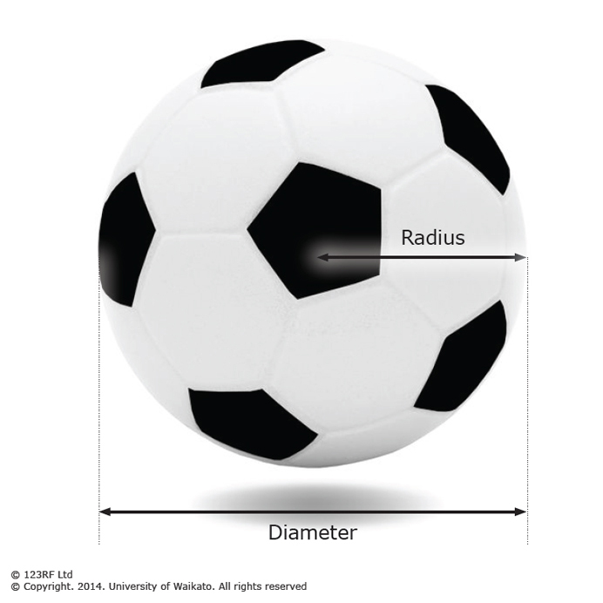
Sphere
Volume = 4/3 x π x (radius)³
- Multiply the radius by itself twice (e.g. 3 x 3 x 3). Multiply that number by 3.14 (an approximation of π).
- Multiply that number by 4.
- Divide that number by 3.

Surface area = 4 x π x (radius)²
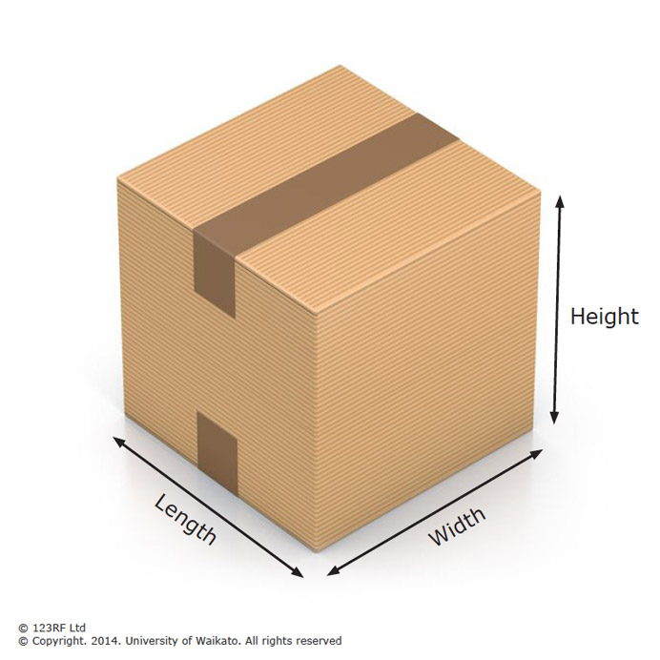
- Multiply the radius by itself once (e.g. 3 x 3).
- Multiply that number by 3.14 (an approximation of π).
- Multiply that number by 4.

Cube
Volume = length x width x height
- Multiply the length by the width.
- Multiply that number by the height.

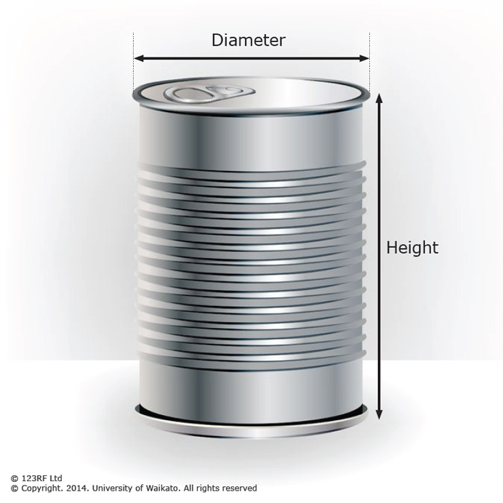
Surface area = length x width x number of sides
- Find the area of one side and multiply by 6.

Cylinder
Volume = height x π x (radius)²
- Multiply the radius of the end circle by itself once (e.g. 3 x 3).
- Multiply that number by 3.14 (an approximation of π).
- Multiply that number by the height of the cylinder.

Surface area = 2π(radius)² + 2π x radius x height
- Multiply the radius of the end circle by 6.28 (which is 2 π).
- Multiply that number by the height.
- Multiply the radius of the end circle by itself once (e.g. 3 x 3).
- Multiply that number by 6.28.
- Add together the results of steps b and d.

