ACTIVITY: Hunt the planet

Activity idea

In this activity, students explore the transit method of searching for planets. They plot graphs of light measurements from stars, searching for dimming that indicates the presence of a planet, and calculate its size.

By the end of this activity, students should be able to:
- understand the transit method for detecting extrasolar planets
- understand that, even though distant planets cannot be seen, their presence can be detected by their effect on something else
- use data to predict scientific outcomes
- work with other people to achieve a shared goal
- plot a line graph.

Introduction/background notes
What you need
What to do
Student handout: Planet detectives
Observation graph
Data sets
Student handout: How big are the star and its planet?

Introduction/background

Many planet-hunting astronomers work in teams to survey star-rich areas of sky, and when they find possible evidence of a planet, they call in others to verify and confirm their findings. In a similar way, students will make decisions about continuing to monitor their star, or switching to support teams that have spotted possible transits.

The data has been invented for this activity, though it is based on actual examples. The number of data points is a lot less than normally used, and the numbers have been rounded off to make manual graph plotting easier.

What you need

- Access to the Space Revealed article Planet hunting and video The transit method
- Copies of the student handout: Planet detectives
- Blank observation graph (one per group)
- Copied data sets for the stars being studied (You will need to copy and cut out the data sets provided below so each team only gets the correct data set for the star they are studying. For example, some teams may choose to change to stars C, D or H after data set 2. As most teams may choose to switch to star D after data set 3, sheets with several copies of star D data sets 4, 5 and 6 have been provided to reduce copying.)
- Calculators

What to do

- Review the Space Revealed article Planet hunting and video The transit method.

- Divide the class into teams – a minimum of 4 teams, a maximum of 10. Give each team a copy of the student handout Planet detectives and a blank observation graph and allot each team a star, numbered A–J. (Make sure that stars C, D and H are allocated, but don’t let the students know these are the vital ones.)

- Only hand out the data sets as described below, not all at once.

- Give each team data set 1 for their star to plot on the graph, according to the student instructions. This establishes the ‘normal’ baseline brightness of the star

- Give each team data set 2 for their star to plot on the graph. When all teams are ready, give them the opportunity to persuade other teams to switch stars if they think their data warrants it.

What the graphs should show after data set 2 has been plotted:
- Stars C, D and H show a small dip at the end of the second data set. This could be the start of a dimming event, but it is too soon to tell. Students could ask for another team to swap to their star at this stage – that’s fine, if they can persuade another team to do so. If a team does switch to another star, they should put the new letter in the next box at the top of the graph.

- Give each team data set 3 for their star to plot on the graph. When all teams are ready, give them the opportunity to persuade other teams to switch stars if they think their data warrants it.

- Give each team data set 4 for their star to plot on the graph. When all teams are ready, give them the opportunity to persuade other teams to switch stars if they think their data warrants it.

What the graphs should show after data set 4 has been plotted:
- The brightness of stars C and H returns to normal, but star D continues to dim. Students will probably assume they have found a transit event and may ask for other teams to swap to their star. Discuss how many teams should swap – confirmation of a transit is needed, but what happens if another star dims later?

- Give each team data set 5 for their star to plot on the graph. When all teams are ready, give them the opportunity to persuade another teams to switch stars if they think their data warrants it.

- Give each team data set 6 for their star to plot on the graph.

After data set 6 has been plotted, the completed graph for star D (the star with the planet) should look something like this:

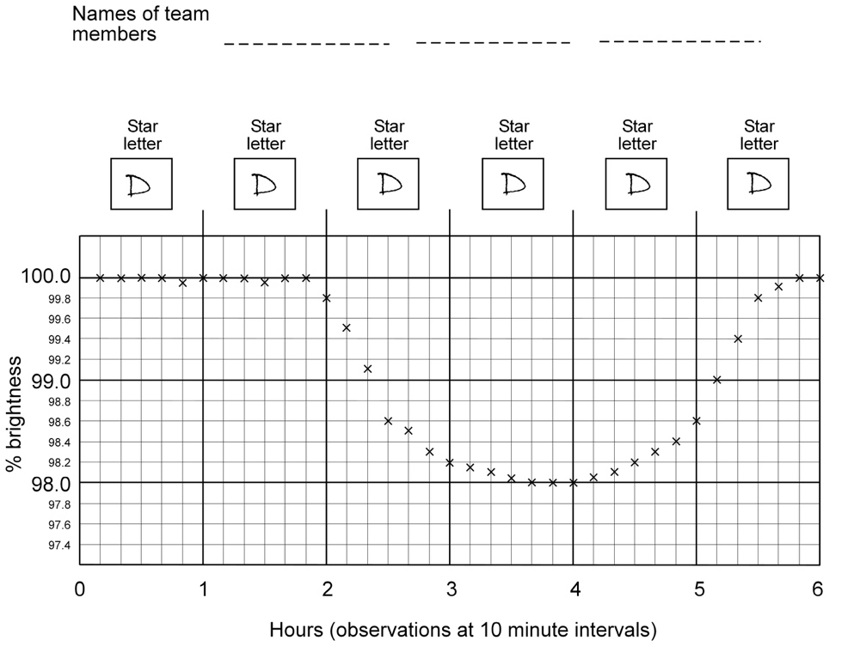

- Survey the class:
- Which teams monitored the star with the planet (star D)?
- How many teams monitored the whole transit?
- Which was the most important part of the transit to record?
- How many teams recorded it?

- You may like students to go on and calculate the size of the planet they have discovered. There are student instructions for this in the student handout: How big are the star and its planet?

If the radius of the star is 800,000 km:
- Area of star = 2,010,620,000,000 km²
- Area of planet = 40,212,400,000 km²
- Radius of planet = 113,137 km
- The planet is a lot bigger than Jupiter, which has a radius of 71,300 km.

Student handout: Planet detectives

You are a group of astronomers hoping to detect an extrasolar planet using the transit method. As a planet passes across the face of (transits) your star, the star will dim very slightly and then become bright again.

You will be working with sets of data from a telescope with a photometer attached, which measures brightness very accurately. Each data set contains brightness measured at 10 minute intervals for an hour. The data is presented as a percentage of maximum brightness.

Other teams will be studying different planets, and you will share your observations as you progress. You may need to convince the other teams to join the observations for your star.

- Fill in your names at the top of the observation graph and enter in the first box the letter of the star you are studying. Plot the information from data set 1 on the graph – this establishes the ‘normal’ baseline brightness of the star.

- Plot the information from data set 2 on the graph.
- Does your graph show the light dimming?
- Have you detected a planet orbiting your star?
- Would you like another team to switch to your star to confirm your findings? (You must have enough information to justify calling another team away from their own recording.)

- Enter the letter of the star you are studying in the next box. Plot the information from data set 3 on the graph.
- Does your graph show the light dimming?
- Have you detected a planet orbiting your star?
- Would you like another team to switch to your star to confirm your findings? (You must have enough information to justify calling another team away from their own recording.)

- Enter the letter of the star you are studying in the next box. Plot the information from data set 4 on the graph.
- Does your graph show the light dimming?
- Have you detected a planet orbiting your star?
- Would you like another team to switch to your star to confirm your findings? (You must have enough information to justify calling another team away from their own recording.)

- Enter the letter of the star you are studying in the next box. Plot the information from data set 5 on the graph.
- Have you detected a planet orbiting your star?
- Would you like another team to switch to your star to confirm your findings? (You must have enough information to justify calling another team away from their own recording.)

- Enter the letter of the star you are studying in the next box. Plot the information from data set 6 on the graph. Now you have finished your plotting, compare your graph with other teams. Which is the star with the planet orbiting it?
Student handout: How big are the star and its planet?

Astronomers already know that the star the planet is orbiting has a radius of 800,000 km. (That is a bit bigger than our Sun, which has a radius nearer 700,000 km.). Remember that stars and planets are spheres, but we see them as discs.

What is the area of the star?

Option 1:
Use the online calculator www.calculatorsoup.com/calculators/geometry-plane/circle.php:
- The units on the screen are metres, but treat them as kilometres.
- Enter the radius of the star (800,000) in the ‘r’ box and click ‘calculate’.
- In the answer box, A is ‘area’.

Option 2:
Calculate the area of the star using the formula area = π r², where π is 3.14 and r = 800,000.

What is the area of the planet?

The light went from 100% to 98.0%, so it reduced by 2%. This means that the disc of the planet covered about 2% of the disc of the star – the planet is 2% the area of the star. Use a calculator to work out what 2% of the area of the star is.

What is the radius of the planet?

You can now work out the radius of the planet.

Option 1:
Use the online calculator www.calculatorsoup.com/calculators/geometry-plane/circle.php:
- Change ‘choose a calculation’ to ‘calculate radius and circumference’.
- Enter the area of the planet and click ‘calculate’.

Option 2:
Calculate the radius of the planet using the formula r = √(area/π).

Is the extrasolar planet bigger or smaller than Jupiter?

Jupiter has a radius of 71,300 km, so is the planet you have discovered bigger or smaller?

Observation graph
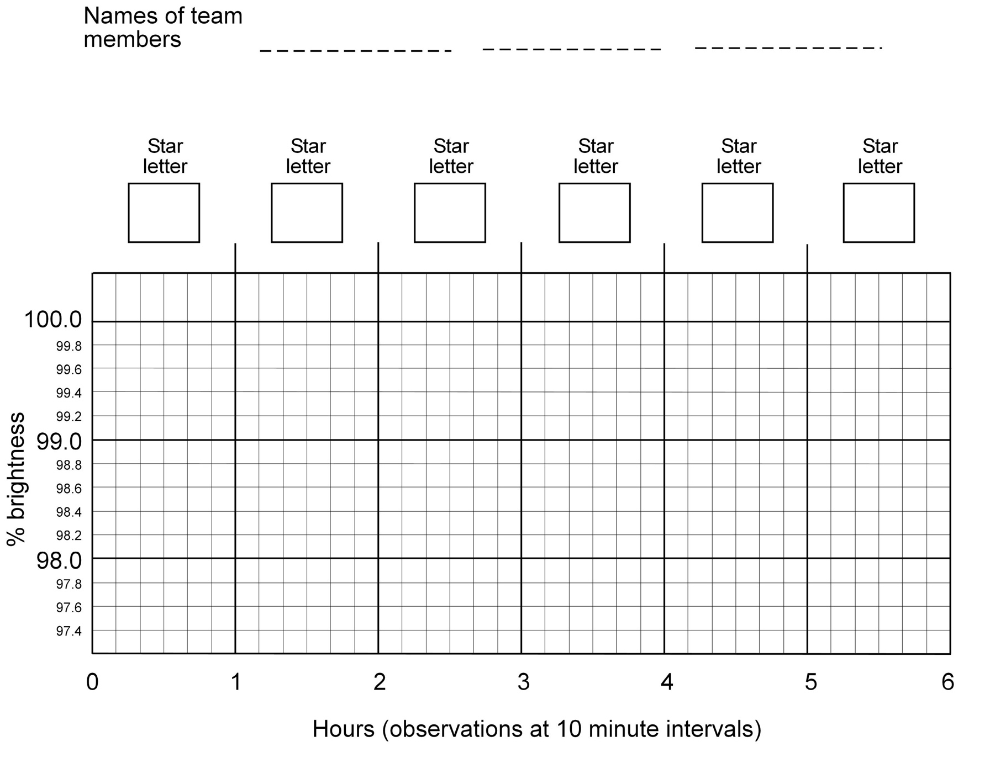
Data set 1 – stars A–J

Star A – data set 1 |  |  | Star B – data set 1 |  |  | Star C – data set 1 |  |  | Star D – data set 1 |  |  | Star E – data set 1
time | brightness (%) |  | time | brightness (%) |  | time | brightness (%) |  | time | brightness (%) |  | time | brightness (%)
10 min | 100 |  | 10 min | 100 |  | 10 min | 100 |  | 10 min | 100 |  | 10 min | 100
20 min | 100 |  | 20 min | 99.95 |  | 20 min | 100 |  | 20 min | 100 |  | 20 min | 100
30 min | 100 |  | 30 min | 100 |  | 30 min | 99.95 |  | 30 min | 100 |  | 30 min | 99.95
40 min | 99.95 |  | 40 min | 100 |  | 40 min | 99.95 |  | 40 min | 100 |  | 40 min | 100
50 min | 100 |  | 50 min | 100 |  | 50 min | 100 |  | 50 min | 99.95 |  | 50 min | 99.95
1 hr | 100 |  | 1 hr | 99.95 |  | 1 hr | 100 |  | 1 hr | 100 |  | 1 hr | 100

Star F – data set 1 |  |  | Star G – data set 1 |  |  | Star H – data set 1 |  |  | Star I – data set 1 |  |  | Star J – data set 1
time | brightness (%) |  | time | brightness (%) |  | time | brightness (%) |  | time | brightness (%) |  | time | brightness (%)
10 min | 100 |  | 10 min | 100 |  | 10 min | 100 |  | 10 min | 100 |  | 10 min | 100
20 min | 100 |  | 20 min | 99.95 |  | 20 min | 100 |  | 20 min | 100 |  | 20 min | 100
30 min | 100 |  | 30 min | 100 |  | 30 min | 99.95 |  | 30 min | 100 |  | 30 min | 99.95
40 min | 99.95 |  | 40 min | 100 |  | 40 min | 99.95 |  | 40 min | 100 |  | 40 min | 100
50 min | 100 |  | 50 min | 100 |  | 50 min | 100 |  | 50 min | 99.95 |  | 50 min | 99.95
1 hr | 100 |  | 1 hr | 99.95 |  | 1 hr | 100 |  | 1 hr | 100 |  | 1 hr | 100

Data set 2 – stars A–J

Star A – data set 2 |  |  | Star B – data set 2 |  |  | Star C – data set 2 |  |  | Star D – data set 2 |  |  | Star E – data set 2
time | brightness (%) |  | time | brightness (%) |  | time | brightness (%) |  | time | brightness (%) |  | time | brightness (%)
10 min | 100 |  | 10 min | 100 |  | 10 min | 100 |  | 10 min | 100 |  | 10 min | 100
20 min | 99.95 |  | 20 min | 100 |  | 20 min | 100 |  | 20 min | 100 |  | 20 min | 100
30 min | 100 |  | 30 min | 99.95 |  | 30 min | 99.95 |  | 30 min | 99.95 |  | 30 min | 100
40 min | 100 |  | 40 min | 99.95 |  | 40 min | 100 |  | 40 min | 100 |  | 40 min | 99.95
50 min | 100 |  | 50 min | 100 |  | 50 min | 100 |  | 50 min | 100 |  | 50 min | 100
2 hr | 99.95 |  | 2 hr | 100 |  | 2 hr | 99.8 |  | 2 hr | 99.8 |  | 2 hr | 100

Star F – data set 2 |  |  | Star G – data set 2 |  |  | Star H – data set 2 |  |  | Star I – data set 2 |  |  | Star J – data set 2
time | brightness (%) |  | time | brightness (%) |  | time | brightness (%) |  | time | brightness (%) |  | time | brightness (%)
10 min | 100 |  | 10 min | 100 |  | 10 min | 100 |  | 10 min | 100 |  | 10 min | 100
20 min | 99.95 |  | 20 min | 100 |  | 20 min | 100 |  | 20 min | 100 |  | 20 min | 100
30 min | 100 |  | 30 min | 99.95 |  | 30 min | 99.95 |  | 30 min | 100 |  | 30 min | 99.95
40 min | 100 |  | 40 min | 99.95 |  | 40 min | 100 |  | 40 min | 100 |  | 40 min | 99.95
50 min | 100 |  | 50 min | 100 |  | 50 min | 100 |  | 50 min | 99.95 |  | 50 min | 100
2 hr | 99.95 |  | 2 hr | 100 |  | 2 hr | 99.8 |  | 2 hr | 100 |  | 2 hr | 100

Data set 3 – stars A–J

Star A – data set 3 |  |  | Star B – data set 3 |  |  | Star C – data set 3 |  |  | Star D – data set 3 |  |  | Star E – data set 3
time | brightness (%) |  | time | brightness (%) |  | time | brightness (%) |  | time | brightness (%) |  | time | brightness (%)
10 min | 100 |  | 10 min | 100 |  | 10 min | 100 |  | 10 min | 99.5 |  | 10 min | 100
20 min | 100 |  | 20 min | 100 |  | 20 min | 100 |  | 20 min | 99.1 |  | 20 min | 99.95
30 min | 99.95 |  | 30 min | 100 |  | 30 min | 99.95 |  | 30 min | 98.6 |  | 30 min | 100
40 min | 99.95 |  | 40 min | 99.95 |  | 40 min | 100 |  | 40 min | 98.5 |  | 40 min | 100
50 min | 100 |  | 50 min | 100 |  | 50 min | 100 |  | 50 min | 98.3 |  | 50 min | 100
3 hr | 100 |  | 3 hr | 100 |  | 3 hr | 99.95 |  | 3 hr | 98.2 |  | 3 hr | 99.95

Star F – data set 3 |  |  | Star G – data set 3 |  |  | Star H – data set 3 |  |  | Star I – data set 3 |  |  | Star J – data set 3
time | brightness (%) |  | time | brightness (%) |  | time | brightness (%) |  | time | brightness (%) |  | time | brightness (%)
10 min | 100 |  | 10 min | 100 |  | 10 min | 100 |  | 10 min | 100 |  | 10 min | 100
20 min | 100 |  | 20 min | 100 |  | 20 min | 100 |  | 20 min | 100 |  | 20 min | 100
30 min | 99.95 |  | 30 min | 99.95 |  | 30 min | 100 |  | 30 min | 99.95 |  | 30 min | 100
40 min | 99.95 |  | 40 min | 100 |  | 40 min | 100 |  | 40 min | 99.95 |  | 40 min | 100
50 min | 100 |  | 50 min | 100 |  | 50 min | 99.95 |  | 50 min | 100 |  | 50 min | 99.95
3 hr | 100 |  | 3 hr | 99.95 |  | 3 hr | 100 |  | 3 hr | 100 |  | 3 hr | 100

Data set 4 – stars A–J

Star A – data set 4 |  |  | Star B – data set 4 |  |  | Star C – data set 4 |  |  | Star D – data set 4 |  |  | Star E – data set 4
time | brightness (%) |  | time | brightness (%) |  | time | brightness (%) |  | time | brightness (%) |  | time | brightness (%)
10 min | 100 |  | 10 min | 100 |  | 10 min | 100 |  | 10 min | 98.15 |  | 10 min | 100
20 min | 100 |  | 20 min | 100 |  | 20 min | 100 |  | 20 min | 98.10 |  | 20 min | 99.95
30 min | 99.95 |  | 30 min | 100 |  | 30 min | 100 |  | 30 min | 98.05 |  | 30 min | 100
40 min | 100 |  | 40 min | 100 |  | 40 min | 100 |  | 40 min | 98.00 |  | 40 min | 100
50 min | 100 |  | 50 min | 100 |  | 50 min | 100 |  | 50 min | 98.00 |  | 50 min | 100
4 hr | 100 |  | 4 hr | 100 |  | 4 hr | 99.95 |  | 4 hr | 98.00 |  | 4 hr | 99.95

Star F – data set 4 |  |  | Star G – data set 4 |  |  | Star H – data set 4 |  |  | Star I – data set 4 |  |  | Star J – data set 4
time | brightness (%) |  | time | brightness (%) |  | time | brightness (%) |  | time | brightness (%) |  | time | brightness (%)
10 min | 100 |  | 10 min | 100 |  | 10 min | 100 |  | 10 min | 99.95 |  | 10 min | 100
20 min | 100 |  | 20 min | 100 |  | 20 min | 100 |  | 20 min | 100 |  | 20 min | 100
30 min | 100 |  | 30 min | 99.95 |  | 30 min | 100 |  | 30 min | 100 |  | 30 min | 100
40 min | 99.95 |  | 40 min | 100 |  | 40 min | 100 |  | 40 min | 99.95 |  | 40 min | 100
50 min | 100 |  | 50 min | 99.95 |  | 50 min | 99.95 |  | 50 min | 100 |  | 50 min | 100
4 hr | 100 |  | 4 hr | 100 |  | 4 hr | 100 |  | 4 hr | 100 |  | 4 hr | 100

Data set 5 – stars A–J

Star A – data set 5 |  |  | Star B – data set 5 |  |  | Star C – data set 5 |  |  | Star D – data set 5 |  |  | Star E – data set 5
time | brightness (%) |  | time | brightness (%) |  | time | brightness (%) |  | time | brightness (%) |  | time | brightness (%)
10 min | 100 |  | 10 min | 100 |  | 10 min | 100 |  | 10 min | 98.05 |  | 10 min | 100
20 min | 100 |  | 20 min | 100 |  | 20 min | 100 |  | 20 min | 98.10 |  | 20 min | 99.95
30 min | 99.95 |  | 30 min | 100 |  | 30 min | 100 |  | 30 min | 98.2 |  | 30 min | 100
40 min | 100 |  | 40 min | 100 |  | 40 min | 100 |  | 40 min | 98.3 |  | 40 min | 100
50 min | 100 |  | 50 min | 100 |  | 50 min | 100 |  | 50 min | 98.4 |  | 50 min | 100
5 hr | 100 |  | 5 hr | 100 |  | 5 hr | 99.95 |  | 5 hr | 98.6 |  | 5 hr | 99.95

Star F – data set 5 |  |  | Star G – data set 5 |  |  | Star H – data set 5 |  |  | Star I – data set 5 |  |  | Star J – data set 5
time | brightness (%) |  | time | brightness (%) |  | time | brightness (%) |  | time | brightness (%) |  | time | brightness (%)
10 min | 100 |  | 10 min | 100 |  | 10 min | 100 |  | 10 min | 99.95 |  | 10 min | 100
20 min | 100 |  | 20 min | 100 |  | 20 min | 100 |  | 20 min | 100 |  | 20 min | 100
30 min | 100 |  | 30 min | 99.95 |  | 30 min | 100 |  | 30 min | 100 |  | 30 min | 100
40 min | 99.95 |  | 40 min | 100 |  | 40 min | 100 |  | 40 min | 99.95 |  | 40 min | 100
50 min | 100 |  | 50 min | 99.95 |  | 50 min | 99.95 |  | 50 min | 100 |  | 50 min | 100
5 hr | 100 |  | 5 hr | 100 |  | 5 hr | 100 |  | 5 hr | 100 |  | 5 hr | 100

Data set 6 – stars A–J

Star A – data set 6 |  |  | Star B – data set 6 |  |  | Star C – data set 6 |  |  | Star D – data set 6 |  |  | Star E – data set 6
time | brightness (%) |  | time | brightness (%) |  | time | brightness (%) |  | time | brightness (%) |  | time | brightness (%)
10 min | 100 |  | 10 min | 100 |  | 10 min | 100 |  | 10 min | 99.0 |  | 10 min | 100
20 min | 100 |  | 20 min | 99.95 |  | 20 min | 100 |  | 20 min | 99.4 |  | 20 min | 99.95
30 min | 100 |  | 30 min | 100 |  | 30 min | 100 |  | 30 min | 99.8 |  | 30 min | 99.95
40 min | 100 |  | 40 min | 100 |  | 40 min | 100 |  | 40 min | 99.9 |  | 40 min | 100
50 min | 99.95 |  | 50 min | 100 |  | 50 min | 99.95 |  | 50 min | 100 |  | 50 min | 100
6 hr | 100 |  | 6 hr | 100 |  | 6 hr | 100 |  | 6 hr | 100 |  | 6 hr | 100

Star F – data set 6 |  |  | Star G – data set 6 |  |  | Star H – data set 6 |  |  | Star I – data set 6 |  |  | Star J – data set 6
time | brightness (%) |  | time | brightness (%) |  | time | brightness (%) |  | time | brightness (%) |  | time | brightness (%)
10 min | 100 |  | 10 min | 100 |  | 10 min | 100 |  | 10 min | 99.95 |  | 10 min | 100
20 min | 99.95 |  | 20 min | 100 |  | 20 min | 100 |  | 20 min | 100 |  | 20 min | 99.95
30 min | 100 |  | 30 min | 100 |  | 30 min | 100 |  | 30 min | 99.95 |  | 30 min | 100
40 min | 99.95 |  | 40 min | 100 |  | 40 min | 100 |  | 40 min | 100 |  | 40 min | 100
50 min | 100 |  | 50 min | 99.95 |  | 50 min | 100 |  | 50 min | 100 |  | 50 min | 100
6 hr | 100 |  | 6 hr | 100 |  | 6 hr | 99.95 |  | 6 hr | 100 |  | 6 hr | 100

Data set 4 – star D

Star D – data set 4 |  |  | Star D – data set 4 |  |  | Star D – data set 4 |  |  | Star D – data set 4 |  |  | Star D – data set 4
time | brightness (%) |  | time | brightness (%) |  | time | brightness (%) |  | time | brightness (%) |  | time | brightness (%)
10 min | 98.15 |  | 10 min | 98.15 |  | 10 min | 98.15 |  | 10 min | 98.15 |  | 10 min | 98.15
20 min | 98.10 |  | 20 min | 98.10 |  | 20 min | 98.10 |  | 20 min | 98.10 |  | 20 min | 98.10
30 min | 98.05 |  | 30 min | 98.05 |  | 30 min | 98.05 |  | 30 min | 98.05 |  | 30 min | 98.05
40 min | 98.00 |  | 40 min | 98.00 |  | 40 min | 98.00 |  | 40 min | 98.00 |  | 40 min | 98.00
50 min | 98.00 |  | 50 min | 98.00 |  | 50 min | 98.00 |  | 50 min | 98.00 |  | 50 min | 98.00
4 hr | 98.00 |  | 4 hr | 98.00 |  | 4 hr | 98.00 |  | 4 hr | 98.00 |  | 4 hr | 98.00

Star D – data set 4 |  |  | Star D – data set 4 |  |  | Star D – data set 4 |  |  | Star D – data set 4 |  |  | Star D – data set 4
time | brightness (%) |  | time | brightness (%) |  | time | brightness (%) |  | time | brightness (%) |  | time | brightness (%)
10 min | 98.15 |  | 10 min | 98.15 |  | 10 min | 98.15 |  | 10 min | 98.15 |  | 10 min | 98.15
20 min | 98.10 |  | 20 min | 98.10 |  | 20 min | 98.10 |  | 20 min | 98.10 |  | 20 min | 98.10
30 min | 98.05 |  | 30 min | 98.05 |  | 30 min | 98.05 |  | 30 min | 98.05 |  | 30 min | 98.05
40 min | 98.00 |  | 40 min | 98.00 |  | 40 min | 98.00 |  | 40 min | 98.00 |  | 40 min | 98.00
50 min | 98.00 |  | 50 min | 98.00 |  | 50 min | 98.00 |  | 50 min | 98.00 |  | 50 min | 98.00
4 hr | 98.00 |  | 4 hr | 98.00 |  | 4 hr | 98.00 |  | 4 hr | 98.00 |  | 4 hr | 98.00

Data set 5 – star D

Star D – data set 5 |  |  | Star D – data set 5 |  |  | Star D – data set 5 |  |  | Star D – data set 5 |  |  | Star D – data set 5
time | brightness (%) |  | time | brightness (%) |  | time | brightness (%) |  | time | brightness (%) |  | time | brightness (%)
10 min | 98.05 |  | 10 min | 98.05 |  | 10 min | 98.05 |  | 10 min | 98.05 |  | 10 min | 98.05
20 min | 98.10 |  | 20 min | 98.10 |  | 20 min | 98.10 |  | 20 min | 98.10 |  | 20 min | 98.10
30 min | 98.2 |  | 30 min | 98.2 |  | 30 min | 98.2 |  | 30 min | 98.2 |  | 30 min | 98.2
40 min | 98.3 |  | 40 min | 98.3 |  | 40 min | 98.3 |  | 40 min | 98.3 |  | 40 min | 98.3
50 min | 98.4 |  | 50 min | 98.4 |  | 50 min | 98.4 |  | 50 min | 98.4 |  | 50 min | 98.4
5 hr | 98.6 |  | 5 hr | 98.6 |  | 5 hr | 98.6 |  | 5 hr | 98.6 |  | 5 hr | 98.6

Star D – data set 5 |  |  | Star D – data set 5 |  |  | Star D – data set 5 |  |  | Star D – data set 5 |  |  | Star D – data set 5
time | brightness (%) |  | time | brightness (%) |  | time | brightness (%) |  | time | brightness (%) |  | time | brightness (%)
10 min | 98.05 |  | 10 min | 98.05 |  | 10 min | 98.05 |  | 10 min | 98.05 |  | 10 min | 98.05
20 min | 98.10 |  | 20 min | 98.10 |  | 20 min | 98.10 |  | 20 min | 98.10 |  | 20 min | 98.10
30 min | 98.2 |  | 30 min | 98.2 |  | 30 min | 98.2 |  | 30 min | 98.2 |  | 30 min | 98.2
40 min | 98.3 |  | 40 min | 98.3 |  | 40 min | 98.3 |  | 40 min | 98.3 |  | 40 min | 98.3
50 min | 98.4 |  | 50 min | 98.4 |  | 50 min | 98.4 |  | 50 min | 98.4 |  | 50 min | 98.4
5 hr | 98.6 |  | 5 hr | 98.6 |  | 5 hr | 98.6 |  | 5 hr | 98.6 |  | 5 hr | 98.6

Data set 6 – star D

Star D – data set 6 |  |  | Star D – data set 6 |  |  | Star D – data set 6 |  |  | Star D – data set 6 |  |  | Star D – data set 6
time | brightness (%) |  | time | brightness (%) |  | time | brightness (%) |  | time | brightness (%) |  | time | brightness (%)
10 min | 99.0 |  | 10 min | 99.0 |  | 10 min | 99.0 |  | 10 min | 99.0 |  | 10 min | 99.0
20 min | 99.4 |  | 20 min | 99.4 |  | 20 min | 99.4 |  | 20 min | 99.4 |  | 20 min | 99.4
30 min | 99.8 |  | 30 min | 99.8 |  | 30 min | 99.8 |  | 30 min | 99.8 |  | 30 min | 99.8
40 min | 99.9 |  | 40 min | 99.9 |  | 40 min | 99.9 |  | 40 min | 99.9 |  | 40 min | 99.9
50 min | 100 |  | 50 min | 100 |  | 50 min | 100 |  | 50 min | 100 |  | 50 min | 100
6 hr | 100 |  | 6 hr | 100 |  | 6 hr | 100 |  | 6 hr | 100 |  | 6 hr | 100

Star D – data set 6 |  |  | Star D – data set 6 |  |  | Star D – data set 6 |  |  | Star D – data set 6 |  |  | Star D – data set 6
time | brightness (%) |  | time | brightness (%) |  | time | brightness (%) |  | time | brightness (%) |  | time | brightness (%)
10 min | 99.0 |  | 10 min | 99.0 |  | 10 min | 99.0 |  | 10 min | 99.0 |  | 10 min | 99.0
20 min | 99.4 |  | 20 min | 99.4 |  | 20 min | 99.4 |  | 20 min | 99.4 |  | 20 min | 99.4
30 min | 99.8 |  | 30 min | 99.8 |  | 30 min | 99.8 |  | 30 min | 99.8 |  | 30 min | 99.8
40 min | 99.9 |  | 40 min | 99.9 |  | 40 min | 99.9 |  | 40 min | 99.9 |  | 40 min | 99.9
50 min | 100 |  | 50 min | 100 |  | 50 min | 100 |  | 50 min | 100 |  | 50 min | 100
6 hr | 100 |  | 6 hr | 100 |  | 6 hr | 100 |  | 6 hr | 100 |  | 6 hr | 100

