ACTIVITY: Communicating with symbols

Activity idea

In this activity, students learn to draw a range of simple circuit diagrams, using specific symbols for electrical components that can be understood worldwide.

By the end of this activity, students should be able to:
- recognise, use and draw specific electrical symbols and diagrams.

Introduction/background notes
What you need
What to do
Extension ideas
Drawing circuits
Activity answers

Introduction/background

This activity will help students develop the way they communicate their ideas about electrical circuits using specific electrical symbols and diagrams rather than drawing actual components.

When scientists or electricians communicate with each other about electrical circuits, they use specific circuit language and symbols. These symbols were developed to stop confusion by having standard representations and are used worldwide.

Electricians, engineers and scientists would be able to construct the circuits just by ‘reading’ the symbols and circuit diagrams. Similarly, they would be able to draw the circuit diagrams of the circuits they have built or designed.

For standard symbols and diagrams used, see http://electronicsclub.info/circuitsymbols.htm and http://electronicsclub.info/circuitdiagrams.htm.

What you need

- Copies of student instructions Drawing circuits
- Copy of Activity answers

What to do

- Discuss the concept of using standard electrical circuits and diagrams and explore these using the website links provided above.

- Give each student a copy of the student instructions Drawing circuits and have them complete it.

- Compare and discuss each diagram as it is completed. All circuit diagrams need to have:
- the correct international symbol for each part
- connecting wires drawn with a ruler
- a small black circle to show if two wires are connected
- the size and units of the components, for example, 3W (watts) and 1.5V (volts)
- the positive and negative battery terminals marked.

Extension ideas

Students could build a circuit using another student’s diagram.
Drawing circuits

  - This circuit diagram of a torch is poorly drawn. Can you find at least 4 mistakes?

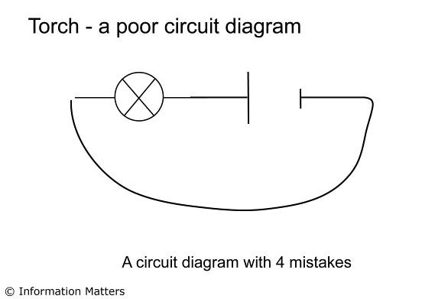

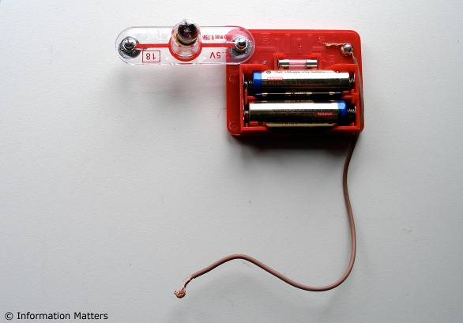

  - Draw a neat circuit diagram of a light that comes on when a door is closed.

  - Draw a neat circuit diagram of a light that comes on when a door is opened.

  - Draw a neat circuit diagram of a light that can be turned on or off regardless of whether you are at the top or bottom of the stairs. (Clue: use 2 two-way switches.)

  - The interior light of a car comes on regardless of which door opens. Draw a circuit diagram of this circuit using a light bulb, battery, wires and 4 switches.

Activity answers

- The corrections on the circuit diagram of a torch are marked in red – 4 of the following need to be identified:
- Gap in circuit in top left.
- Three connectors were not shown.
- Wire was drawn with a ruler.
- Battery terminals were not identified.
- Voltage of battery and bulb not shown.
- Wattage of bulb not shown (optional).

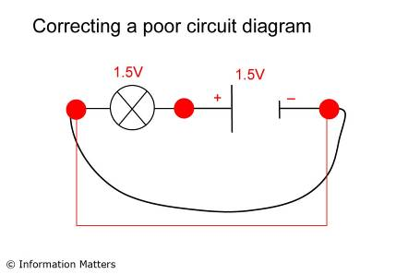

- Light that comes on when a door is closed.

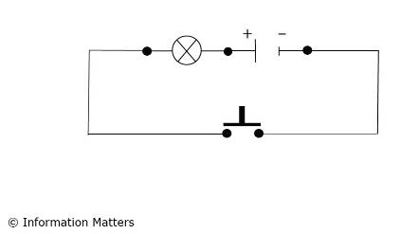

- Light that comes on when a door is opened.

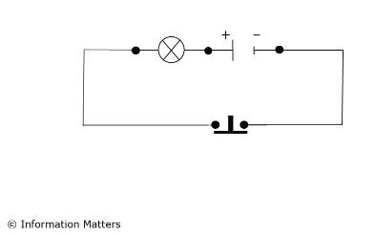

- Light that can be to be turned on or off from top or bottom of the stairs.

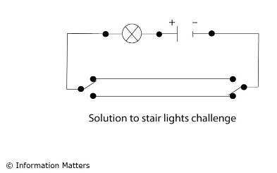

- Car door light.

