ACTIVITY: Controlling resistance

Activity idea

In this activity, students explore the concept of variable resistance by using a simple electrical circuit.

By the end of this activity, students should be able to:
- construct simple electrical circuits to explore variable resistance
- show that the flow of electric charges can be controlled and modified by changing the length of wire or strip of carbon that conducts the current.

Introduction/background notes
What you need
What to do
Discussion questions
Controlling volume and light

Introduction/background

Electrical resistance reduces the electric current in the circuit. The material that the resistor is made of, its thickness and length affect the amount of resistance in the circuit.

Controlling the resistance, which controls the current, can be very useful. Examples of resistance controllers are light switch dimmers, volume controls and speed controllers.

Controlling electricity by changing resistance is often achieved using a variable resistor, which has a knob that can be turned or a slider. Moving the knob changes the length of the resistance wire or strip of carbon in the resistor and so changes the resistance in the circuit.

Variable resistors may control other devices in a circuit, such as lights, speakers or motors.

The two most common variable resistors are those made from carbon and nichrome wire:
- The carbon-based ones are mass produced and then sorted into groups depending on the resistance they have, rather than made to a particular value. The difference in resistance is due to the length of the carbon and how many tiny cracks appear in the carbon during manufacture. Often, the carbon-based ones continue to crack with use and temperature changes, so they fail when used frequently – this is why, in some cheap equipment, the volume cannot be set properly or it crackles when adjusted.
- Variable resistors using nichrome (an alloy of nickel and chromium) wire are more reliable, but are harder to make and more expensive. The wire is wrapped around a semicircle of plastic. Nichrome wire is also used for the element that glows red in toasters and heaters. It is also used in fuses. Nichrome wire is not used in domestic light dimmers because it gets so hot.

Where there is a high resistance to electricity, most of the electrical energy is converted into heat. This is how a tungsten light bulb works – the resistance wire in it gets hot and glows.

What you need

For each group of students:
- Copies of student instructions Controlling volume and light
Making a volume control
- Soft, dark pencil (2B or greater)
- 9V battery
- Battery connector for 9V battery
- Two connecting wires
- 9V buzzer
- Paper
Making a light dimmer
- Nichrome wire
- 1.5V AA batteries
- Battery connector for AA batteries
- Two connecting wires
- 1.5V bulb

What to do

- Discuss the concept of electrical resistance in circuits.

- Divide students into groups and assist them to gather the equipment they need to construct the circuits to explore variable resistance.

- Have students complete steps 1–4 of the student instructions and discuss their findings.

- Have students complete steps 5–7 of the student instructions and discuss their findings.

Discussion questions

- What is the symbol used for a variable resistor?
- What effect does the length of the nichrome wire have on the brightness of the bulb?
- Can you explain what is happening in the circuit?
- Will this circuit work if you use wire made of other materials instead of nichrome?
- Can you think of other variables to change in the investigation? (Use the question prompt “I wonder what would happen if….?”)
Controlling volume and light

Making a ‘cracked carbon’ volume control  - Using a soft, dark pencil (2B or greater), create the shape shown in the picture. A pencil lead contains carbon and carbon is a good conductor of electricity. This resistor works really well if a lot of carbon (or pencil lead) is used.  - Make a slider in the same way, by drawing a thick strip, then turn it over so the two carbon surfaces are together.  - Construct the circuit using a 9V battery, two wires and a buzzer (9V). Attach the wires as shown in the picture.  - Rotate the slider around the wider circle, which should vary the sound volume created by the buzzer. Smaller batteries and bulbs may also be controlled using this device. | 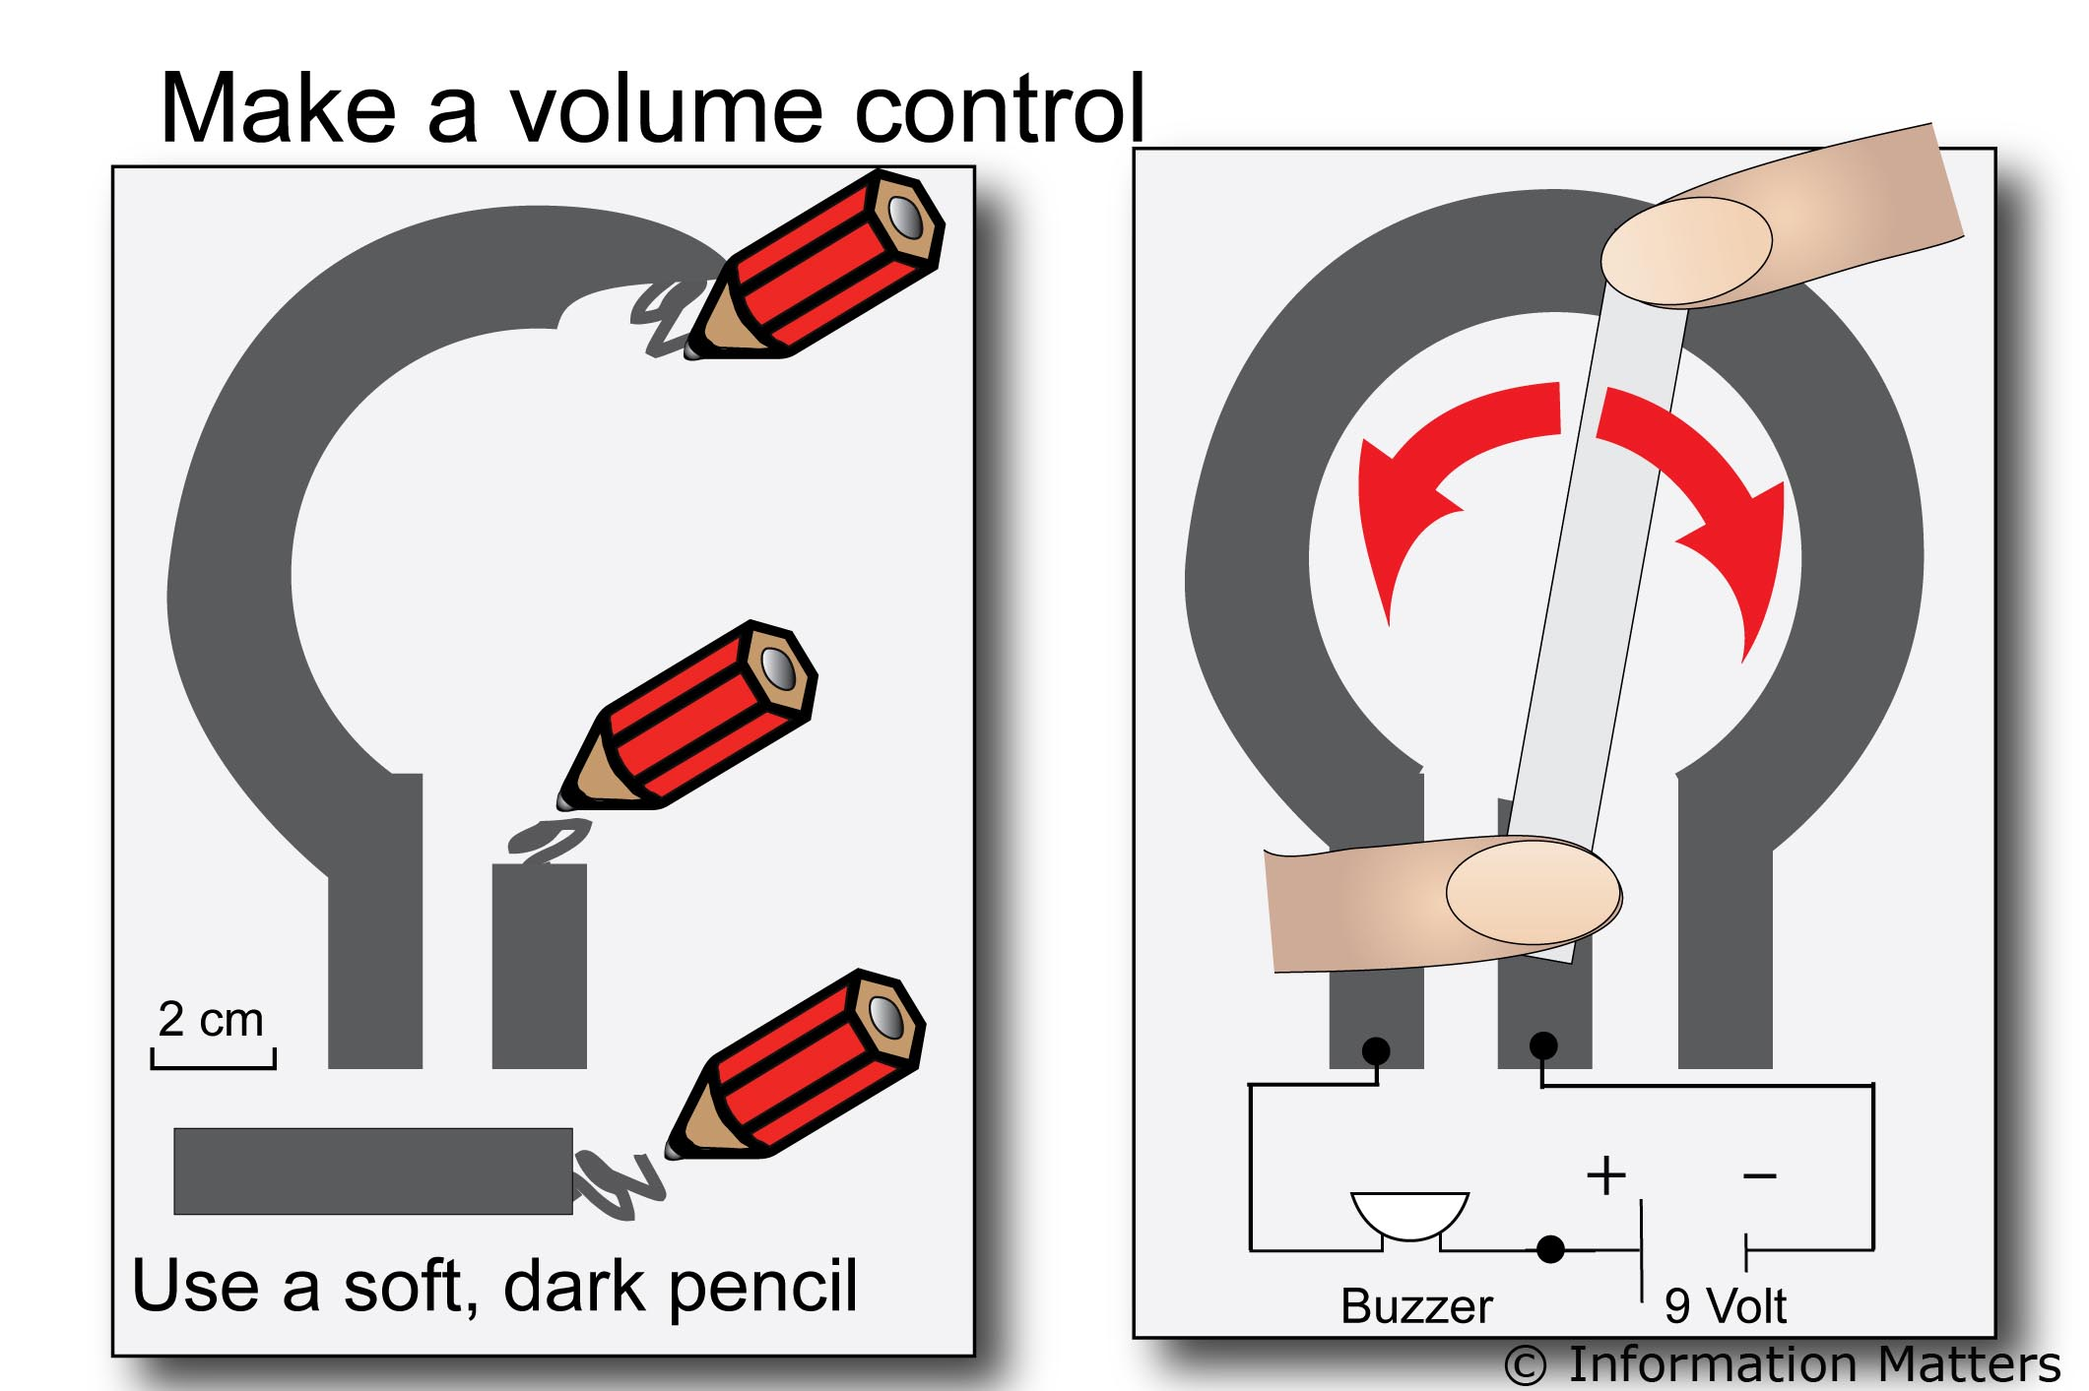
 | 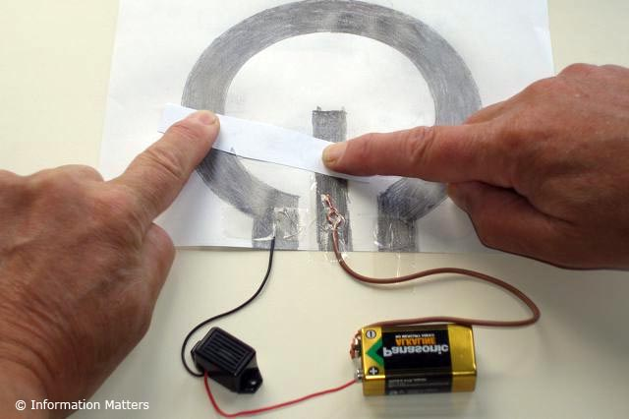

Making a light dimmer  - Build the circuit as shown in the diagram.  - Control the brightness of a bulb by sliding the contact along the nichrome wire, which changes the resistance in the circuit.  - The same method can be used with other batteries, bulbs and devices such as buzzers and fans to test the effect of changing the resistance in the circuit. | 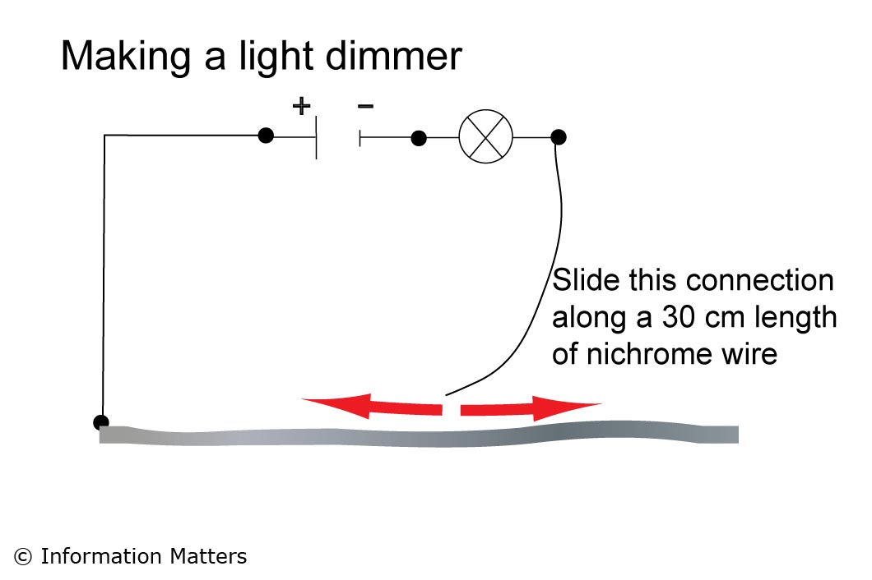
 | 