ACTIVITY: Testing for conductivity

Activity idea

In this activity, students construct simple electrical circuits and test a variety of materials to identify those that are good conductors and those that do not conduct electricity.

By the end of this activity, students should be able to:
- construct simple electrical circuits to test the conductivity of liquids and solids
- predict if a material is a good conductor and test their hypothesis
- rank/group materials according to their conductivity.

Introduction/background notes
What you need
What to do
Discussion questions
Conducting experiments

Introduction/background

Electric charges will not flow unless there is a complete closed path. The route along which electric charges flow is called an electrical circuit.

A conductor is a material that will let electric charges flow through it. Some materials allow electricity to travel through them more easily (such as copper) and are considered good conductors.

What you need

For each group of students:
- Copies of student instructions Conducting experiments
- 1 light bulb or light emitting diode (LED) and 1 light bulb holder (you can use a buzzer instead of a bulb)
- 1 battery (voltage to suit the light bulb, for example, a 9 volt battery with a 9 volt bulb)
- 3 wires
- 2 spoons
- Selection of solid and liquid materials for testing

What to do

- Discuss how electrical circuits work and the role of the conductor.

- Divide students into groups and assist them to gather the equipment they need to construct the circuits to test materials.

- Have students complete steps 1–6 of the student instructions and discuss their findings.

Metals and carbon conduct electricity. An ordinary pencil usually conducts electricity because the ‘lead’ is actually carbon (graphite). If it doesn’t, there is probably a break inside the pencil. Coloured pencils are unlikely to conduct as they are often made of coloured clays or waxes.

- Have students complete steps 7–10 of the student instructions and discuss their findings.

Usually water molecules (such as in distilled water) are poor conductors and certainly do not conduct at the low voltages (1.5–9V) used here. Adding a small quantity of the additives listed may change the conductivity.

It depends on what the additive does as it dissolves. If it breaks up (ionises) in the water, it will probably conduct. Vinegar, lemon juice, sports drinks and soft drinks all conduct electricity as they form ions in the water and carry charges.

Although electricity is conducted, only a small current passes, and the movement of the electrons is not sufficient to cause the bulb to light up. Instead, bubbles of hydrogen gas form on the spoon connected to the negative terminal. The tiny quantity of gases produced is not sufficient to be harmful. These bubbles only form if the circuit is complete and electric charges flow through the circuit.

Both spoons may produce bubbles depending on what is being added.

Tips for testing liquids

- Rinse the glassware well between tests.
- Set it up with distilled water each time, then add what you want to test.
- Allow a minute for what you are testing to dissolve in the water.
- Use similar spoons so they do not react with one another and cause confusion.
- The colour of the plastic on the wire does not matter.

Testing liquids results

Item | Conducts? | Item | Conducts?
1. Distilled water | No | 6. Lemon juice | Yes
2. Tap water | Yes | 7. Sports drinks | Yes
3. Salt | Yes | 8. Soft drinks | Yes
4. Sugar | No | 9. Baking soda solution | Yes
5. Vinegar | Yes | 10. Free choice

Discussion questions

- Why do you think you should never touch a power socket with wet hands?
Conducting experiments

A conductor is a substance that allows electric charges to flow through it.

This activity will allow you to test a variety of solids and liquids to see if and how well they conduct electricity.

Testing solids  - Construct a circuit as shown in the images. You can use commercially bought kits or components (parts) obtained from an electrical retailer.  - Test the circuit to see if it works. If the connection is not complete, the pathway is broken and the bulb does not glow.  - Connect the free ends of the wires to the object you wish to test. If the object is able to conduct electricity it will complete the circuit, the bulb will glow and you can conclude that the item is a good conductor. If the object cannot conduct electricity, the pathway will be blocked, the bulb will not glow and this shows that the item is a poor conductor (an insulator).  - Repeat with 9 other objects and record your results in the table below. | 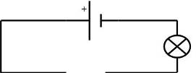
 | 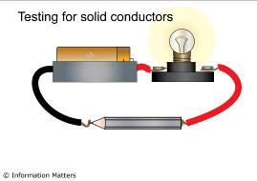
 | 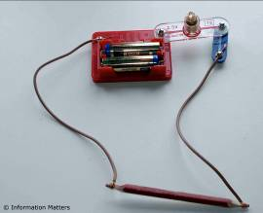

Item | Conducts? | Item | Conducts?
1. Coin | Yes | 6.
2. Pencil |  | 7.
3. |  | 8.
4. |  | 9.
5. |  | 10.

- Put the materials that conduct electricity in one pile and those that don’t into another pile. Do you notice any similarities between the objects in each group (conductors and non-conductors)? What do you think makes an object a good conductor?

- Use your ideas to predict if the objects in the following table are good conductors and then test them to see if you are correct.

Object | Prediction | Good conductor?
Blades of a pair of scissors
Plastic handles of a pair of scissors
Ballpoint pen
Nail or screw
Dinner plate
Rubber sole of a gumboot
Aluminium drink can
Human hair

Testing liquids  - Construct a circuit as shown in the images. You can use commercially bought kits or components (parts) obtained from an electrical retailer.  - Test the circuit to see if it works. Check that the two spoons are not touching (the bulb protects the battery if they do and stops the battery from being damaged).  - If the water conducts electricity, bubbles will form on one of the spoons. However, it is unlikely that enough electricity will flow to make the bulb shine. Remember, you will be looking for bubbles on the spoon, not to see if the bulb lights. Try out this circuit with the other liquids suggested in the table below and deduce whether they can conduct electricity. Note that the salt, sugar and baking soda need to be dissolved in distilled water. | 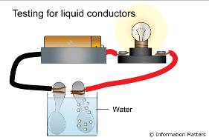
 | 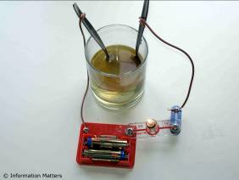

Item | Conducts? | Item | Conducts?
1. Distilled water | No | 6. Lemon juice
2. Tap water |  | 7. Sports drinks
3. Salt |  | 8. Soft drinks
4. Sugar |  | 9. Baking soda solution
5. Vinegar |  | 10. Free choice

- Which liquid caused the most number of bubbles to appear on the spoon? Rank the liquids in order of their conductivity, i.e. how good they are at conducting electricity according to the amount of bubbles produced.

